Software Developers User's Guide for the Data Link Communication Application (DLCA) ARINC 661 Projects

Document Number 946-5683-XXX

Revision

CAGE Code 0EFD0

Rockwell Collins

Contract Number None

|  | **NAME** | **TITLE** | **APPROVAL** |
| --- | --- | --- | --- |
| Prepared By: | Lori J. Sipper | Engineer | N/A |
| Approved By: | James M. Wolff | Engineer | On File |

NOTICE: The contents of this document are proprietary to Rockwell Collins and shall not be disclosed, disseminated, copied, or used except for purposes expressly authorized in writing by Rockwell Collins.

The technical data in this document (or file) is controlled for export under the Export Administration Regulations (EAR), 15 CFR Parts 730-774. Violations of these export laws may be subject to fines and penalties under the Export Administration Act.

© 2014 Rockwell Collins. All rights reserved.

REVISION HISTORY

| **REV** | **DESCRIPTION** | **DATE** | **APPROVED** |
| --- | --- | --- | --- |
| - | Initial Release | 2014-05-20 |  |
|  |  |  |  |
|  |  |  |  |
|  |  |  |  |
|  |  |  |  |
|  |  |  |  |
|  |  |  |  |
|  |  |  |  |

Table of Contents

Software Developers User's Guide for the Data Link Communication Application (DLCA) ARINC 661 Projects 1

1. Scope 7

1.1 Purpose 7

1.2 Applicability 7

2. Reference Documents 7

2.1 Rockwell Collins (RC) Internal Documents 7

3. Drives and Software versions 7

4. DOORS 9 8

4.1 Software Installation 8

4.2 Doors Views 9

4.2.1 Peer Review View 9

5. Clear Quest 13

5.1 Software Installation 13

5.2 General Configuration 13

6. PREP 17

6.1 Software Installation 17

6.2 General Configuration 17

6.2.1 Add new Project 17

6.2.2 SVN History configuration 20

7. TortoiseSVN 21

7.1 Software Installation 21

7.1.1 ETIPEDIA Help Link 21

7.2 General Configuration 22

7.2.1 Create Working Copy on PC 22

7.2.2 Modifying Files 22

7.2.3 Update 23

7.2.4 Commit 23

7.2.5 Comparing Versions 24

7.2.6 Editing 25

7.2.7 Adding the files 25

7.2.8 Parallel Development 26

7.3 TortoiseSVN Log Extension 28

8. Beyond Compare Pro 31

8.1 Using Prep 31

8.2 Using in Subversion 32

9. IDE (Eclipse, Visual Studio 2008, and VS Code) 32

9.1 Common 32

9.1.1 Supporting Software (MinGW/Msys) 32

9.1.2 Supporting Software (LynxOS-178 v2.2.2) 33

9.1.3 Supporting Software (C++ Redistributable) 34

9.1.4 Supporting Software (.NET Framework) 35

9.2 Installing Eclipse 4.12 36

9.2.1 Moving from Eclipse 3.7.2 to ECLIPSE 4.12 36

9.2.2 Beginning with Eclipse 4.12 38

9.2.3 Import DLCA Project into eclipse: 42

9.2.4 Build the Project 49

9.2.5 Build Project to Target 50

9.2.6 Eclipse 4.12 Preferences 52

9.2.7 Debugging Software via Eclipse and VISTA 54

9.2.8 Initial Debug Configuration Setup 54

9.2.9 Debugging with an existing Debug Configuration 60

9.3 Visual Studio 2008 65

9.3.1 Software Installation 65

9.3.2 General Configuration 66

9.4 VS Code 71

9.4.1 Installing VS Code 71

9.4.2 Extensions 71

9.4.3 Opening the DLCA Project in VS Code 73

9.4.4 Building the project in VS Code 75

10. Running the DLCA Application 75

10.1 Running the Simulation 75

10.1.1 Vista_Sim_EDS 76

10.1.2 Vista_Sim_IPS 77

11. Automated Instrumentation (WIP) 77

12. VISTA 77

12.1 Software Installation 78

12.2 General Configuration 78

12.3 Running VISTA 78

12.3.1 Single DLCA – Host PC – M145_M170 78

12.3.2 Single DLCA – Host PC – CSeries 78

12.3.3 Activate KeyBoard and Mouse 78

12.3.4 AGPS Registration Key 79

12.4 Stopping VISTA 82

13. VAPS 83

13.1 Installing PERL 83

13.2 Installing Python 3.3 84

13.3 Widget Library 85

13.4 Installing VAPS 86

13.5 Start VAPS 89

14. SciTool’s Understand 89

14.1 Software Installation 89

14.2 Tool License 94

14.3 Software Configuration 94

14.3.1 Load DLCA-6500 Project 94

14.3.2 Configure project portability mode 94

14.3.3 Configure C++ Options 97

14.3.4 Adding/Remove Project Files 100

14.3.5 Adding Rockwell Collins Custom CodeCheck rules 103

14.3.6 Configure CodeCheck ‘Files’ settings 103

14.3.7 Configure CodeCheck ‘Checks’ settings 105

14.4 Running the CodeCheck checks using the IDE 106

14.5 Understand Checks vs Datalink Coding Standard Rules 109

15. Write a Change Request 115

15.1 Guidelines to write a CR: 115

15.2 Things To Do 116

15.3 Things to NOT DO 117

15.4 Writing a Good Change Request Summary 117

15.5 Project Data 118

15.6 Change Request – Investigations 119

15.7 Change Requests - Legal Considerations 119

16. Good Coding Practices 119

17. How To use DOORS 126

17.1 Write Requirements in DOORS 126

17.2 DOORS _Proposed change column usage 127

17.3 DL-6500 Deviation 128

17.4 Update DOORS L3 - REQ - SRS for FANS ATN HMI 128

17.5 Writing Good Requirements 130

17.6 Requirement Linking 131

17.6.1 Linking from LLR to the HLR 132

17.6.2 Linking from Code to LLR 132

18. Software Code Information 133

18.1 Comment Header Files 133

18.2 Completing a Change Request for a Software Build 135

18.3 Delivery of Requirements 136

18.4 Lint Guidelines 136

18.4.1 Installation 136

18.4.2 Using Lint on the Code 136

18.4.3 When to Run Lint 139

18.4.4 Suppressing Lint Errors/Warnings/Infos 140

18.4.5 Resources 145

18.5 Coverity Setup 145

18.5.1 Obtaining Coverity License 145

18.5.2 Installing Coverity 146

18.5.3 Configure Coverity Environment 151

18.5.4 Running Coverity 152

18.5.5 Getting the Coverity Output 152

18.5.6 Understanding the Coverity Output 153

18.5.7 Manually Build Project with Coverity 154

18.5.8 Manually Analyze the Build 156

19. Prep Review Guidance 157

19.1 Official PREP document. 157

19.2 General Guidance 157

19.2.1 SRS Review 157

19.2.2 Design/Code Review 158

19.2.3 Branch Process 159

19.3 Leader Checklist Guidelines 159

20. VectorCAST 6.2F and Build Instrumentation 161

20.1 Download and Install VectorCAST Version 6.2f 161

20.2 SVN Export the Build 164

20.3 Launch VectorCAST 166

20.4 Instrumenting files 183

20.5 Creating the executable 185

20.6 Source Code Analysis (SCA) Tips 188

20.6.1 “If” Statements - Avoid unnecessary use of “else” 188

20.6.2 “Case” Statements 189

20.6.3 Early outs 190

20.6.4 Implementing same code multiple times 191

20.6.5 Declaring class methods that are never called 192

21. Loading a build onto target 193

21.1 Loadset Preparation 193

21.2 615A Load 195

21.3 Lauterbach load 200

21.4 Starting Target 204

21.5 EDS Remote dataloader 204

22. The Role of the BuildMaster 205

22.1 Preparation 205

22.2 Build Process 205

22.3 Publishing the Build 207

22.4 DLCA-6500 Build Announcements 207

23. EXCEL 216

23.1 Open spreadsheets in separate windows. 216

24. LynxOS Tools: Managing Scarce Licenses on Windows 217

25. Software Design Document 218

25.1 High Level SDD – Microsoft Word 218

http://asvn/dlnk-dlca/trunk/Project Documents/High Level SDD/945-7650-xxx SDD.docx 218

25.1.1 Diagrams 218

25.2 SDD Traceability 218

25.2.1 Adding function definitions to SDD Doors proxy 218

25.2.2 Linking Requirements 220

26. WINDOWS 7 UPGRADE TIPS 226

27. Source code Peer Review and SLOC information 227

28. Footprint Analysis 229

29. Dr. Memory 231

30. Training & Tips 232

31. Miscellaneous 234

32. Nameplates 234

33. Seamless transfer check between ATN <-> FANS 236

# Scope

## Purpose

The purpose of this document is to capture all software development day-to-day activities and list all software development related artifacts. This document contains all details associated with the project’s software development effort. The details in this document include enough information for training, for consistency and repeatability of software development activities and artifact preparation, and for understanding why the activities and artifacts are in place to assist with continuous process improvement. All decisions made relating to a software development issue should be documented to promote communication and consistency in software development.

## Applicability

This document applies to the Data Link Communication Application (DLCA) ARINC 661 projects of the Rockwell Collins Commercial Systems Data Link group.

# Reference Documents

The documents listed in this section are referenced in one or more places throughout this document.  This section provides the precise title, publisher, control numbers (if any), and date of publication (if necessary for control) of each referenced document.  For easy identification, each point of reference includes a bracketed number (defined in this section) that corresponds to the document being referenced. References with TBD or XXX in the part number have either not been released or not had a part number assigned.

## Rockwell Collins (RC) Internal Documents

**Policies and Procedures**

1. The DOORS Documentation Method for the System Architectures Department, RCPN 945-9527-001
2. Peer Review Method Using PREP for the System Architectures Department, RCPN 945-9104-xxx

# Drives and Software versions

If you do not have access to some of the drives listed you must go to the RWeb and type in EBSS. Click on Share Management and request access to the drives listed below. Note: “Project_Files” is usually replaced by “rw_apps” as the local software storage directory for drive C.

| **Drive** | **Path** | **Note** |
| --- | --- | --- |
| S: | \\ccanet\approot | Standard mount location.  *[Some build tools depend upon this mapping]* |
| W: | \\ccanet\cs\dlnk | Mount the following path to your W: drive  *(or any other available drive letter)* |
| C:\Project_Files\dlca\ | <http://asvn/dlnk-dlca>/trunk | Subversion Repository mapping for development. (*Note: mapping to http://asvn/dlnk-dlca will trigger tens of GB of extra unneeded data to be “checked out” onto your hard disk. As the number of branches and tagged builds increases the size of the unwanted extra data will increase as well. Checking out this extra data wastes hours, the cleanup later wastes more hours of work time. )* |

|  |  |  |
| --- | --- | --- |
| # | Software Version | Link to Software Centre/server |
| 1 | Doors v9 | [**DOORS v9 Install**](http://rwebapps.rockwellcollins.com/SoftwareCenterIntl/Software.aspx?ID=7926) |
| 2 | Clear Quest v7.0.1.2 | [**ClearQuest v7.0.1.2**](http://rwebapps.rockwellcollins.com/SoftwareCenterIntl/Software.aspx?ID=8126) |
| 3 | Prep v3.0.0 | [**PREP (Peer Review Eclipse Plugin) 3.0.0**](http://rwebapps.rockwellcollins.com/SoftwareCenterIntl/Software.aspx?ID=7501) |
| 4 | Java runtime environment v1.6.0 | [**Java 2 Runtime Environment v.1.6.0_20**](http://rwebapps.rockwellcollins.com/SoftwareCenterIntl/Software.aspx?ID=4572)  (*Note: the final build number “20” is not significant.*) |
| 5 | Tortoise SVN (Latest version) | [**TortoiseSVN**](http://rwebapps.rockwellcollins.com/SoftwareCenterIntl/Software.aspx?ID=1741) |
| 6 | Visual Studio 2008 | [**Visual Studio Professional 2008**](http://rwebapps.rockwellcollins.com/SoftwareCenterIntl/Software.aspx?ID=7250) |
| 7 | Eclipse v3.6.2 | [**Eclipse 3.6.2**](http://rwebapps.rockwellcollins.com/SoftwareCenterIntl/Software.aspx?ID=9541) |
| 8 | MinGW v3 | [**MinGW 3 - Minimalist GNU for Windows with MSys**](http://rwebapps.rockwellcollins.com/SoftwareCenterIntl/Software.aspx?ID=1639), |
| 9 | LynxOS-178 v2.2.2 | [**LynxOS-178 v2.2.2**](http://rwebapps.rockwellcollins.com/SoftwareCenterIntl/Software.aspx?ID=8106) |
| 10 | Vista v8.5.0 | [**VISTA 8.5.0**](http://rwebapps.rockwellcollins.com/SoftwareCenterIntl/Software.aspx?ID=8357) |
| 11 | Vista SDK v8.5.0 | [**VISTA 8.5.0 SDK**](http://rwebapps.rockwellcollins.com/SoftwareCenterIntl/Software.aspx?ID=8355) |
| 12 | Signal Analyzer v2.7.0 | [**VISTA Signal Analyzer 2.7.0**](http://rwebapps.rockwellcollins.com/SoftwareCenterIntl/Software.aspx?ID=8898) |
| 13 | Signal Generator 2.4.0 | [**VISTA Signal Generator 2.4.0**](http://rwebapps.rockwellcollins.com/SoftwareCenterIntl/Software.aspx?ID=8422) |
| 14 | Socket IO 1.3.0 | [**VISTA Socket IO 1.3.0**](http://rwebapps.rockwellcollins.com/SoftwareCenterIntl/Software.aspx?ID=8481) |
| 15 | Visual Studio 2008 re-distribution files | \\ccanet\cs\dlnk\DLCA\Tools\V2008 Re-distributionfiles |
| 16 | Commit Monitor (Latest) | [**CommitMonitor**](http://rwebapps.rockwellcollins.com/SoftwareCenterIntl/Software.aspx?ID=4574) |
| 17 | SciTool’s Understand | <http://asvn/dlnk-dlca/trunk/Tools/Understand> |
| 18 | PC-Lint Ver. 9 (Gimpel Software) | [**PC-Lint v9 Install**](http://rwebapps.rockwellcollins.com/SoftwareCenterIntl/Default.aspx) |

# DOORS 9

## Software Installation

Go to the ePedia web site. On the ePedia main website, search using “DOORS” as the search word. Page down until the “Navigation” section is visible. Find the “Categories” window and then click on the “Installation” bulleted item. Note that the DOORS database which houses the DLCA DOORS documents is Collins1.

Follow the directions on the DOORS Installation web page for installing DOORS.

If you do not have access to the “DLCA ATN-FANS” and/or “DLCA FANS Only” project(s) on the Collins1 Database then check with an EPA, EPS, or project administrator and ask them to get you added to the project group(s) as needed. See the graphic below to see what the DLCA folders look like, once DOORS is active and you have read-only privileges or higher.

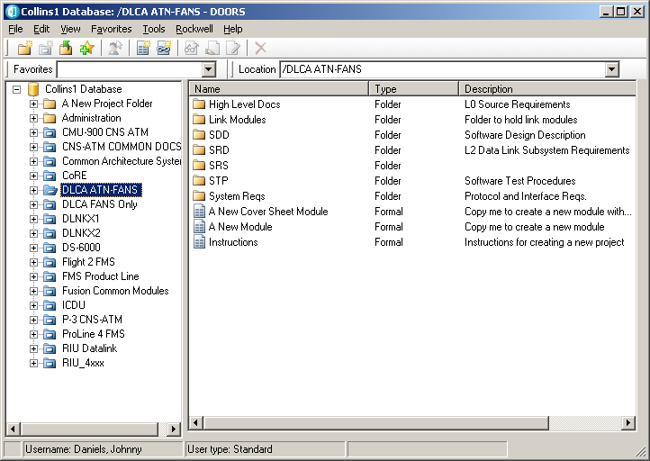

## Doors Views

### Peer Review View

* Peer Review view should be setup by the Admin/EPA at the start of the project.
* Refer the Doors Process document to include all the required attributes.
* Follow the below steps to create Link information columns for Doors modules.

**Step 1:** Open the SRS module.

**Step 2:** Go to Analysis -> Wizard.

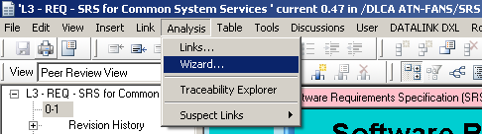

**Step 3:** Select Link direction as “Out-links” and Links types as “Doors links”. Click “Next”.

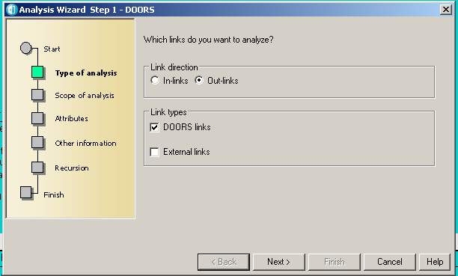

**Step 4:** Select Module as “Specific” and browse to required High level module. Click

“Next”.

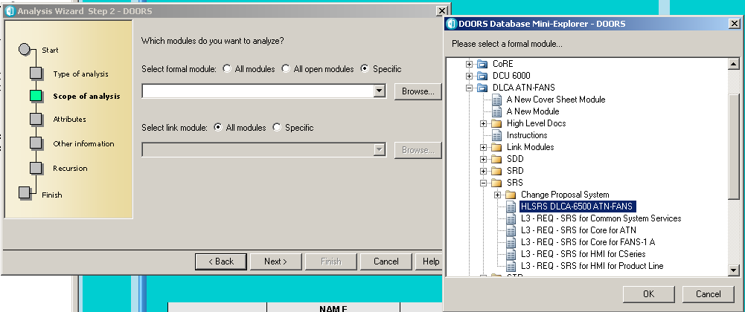

**Step 5:** Select “Object Identifier” as the attribute to be displayed in the traceability column. Click “Next”.

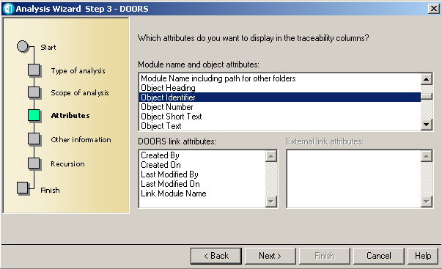

**Step 6:** Set “Specific depth of analysis” to 1. Click “Finish”.

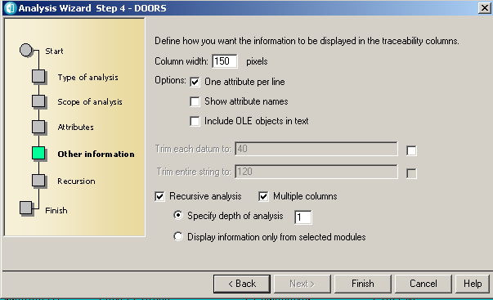

**Step 7:** A new column should have created. Go to properties of the column and update the Column Title as defined in the process/discuss with Lead.

Ex: _LINK_xxxx

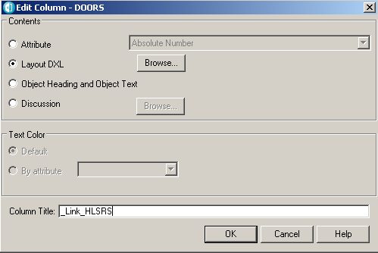

**Step 8:** Save the view as “Peer Review View”

**Note:**

*Run the above steps by selecting appropriate modules in* ***Step 4*** *above. Each execution of the above steps creates a traceability column to the selected high level module.*

***Ex:*** *If a SRS module is having out-links to 2 higher level modules then* ***Steps 1 to 8*** *needs to be executed twice (once per each module selected as destination module in* ***Step 4****). As a result 2 columns will be created listing link information to each destination module.*

# Clear Quest

Change requests will be written using this tool. For instructions to write a change request (CR), click here.

## Software Installation

Go to the Software Center and install [**ClearQuest v7.0.1.2**](http://rwebapps.rockwellcollins.com/SoftwareCenterIntl/Software.aspx?ID=8126) software. Use the standard configuration.

## General Configuration

1. Select Start Menu🡪 All Programs🡪 IBM Rational 🡪 IBM Rational ClearQuest 🡪 ClearQuest maintenance tool.
2. Select File 🡪 Import Profile

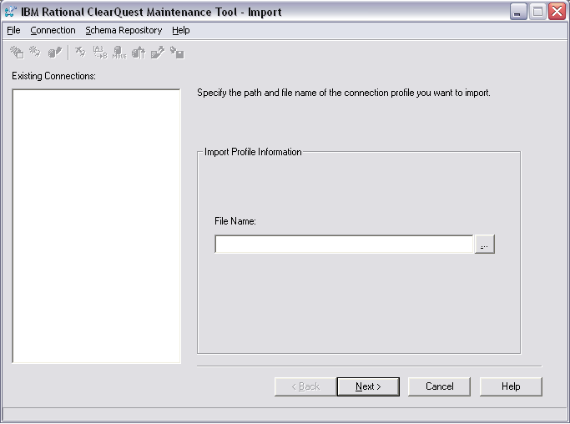

1. Browse and import the following schema

\\crntcc02\ccstg_h\install\ClearQuest\INI_FILES\CommercialSystems.ini

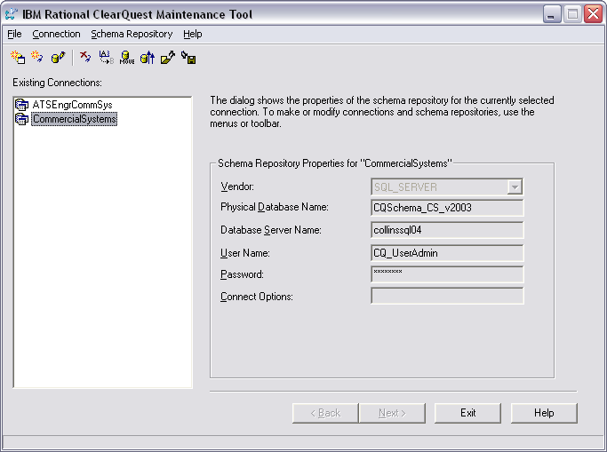

1. Exit the Maintenance tool**.**
2. Open ClearQuest
3. Select File🡪 database 🡪 Connect 🡪 New Connection. Select Schema repository as CommercialSystems

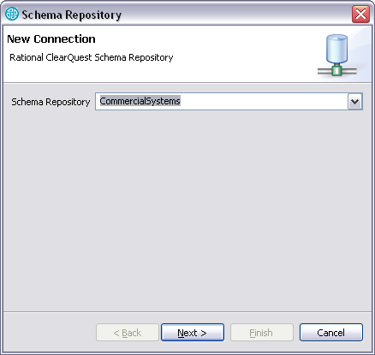

1. Select ‘Next’ and enter your User ID. Then select Finish

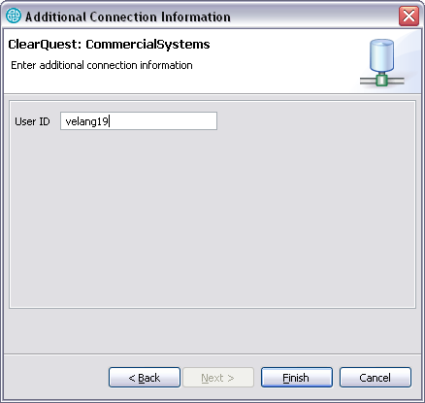

1. Select the database as “**FUSN:PLFusion Integration”.** Enter the password and select Ok. This setting will be saved from this point on.

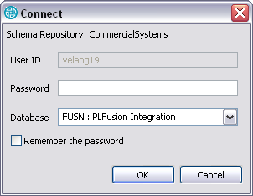

CRs are raised under the following location:

**Commercial system schema->Fusion under, Product lines->DLCS**

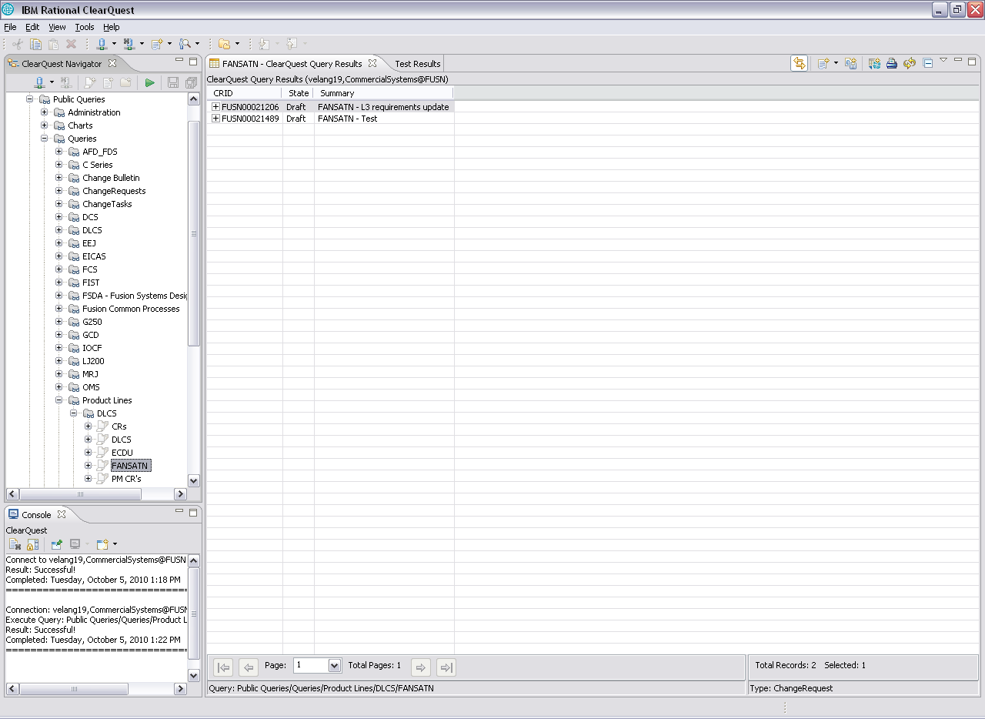

# PREP

This software is used for all peer reviews. See section, Prep Review Guidance, for PREP tips.

## Software Installation

Go to the Software Center and install [**PREP (Peer Review Eclipse Plugin) 3.0.0**](http://rwebapps.rockwellcollins.com/SoftwareCenterIntl/Software.aspx?ID=7501) and [**Java 2 Runtime Environment v.1.6.0_31**](http://rwebapps.rockwellcollins.com/SoftwareCenterIntl/Software.aspx?ID=4572) (If not available in your PC, note: on the ‘Add or Remove Programs console this will appear as **“Java™ 6 Update 31”** ).

Once this is installed create a short cut on your desktop to access PREP. You should now be able to use PREP.

## General Configuration

The Prep database for the FANS/ATN project is **PREP_CS_Datalink/FANS.ATN**. All Foreign nationals need to get their ACP updated to have access to this DB. Once the ACP is updated have the EPA provide you access to the Prep DB

### Add new Project

This section will show you how to add New DLCA Project to PREP

Open PREP and Select “Connect to Project” button

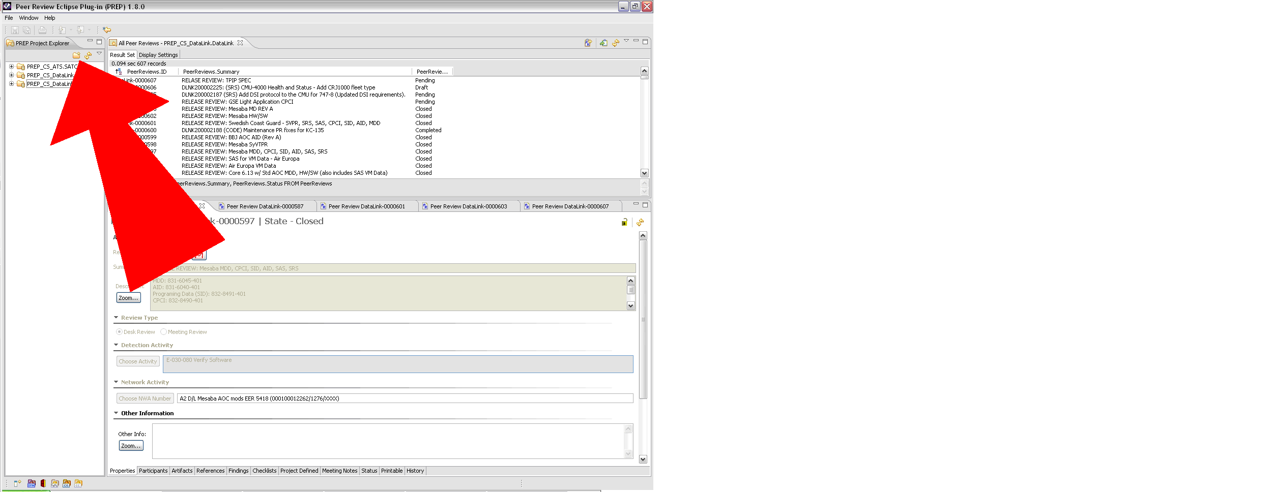

Select on PREP_CS_DataLink

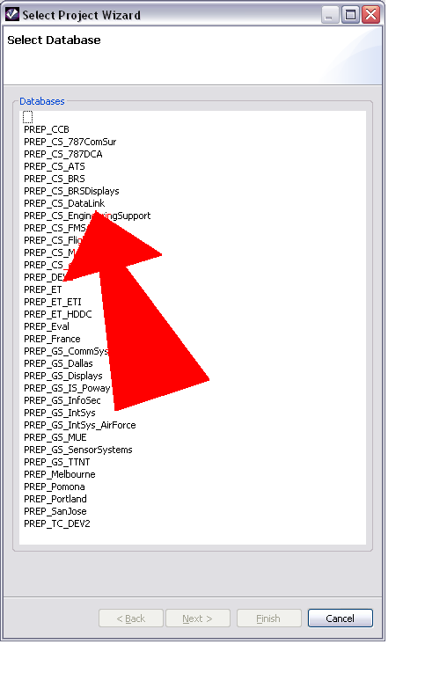

Click Next

Click on FANS.ATN

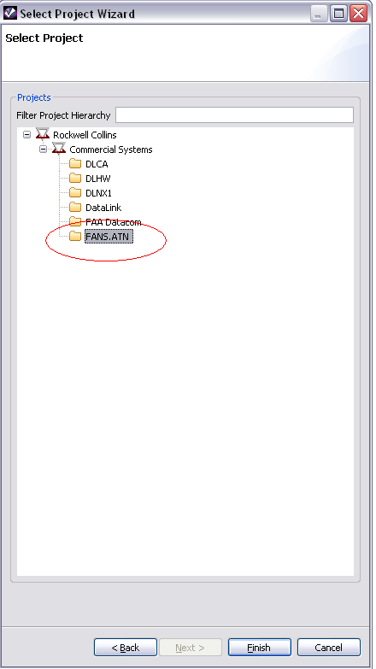

Click Finish.

PREP_CS_Datalink/FANS.ATN now appears in your Project Explorer.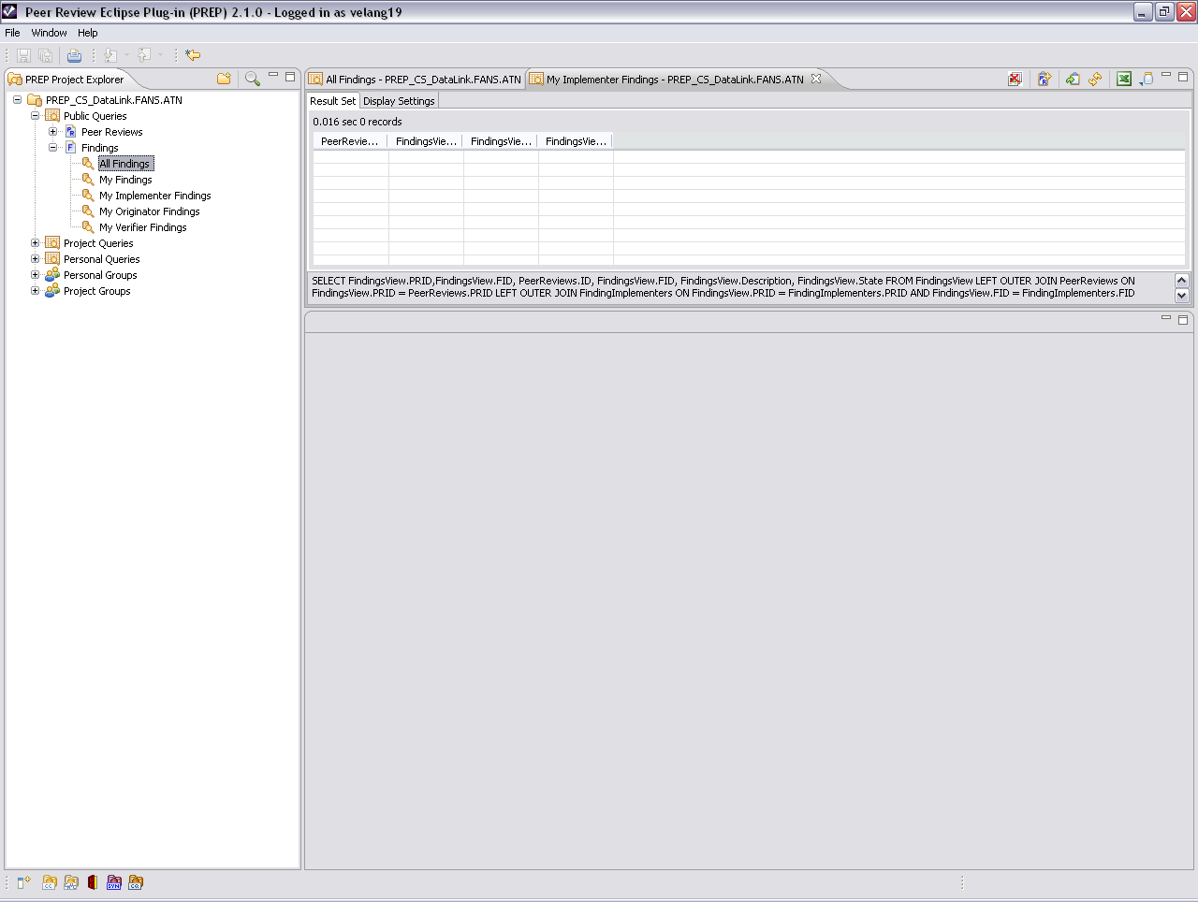

### SVN History configuration

Select Window->Preferences and make sure that Show All Revisions is checked, then click Apply.

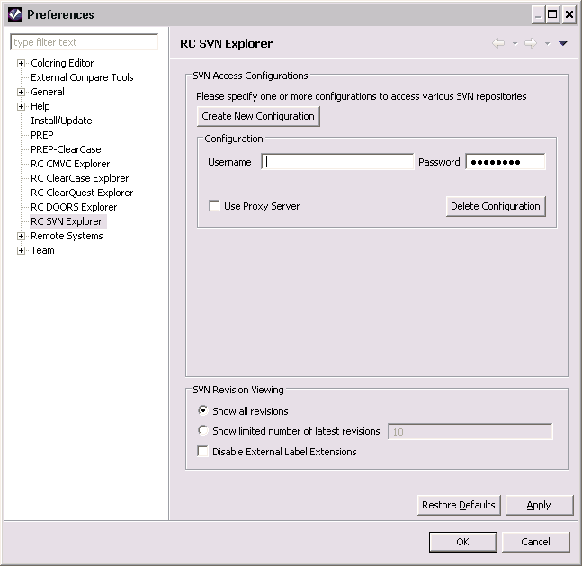

# TortoiseSVN

This install provides a Windows Explorer integrated graphical interface to access a Subversion server.

## Software Installation

Go to the Software Center and install [**TortoiseSVN**](http://rwebapps.rockwellcollins.com/SoftwareCenterIntl/Software.aspx?ID=1741) software.

Continue with the installation until you get to the page below. If Tortoise SVN is already installed on your device and you need to reach this page, in your windows search bar search add or remove programs. Next type in Tortoise SVN and select it. Click modify. Navigate through tortoise SVN and select modify when prompted. You should now see the page below.

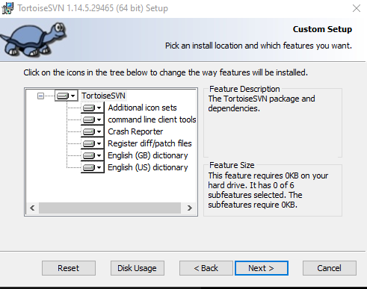

Make sure to set all options to “Will be installed on local hard drive.” Then Finish

SVN access rights needs to be given to access repository <http://asvn/dlnk-dlca> and for foreign nationals ACP needs to be updated to access the SVN Repository

### ETIPEDIA Help Link

See the following link for subversion help.

<http://etipedia.rockwellcollins.com/wiki/Subversion>

Select “[How do I get started using Subversion?](http://etipedia.rockwellcollins.com/wiki/How_do_I_get_started_using_Subversion%3F)” to install Tortoise SVN, checkout a working copy, modify files, and commit files

Select the following link for common “How to…” questions.

<http://etipedia.rockwellcollins.com/wiki/TortoiseSVN#How_do_I_update_my_working_copy_directory_to_the_latest_files_in_the_repository.3F>

## General Configuration

### Create Working Copy on PC

Create a new folder (if necessary) on your PC at C:\Project_Files\dlca to contain a copy of the subversion repository by following the steps below.

**Note**: While it is not ‘essential’ that you use the path specified above, it will simplify following the instructions in this guide. If you use a different path you will need to substitute your base path in place of C:\rw_apps\dlca wherever it is mentioned in this document.

Right-Click on the folder “**dlca**” and then select “SVN Checkout”. Set the value for ‘URL of repository:” to http://asvn/dlnk-dlca/trunk and Select OK.

The *SVN Checkout* procedure will take a long time (hours) for the initial checkout. SO be sure to exclude the branches and tags directories that exist at the same level as the trunk directory. Subsequent checkouts may not take as long, depending on the number of files changed since the previous checkout.

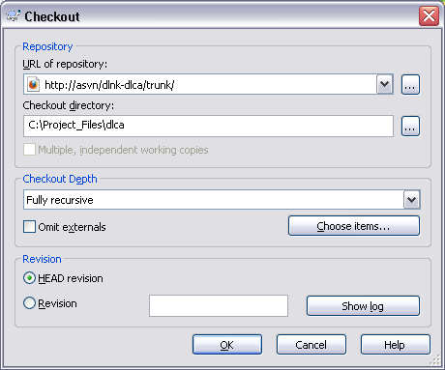

### Modifying Files

Many files are read only until a lock is obtained on the file to be edited.

A lock is obtained by right clicking on the files and selecting Get lock in TortoiseSVN. If a lock cannot be obtained because of a wrong version or it is already obtained by someone else, you will receive an error. On this project, locks are required to edit files and there will be no stealing locks.

(Note: Because of the way that subversion actually works, it is not necessary to obtain a lock to work on a file. However if a file is “high-jacked” by just removing the read-only attribute then someone else may have placed a lock on the file. When this happens you will not be able to commit a new version of the file until the lock is removed. Once that happens you can commit your changes but they will be merged into the changes committed by the other person. This may result in unexpected results and must be checked very carefully to be sure that the final operation of the code works as intended. For binary files (xl spreadsheets, word docs, omfs, etc.) the merge is not possible and all changes will have to be merged by hand using tools outside of subversion.

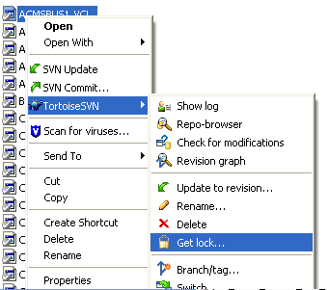

### Update

The working copy of the repository is static. It has to be updated occasionally to get all the current versions. This should be done when reviewing tests and editing files. This will not affect the repository.

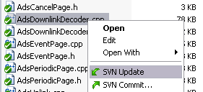

### Commit

After editing the file, it should be committed into SVN at the appropriate path. This will update the repository version and add the updated file to the current Repository. This cannot be undone. The repository can be reverted to a previous configuration but will still result in updating the repository. While committing the file, the comment has to be provided which should be short and specific.

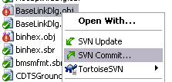

(Note: For changes made that span multiple directories the TortoiseSVN tool “SVN Check for modifications” can be used at the appropriate directory level to list all the files which were modified in a single window. In this window multiple files can be highlighted using the usual keyboard commands, cntrl A, cntrl left mouse click, etc. to mark the files that you wish to commit.)

Upon selection of the SVN Commit button you will be prompted with the below screen. All commits related to the DLCA6510_dev folder should have the **Work Package** number entered in the field titled “WP Issue #” located in the top right (Ex. DLSS-12345). The task number or work element number should not be entered. Additionally, when committing artifacts, write a short description of what you changed. “Updated per WP/WE” is not a sufficient description.

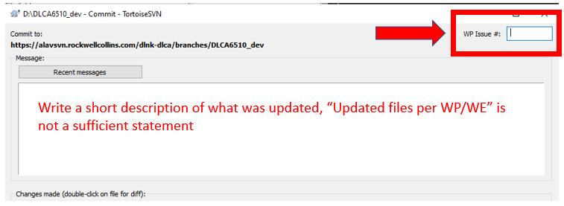

### Comparing Versions

(Note: It is strongly recommended that the comparison tool Beyond Compare be used instead of Subversion’s built in compare tool. Subversion can be configured to automatically use the commercial tool.)

This can be done by looking at the log for the individual file and using the Ctrl key to select the versions you would like to view as shown below:

View the log:

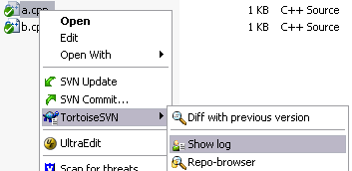

Compare the revisions:

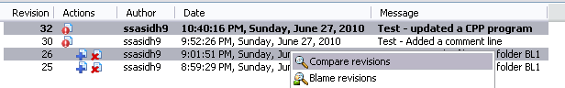

### Editing

Once the file is edited, the icon of the file changes to red as shown below:

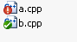

Once the icon changes as shown above, the file will likely to be committed (if that was the user’s intent) as explained in sec 3.3.5 Commit

### Adding the files

Files can be added by simply copying the file into the folder under Subversion Control

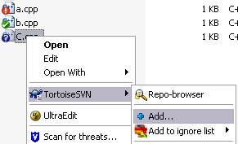

Once the files are added as above, the file needs to be committed as explained in section 1.5.2.3 Commit

### Parallel Development

When multiple engineers want to work on same artifact same time, we use branching.

Right click on the trunk\BL1 🡪 Select TortoiseSVN 🡪 Branch / Tag

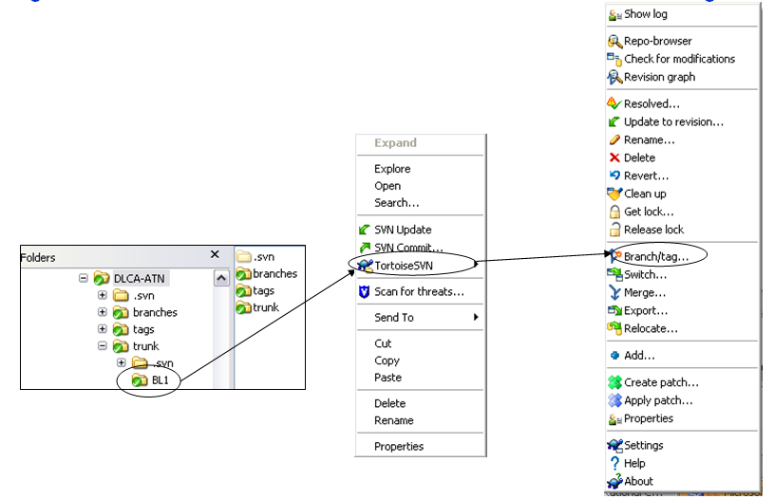

1. Select the browse button next to “To URL” and select Branches 🡪 individual folder

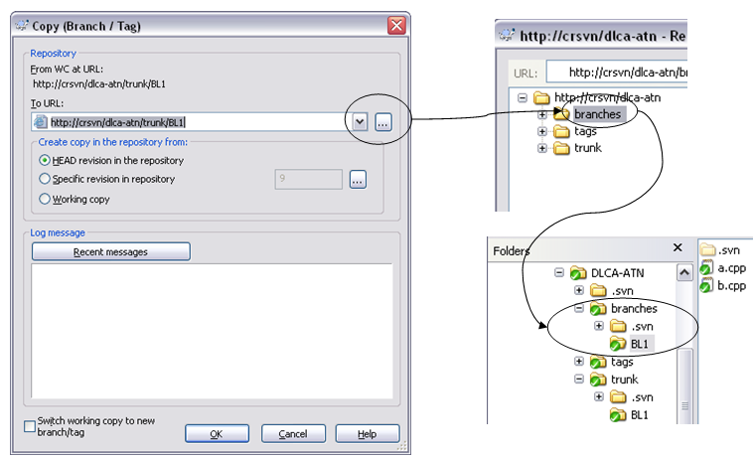

1. When the trunk and branch gets modified and committed a couple of times, it looks like below:

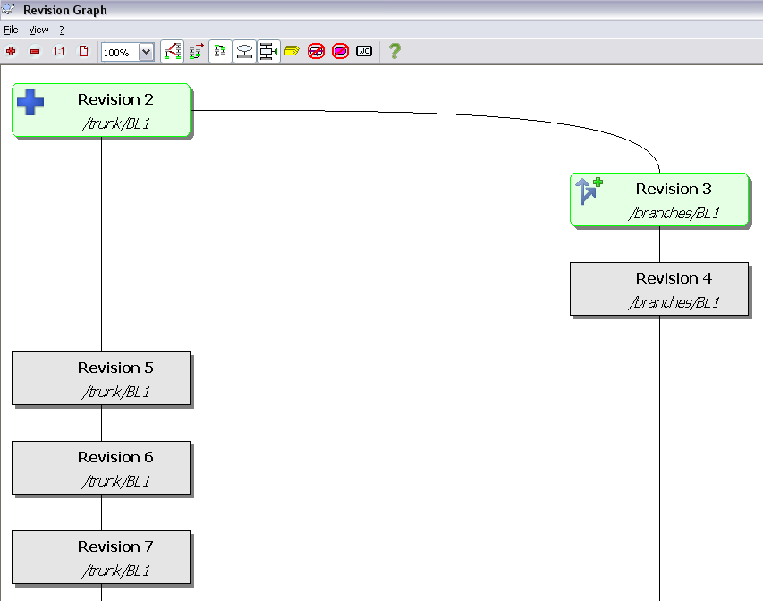

1. Merging the Branch into Trunk:

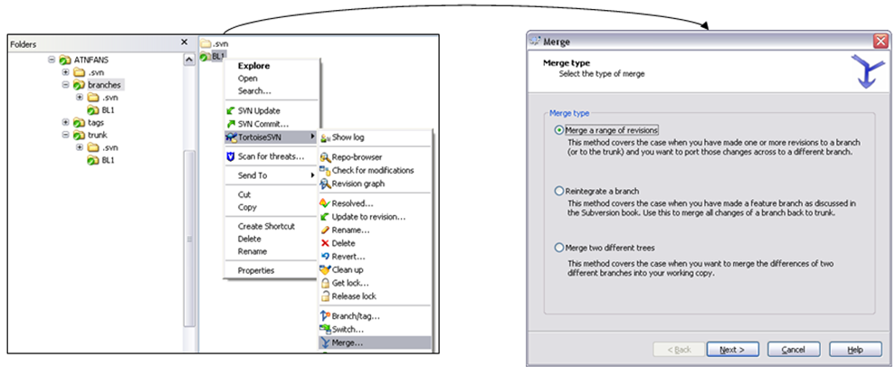

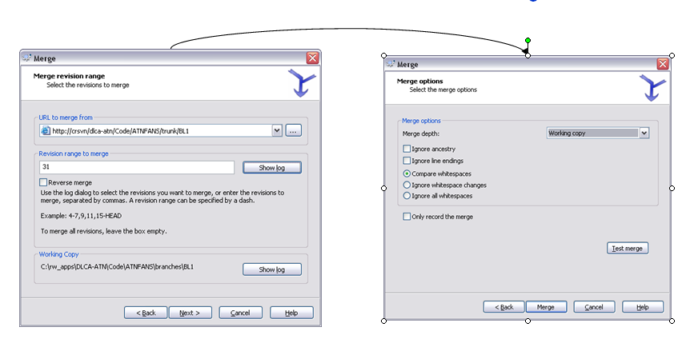

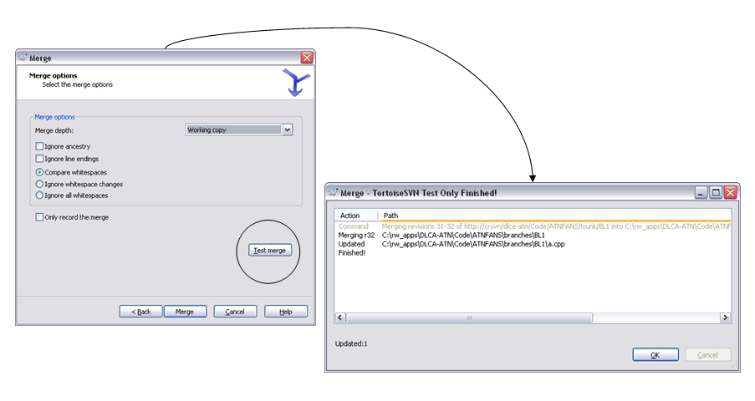

## TortoiseSVN Log Extension

By Default, TortoiseSVN limits the number of logs entries it will store. This inhibits, depending on the repository history, the date ranges allowed in “Show Log” in TortoiseSVN. To extend the history window, perform the following steps:

**Step 1**: Go to TortoiseSVN Settings

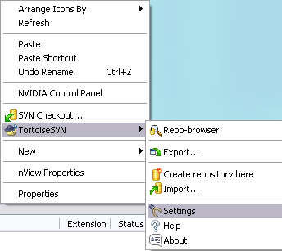

**Step 2**: Select **Dialog 1** and change “**Default number of log messages”** to the desired number of log messages. Increasing the number of logs will extend the date ranges.

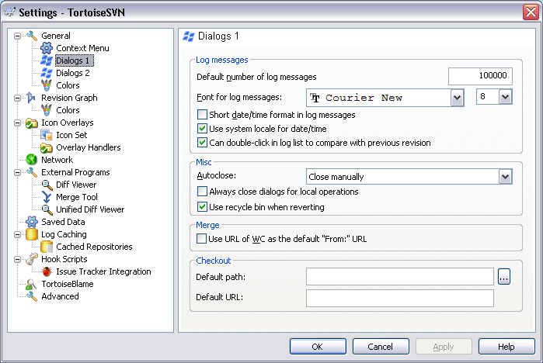

Check the new date ranges on the log dialog:



If you rely on the log cache, ensure that you update your cache from time to time. Log messages can be changed.

# Beyond Compare Pro

Install via the Software Center

<http://rwebapps.rockwellcollins.com/SoftwareCenterIntl/Default.aspx>

## Using Prep

To Use in Prep you must setup the file extensions you would like to use the tool. You do this via the Preferences.

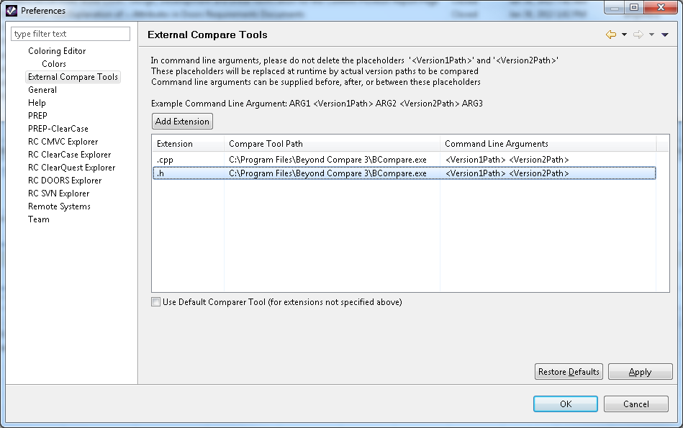

## Using in Subversion

To Use in Subversion you must setup the tool as an external editor. To

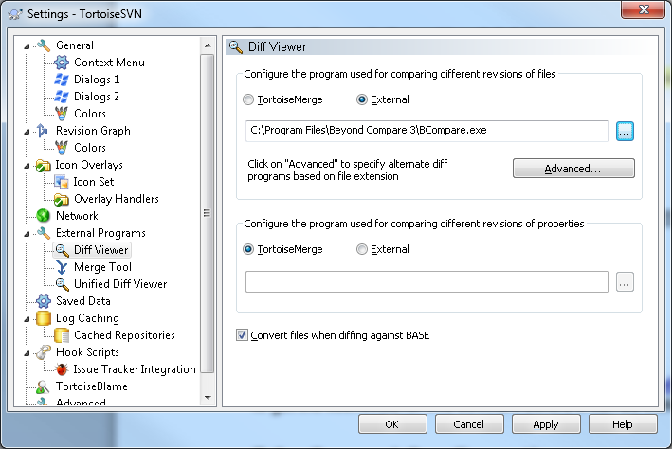

# IDE (Eclipse, Visual Studio 2008, and VS Code)

**\*NOTE:** For initial setup follow the common section to install supporting software

## Common

Install the following supporting software prior to installing your preferred IDE.

### Supporting Software (MinGW/Msys)

If the following is not already installed – click the specified link(s) to load the software from the Software Center.

1. [**MinGW 5 - Minimalist GNU for Windows with MSys**](http://rwebapps.rockwellcollins.com/SoftwareCenterIntl/Software.aspx?ID=1639)

Install MinGW in the following path: C:\rockwellcollins\localapps\MinGW5

Make sure that your PATH environment variable (in both the User Variables and System Variables sections) does ***not*** include paths for folders under either the MinGW or Msys installation locations.

While possibly inconvenient for support of other projects, if these are included in the standard Windows search path(s) they can interfere with building the DLCA application under Eclipse.

OR

The MinGW tools are also stored in SVN.

<http://asvn/dlnk-dlca/trunk_PL3/Tools/MinGW>

The Gbd.exe located in the following path is required to debug with Eclipse.

http://asvn/dlnk-dlca/trunk_PL3/Tools/MinGW/bin/gdb.exe

### Supporting Software (LynxOS-178 v2.2.2)

If the following is not already installed – click the specified link in ***a*** to load the software from the Software Center. If the software installation is not available in Software center, then follow the link in ***b*** to access the setup executable.

1. [**LynxOS-178 v2.2.2**](http://rwebapps.rockwellcollins.com/SoftwareCenterIntl/Software.aspx?ID=8106)
2. **\\crnas21\sds$\LynuxWorks\Installations\LynxOS-178_222_Win**

Use the installation location shown below

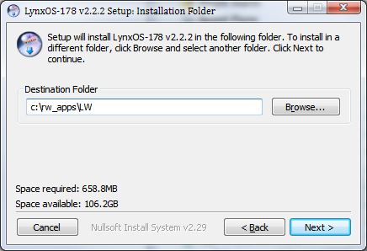

Add the following “System Variables” (Lower part of the Environment Variables page)

Variable Name: **PATH**

Variable Value: Append the following (in the specified order) to the end of your **PATH** variable once you have successfully installed LynxOS-178 2.2.0

C:\ro_apps\LW\2.2.2\ppc_rsc\cdk\win32-xcoff-ppc\usr\bin;

C:\ro_apps\LW\2.2.2\usr\bin;

### Supporting Software (C++ Redistributable)

If not already installed, download and install these two C++ redistibutables from Microsoft:

* 1. <https://download.microsoft.com/download/9/7/7/977B481A-7BA6-4E30-AC40-ED51EB2028F2/vcredist_x86.exe>
  2. <https://download.microsoft.com/download/9/7/7/977B481A-7BA6-4E30-AC40-ED51EB2028F2/vcredist_x64.exe>

After clicking one of the above links, the download will begin. Once the download is complete, click the executable to run the installation. If the following window displays, then the redistributable is already installed on your PC. Otherwise follow the on-screen prompts to finalize the installation.

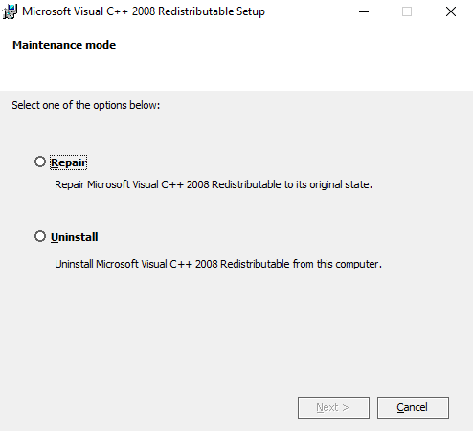

This window indicates that the C++ redistributable you are attempting to install is already installed on your local PC. Cancel and move on to the next item.

### Supporting Software (.NET Framework)

If .NET 4.8 is not already installed, then follow this [link](https://dotnet.microsoft.com/en-us/download/dotnet-framework/net48) to download the software from Microsoft. Once on the website, click on “Download .NET Framework 4.8 Runtime“.

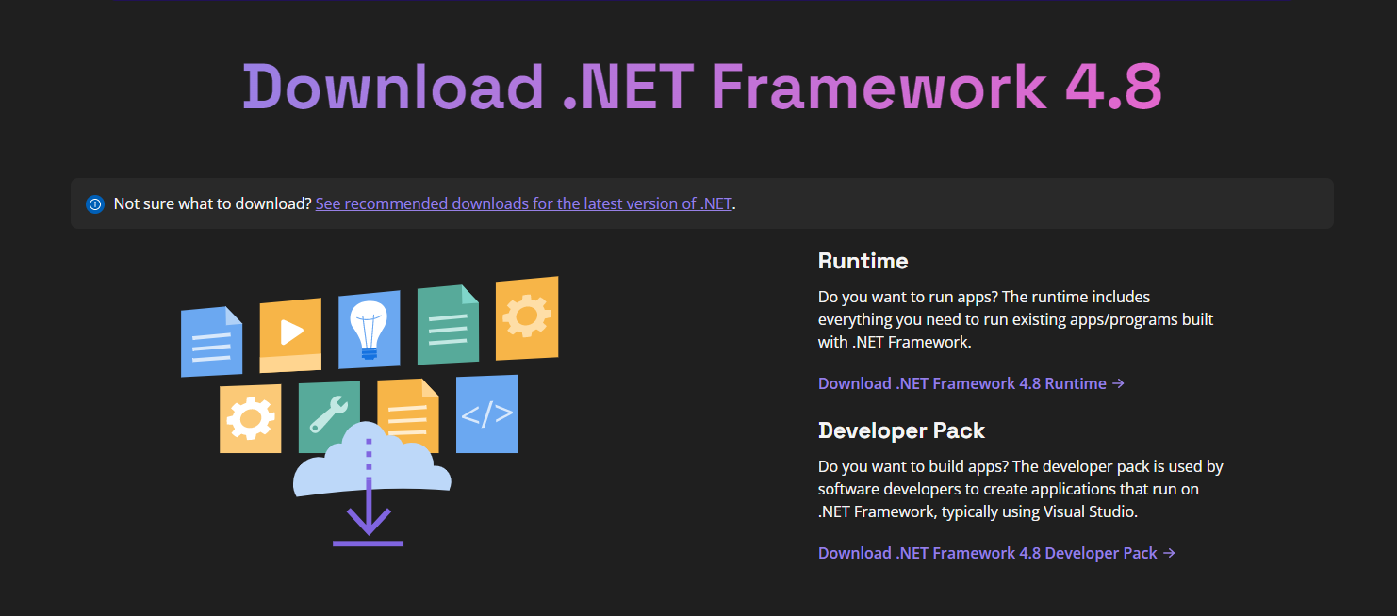

Next run the installer and follow the on-screen prompts to finish installing the .NET 4.8 Framework.

## Installing Eclipse 4.12

### Moving from Eclipse 3.7.2 to ECLIPSE 4.12

**\*NOTE: See section 9.2.2 for instructions on starting with Eclipse 4.12**

1. Copy current eclipse workspace to a temporary location
2. Install Eclipse 4.12 here:

[Software Center - Software Center (rockwellcollins.com)](http://rwebapps.rockwellcollins.com/SoftwareCenterIntl/Software.aspx?ID=15132)

1. Move workspace from temporary location to:

C:\RW_APPS\workspace

1. Start eclipse 4.12
2. If prompted to select a directory as workspace, then set the directory to:

C:\RW_APPS\workspace

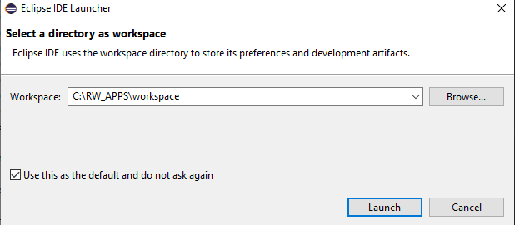

5.1 If Eclipse does not prompt you to select a directory as your workspace, then navigate to:

File > Switch Workspace > Other…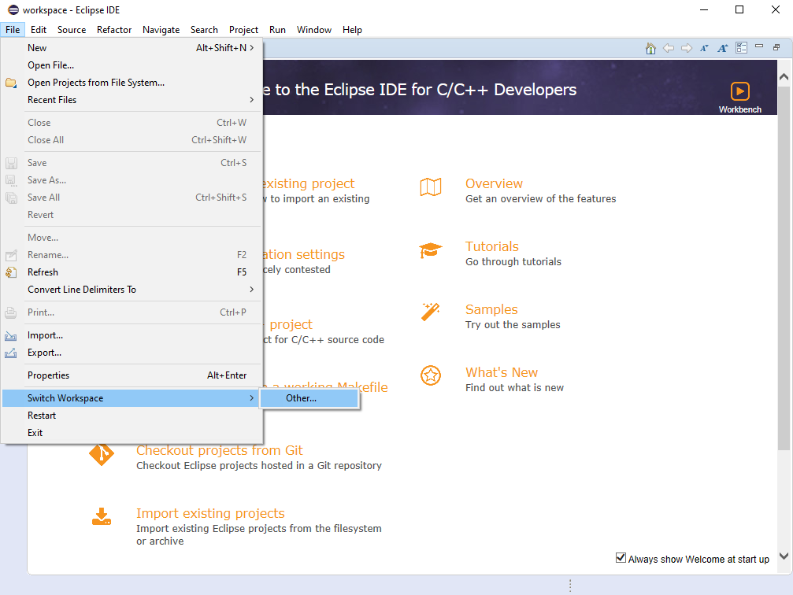

5.2 Then set the workspace to:

C:\RW_APPS\workspace

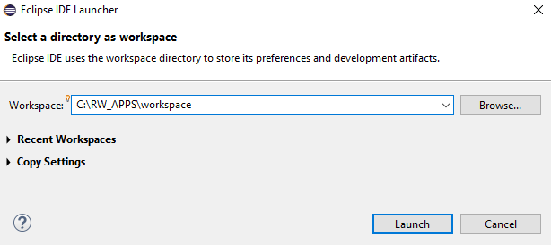

5.3 Click “Launch”

### Beginning with Eclipse 4.12

1. Install eclipse from:
2. Start eclipse
3. If prompted to select a directory as your workspace, set it to:

C:\RW_APPS\workspace



3.1 If eclipse does not prompt you to select a directory as your workspace, then navigate to:

File > Switch Workspace > Other…



3.2 Then set the workspace to:

C:\RW_APPS\workspace



3.3 Click “Launch”

1. Navigate to:

Help > Install New Software…

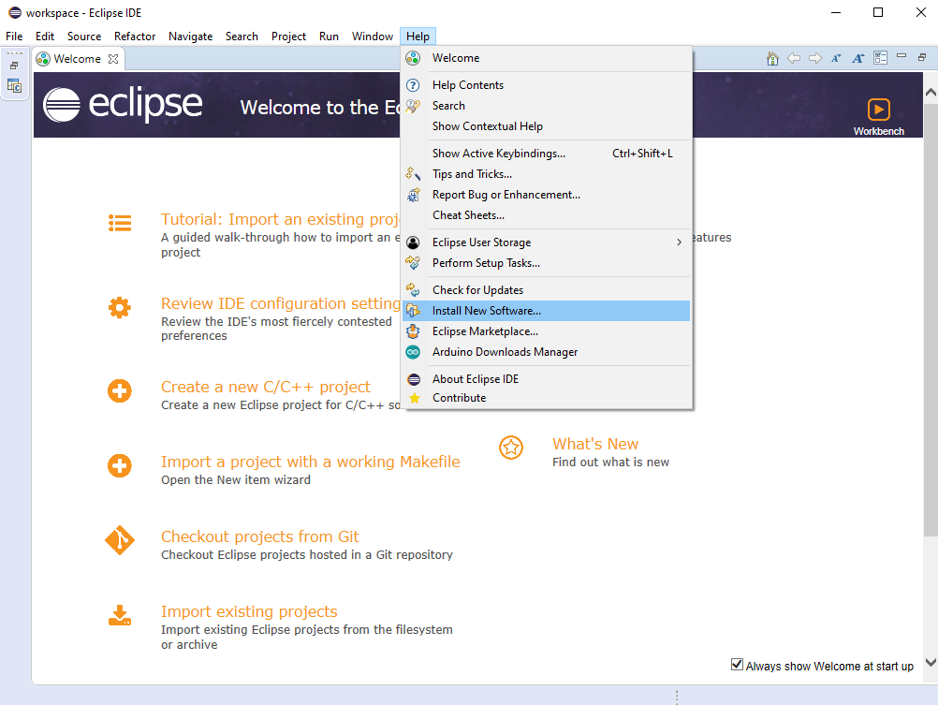

1. 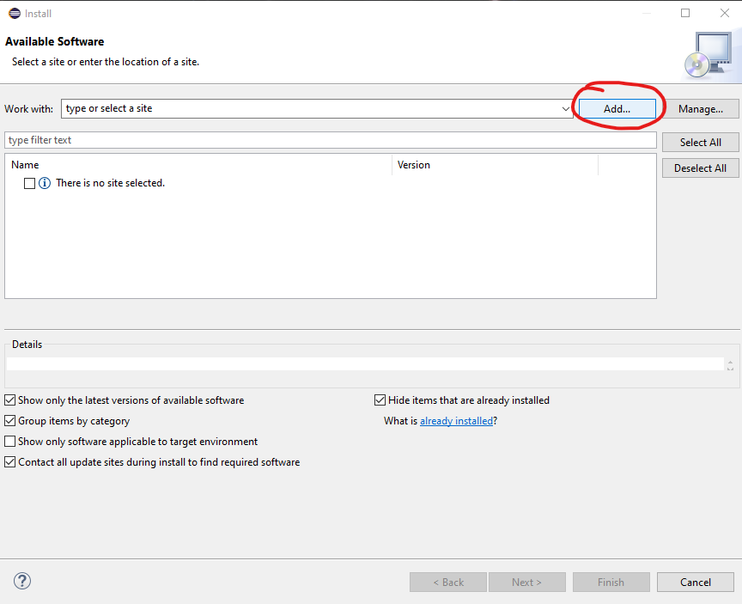Click “Add”
2. 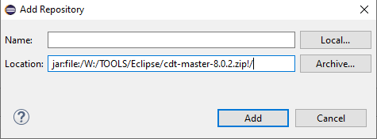In the Location: field input: jar:file:/W:/TOOLS/Eclipse/cdt-master-8.0.2.zip!/
3. Click “Add”
4. 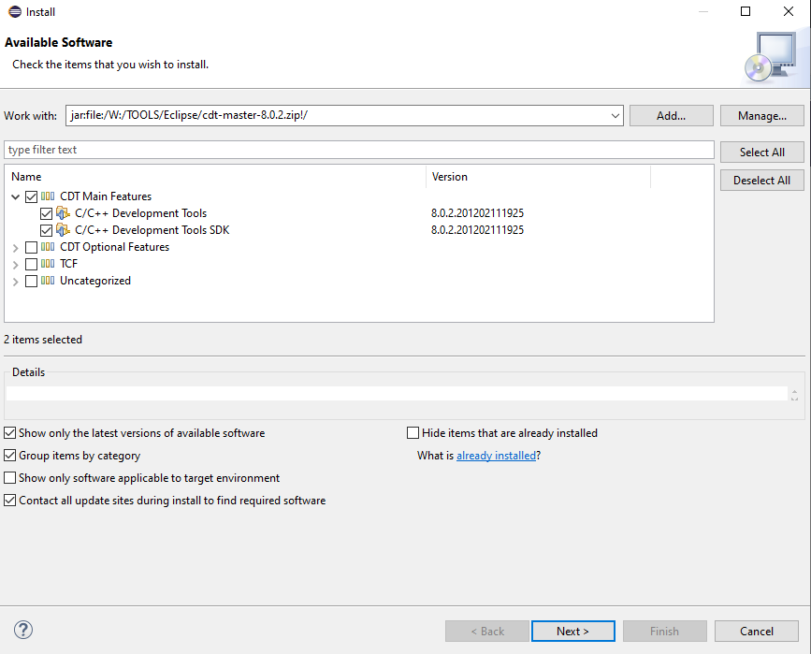Select C/C++ Development Tools & C/C++ Development Tools SDK
5. Click “Next >”

POSSIBLE ISSUE:

If you see this window:

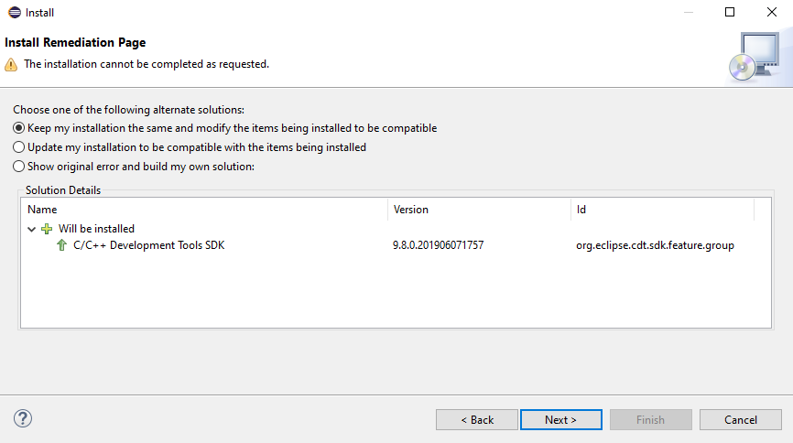

9.1 Click Next > Next > Accept terms > Finish

1. Restart when instillation is complete
2. C++ Tools are installed

### Import DLCA Project into eclipse:

Make sure you have an updated version of this repo:

https://alavsvn.rockwellcollins.com/dlnk-dlca/branches/DLCA6510_dev

If a previous DLCA (or DLCA_65X0) project is shown:

1. Right click the project > Delete

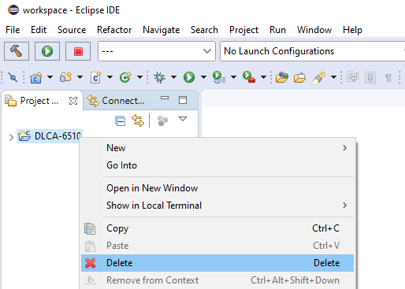

1. DO NOT SELECT “Delete project contents on disk (cannot be undone)
2. Click “OK”

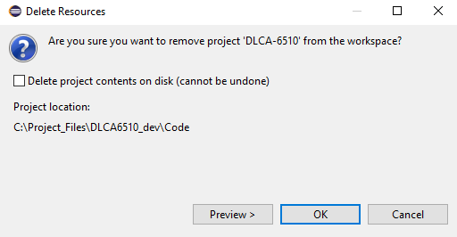

1. Select File > Import

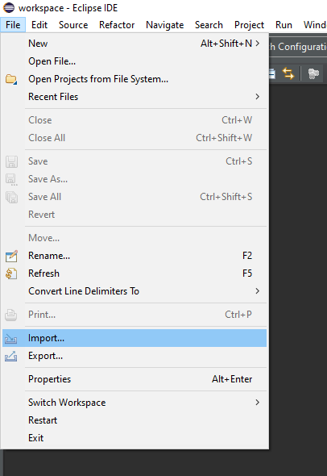

1. Select General > Existing Projects into Workspace

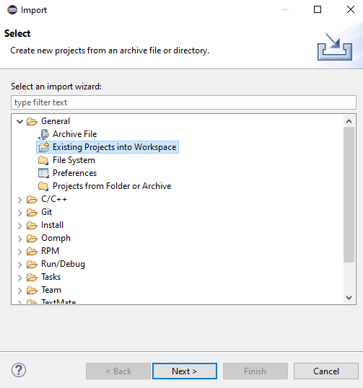

1. Click “Next >”
2. You should now see this window

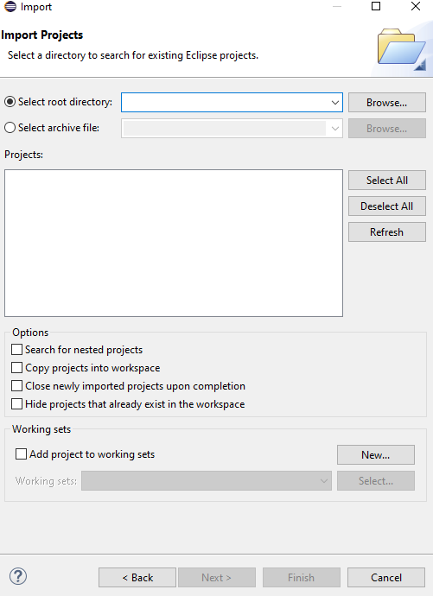

1. Click the “Browse…” button and navigate to

C:\<YOUR DLCA PROJECT LOCATION>\Code\ and select ‘OK’ (Note: the graphic below is for illustration purposes only, perform the steps as indicated in the text, not what is shown in the picture.)

1. Click “Finish”

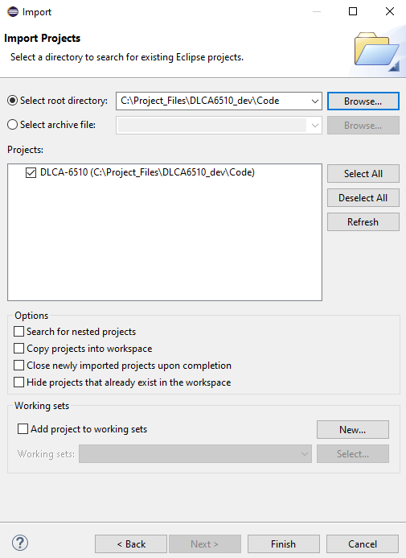

1. After Selecting finish you should see the project

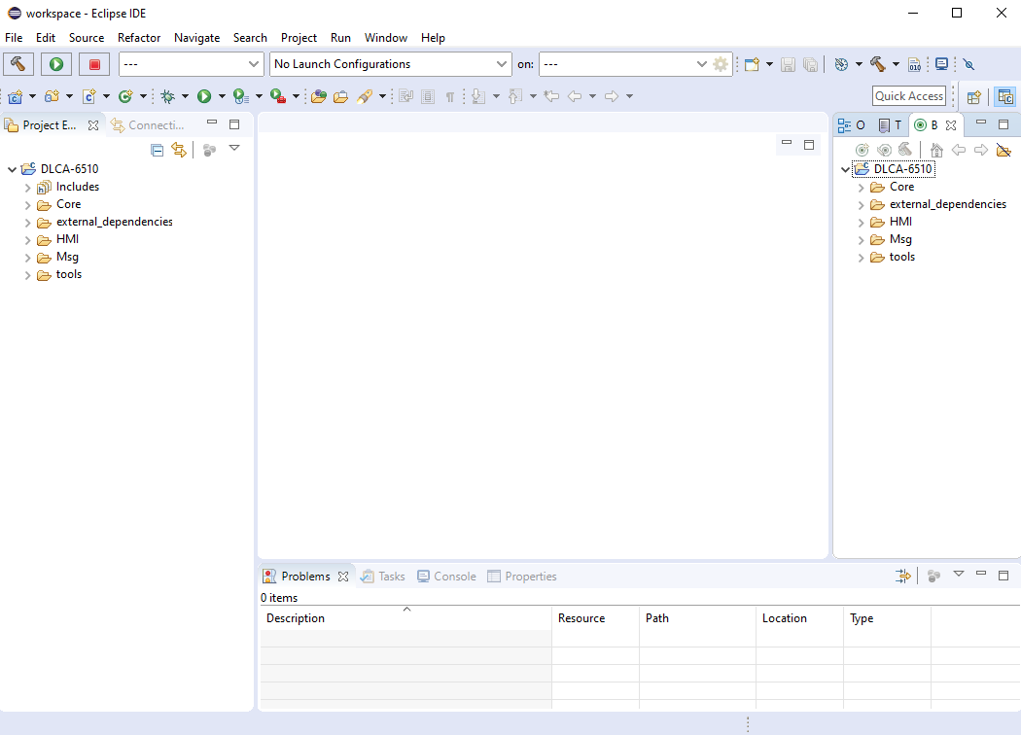

### Build the Project

1. On the right side of eclipse navigate to <DLCA PROJECT>/tools/dlca_6500_makefiles/Hmi
2. Double click “clean_all”

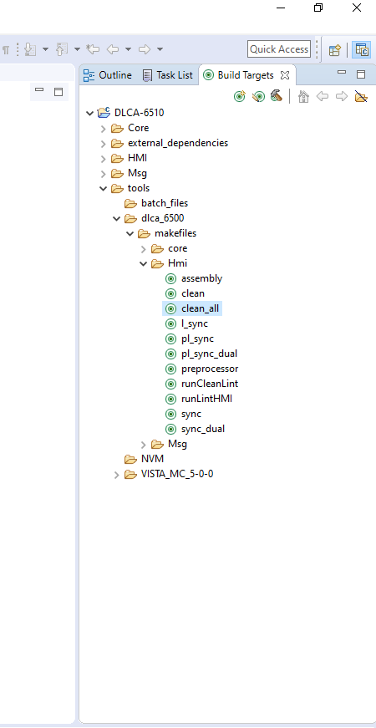

1. In the top tool bar, select the drop down next to the dial icon
2. select CommonHMI_win32

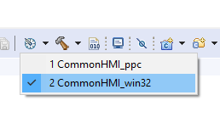

1. Select the hammer icon to build the project:

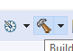

### Build Project to Target

LynxOS-178 v2.2.2 is required to perform a target build using Eclipse (see Supporting Software (LynxOS-178 v2.2.2) for installation instructions).

To use this software the Lynx OS License Manager must be running. This License manager can be started by creating, then running, the following batch file:

Copy the following text into a notepad and save it as launch_lwsmgr.cmd into your c:\Tools directory.

echo off

set ENV_PREFIX=C:\rw_apps\LW\2.2.2\ppc_rsc

set LYNXRTSD_LICENSE_FILE=49152@sunlic1;49152@sunlic2;49152@sunlic3

C:\rw_apps\LW\2.2.2\ppc_rsc\cdk\win32-xcoff-ppc\bin\lwsmgr

You will need to run this batch file and keep it open all of the times if you are performing a target [Power PC (ppc)] build. For more information refer to <http://etipedia/wiki/LynxOS-178_FLEXlm_Licensing>

1. Upon launching the batch file the following console will be displayed:

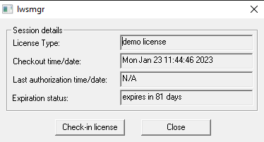

(Note: it may take a few seconds for the fields to populate)

**Important Note:** Start and use License Manager only when generating the target build and once the build is completed. Please close the lwsmgr window (or click the ‘Check-in license’ button) when not actively building for target.

This is to be strictly followed due to limited License availability. Click here for further information.

1. In the top tool bar, select the drop down next to the dial icon
2. select CommonHMI_ppc

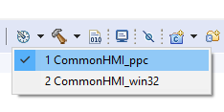

1. Select the hammer icon to build.
2. The license manager window should now show a date for “Last authorization time/date:” and the project should successfully build.

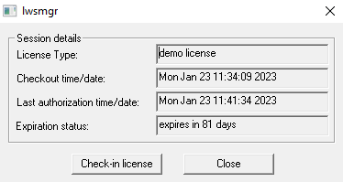

### Eclipse 4.12 Preferences

#### Dark theme:

1. Window>Preferences>Appearance
2. Select enable theming (requires restart)
3. Theme: Dark
4. Apply and Close
5. Restart eclipse: File > restart

#### SVN Support:

1. **Help>Eclipse Marketplace…**
2. **In the “Find:” bar type: “Subclipse”**
3. **Click “Go” or ENTER**

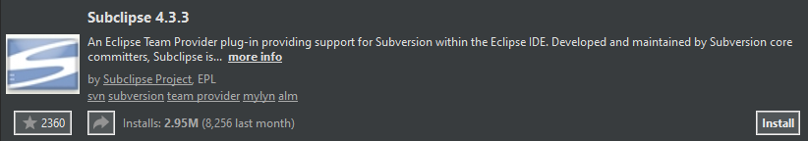

1. **Click “Install”**
2. **Keep all items checked**
3. **Click “Confirm >”**
4. **Accept the terms**
5. **Click “Finish”**
6. **If prompted with:**

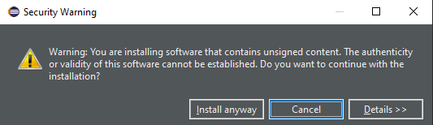

**Select “Install anyway”**

1. **If prompted to restart, click “Restart Now”**

**If not prompted to restart, click File > “Restart”**

#### File explorer

1. **Help>Eclipse Marketplace…**
2. **In the “Find:” bar type: “Eclipse Explorer”**
3. **Click “Go” or ENTER**

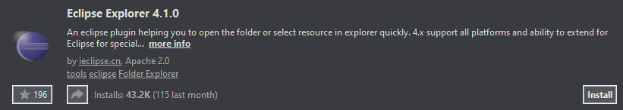

1. **Click “Install”**
2. **Check all items**
3. **Click “Confirm >”**
4. **Accept the terms**
5. **Click “Finish”**
6. **If prompted with:**



**Select “Install anyway”**

1. **If prompted to restart, click “Restart Now”**

**If not prompted to restart, click File > “Restart”**

#### Edit Box

1. **Help>Eclipse Marketplace…**
2. **In the “Find:” bar type: “Edit Box”**
3. **Click “Go” or ENTER**

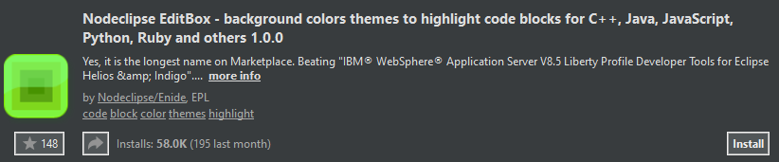

1. **Click “Install”**
2. **Only check “EditBox (required)”**
3. **Click “Confirm >”**
4. **Accept the terms**
5. **Click “Finish”**
6. **If prompted with:**



**Select “Install anyway”**

1. **If prompted to restart, click “Restart Now”**

**If not prompted to restart, click File > “Restart”**

1. **Navigate to:**

**Window > Preferences > EditBox**

1. **Select the c++ tab**
2. **Select import**
3. **Navigate to <CURRENT THEME LOCATION>**
4. **Click “Open”**
5. **Click “Apply and Close”**

### Debugging Software via Eclipse and VISTA

1. Generate a win32 build in Eclipse (see Win32 Builds )
2. Start running your VISTA simulation (see Running VISTA)
3. Go to the Eclipse console and create a Debug Configuration (as described below) or proceed to Debugging with an existing Debug Configuration.

### Initial Debug Configuration Setup

Note: If you already have already created a Debug Configuration proceed to “Debugging with an existing Debug Configuration”

1. Select and expand the "bug" 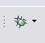 option and select Debug Configurations.

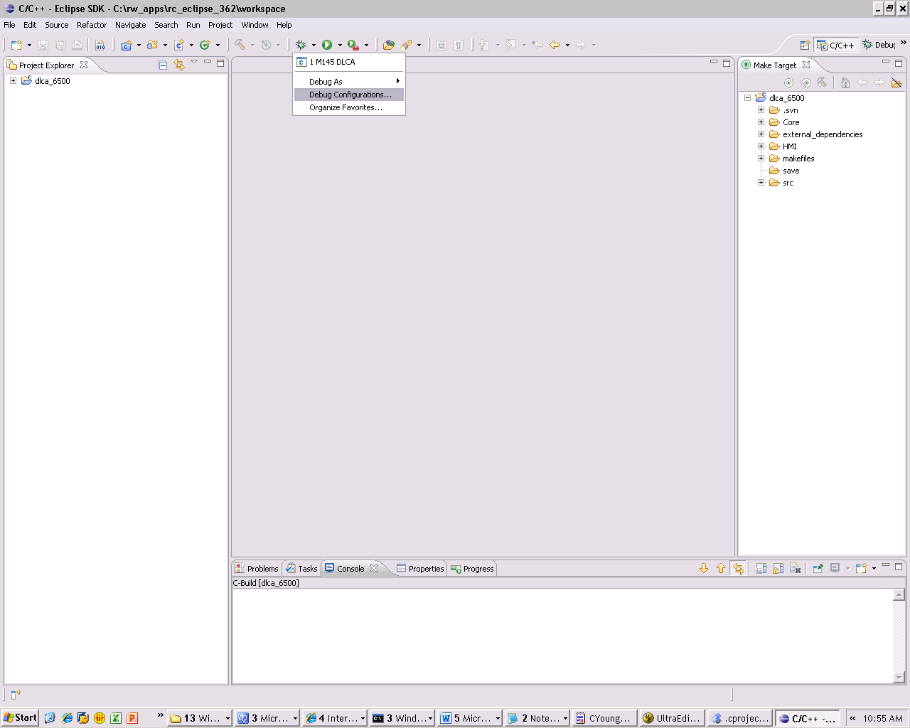

1. Click on C/C++ Attach to Application and then select the ‘New’ button

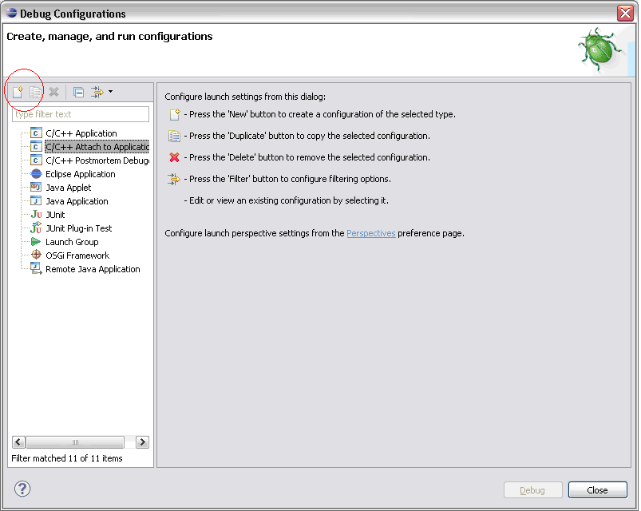

1. The following screenshot reflects the initial Debug Configuration page:

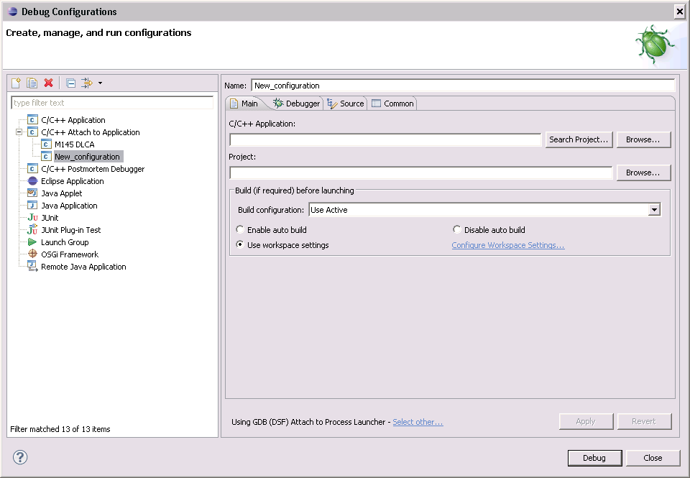

1. Under the Project: field - Click the browse button and Select the ‘dlca_6500’ project and then click ok

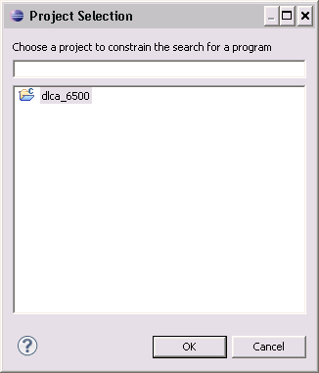

1. Change the name for this Debug Configuration to a something easily remembered (DLCA is used in the example below)

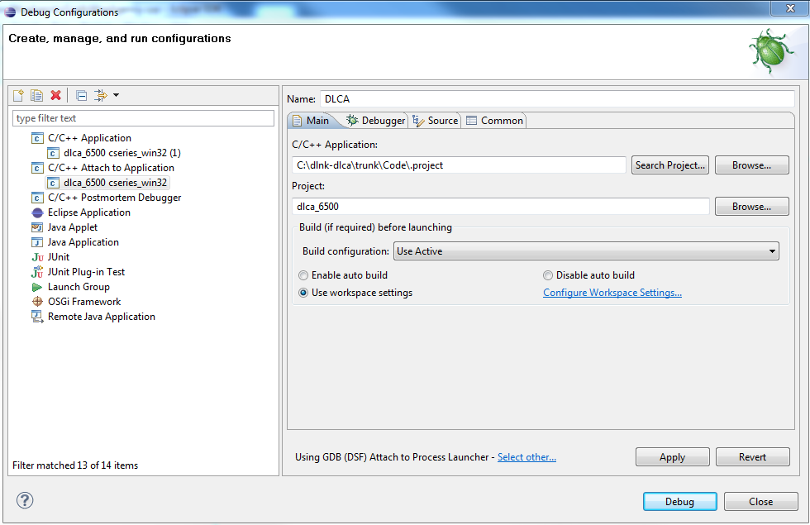

1. Select the Debugger tab. At the bottom of the window find the statement “Using GDB (DSF) Attach to Process Launcher – Select other …” and click on Select other.

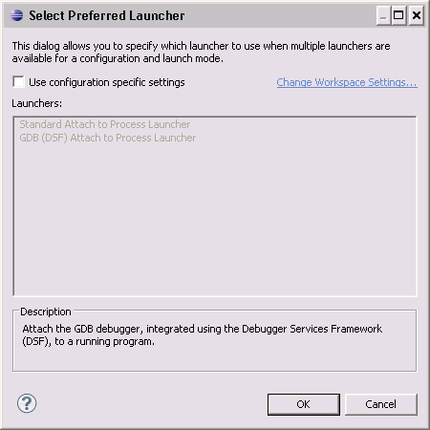

1. Check “Use configuration specific settings”, then select “Standard Attach to Process Launcher”

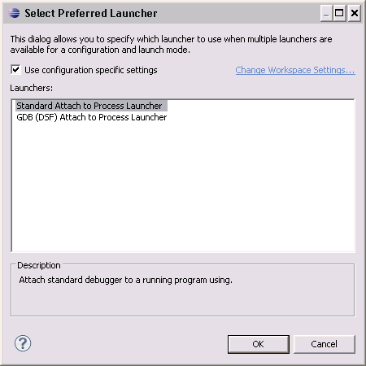

1. Click OK
2. On the Debugger tab; pull down the Debugger list and select MinGW gdb

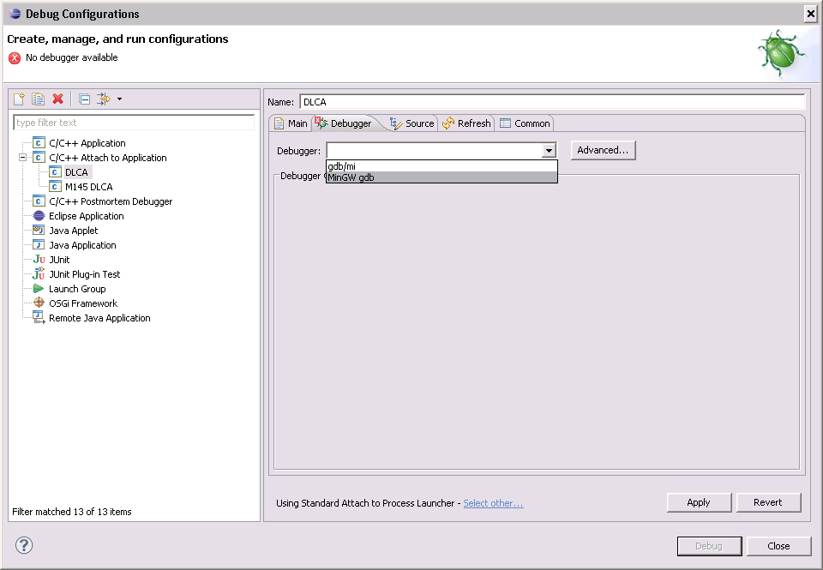

1. Under the Main Tab of the Debugger Options Browse to the MinGW gdb executable.

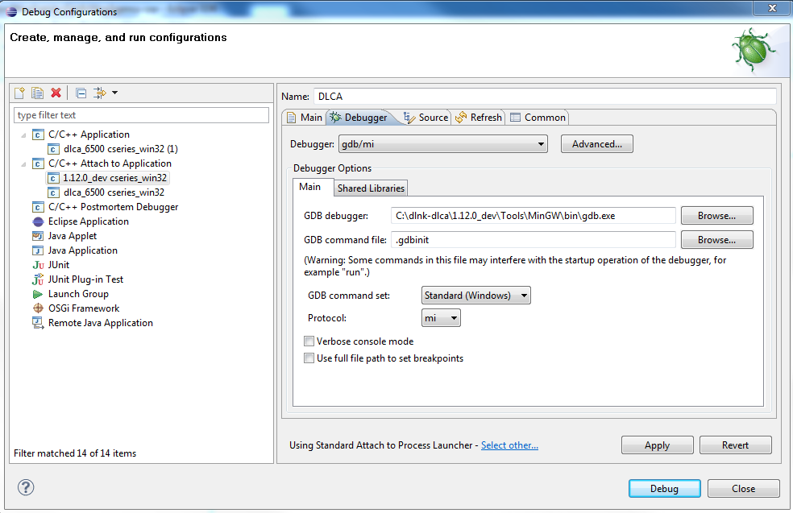,

1. Click the Apply Button.

### Debugging with an existing Debug Configuration

1. Select and expand the "bug"  option and select Debug Configurations.

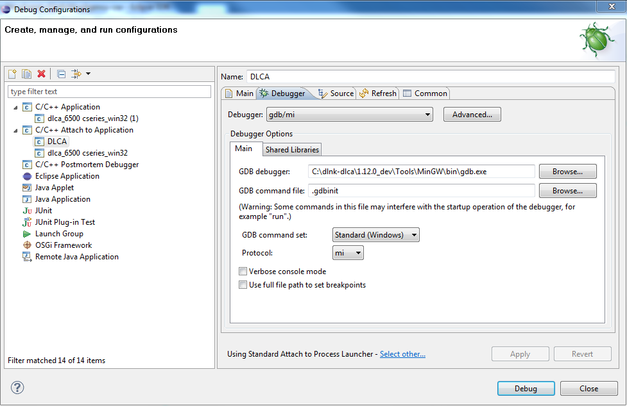

1. Select the previously created configuration and click the Debug button.

Note: If Debug has already been selected from the Debug Configuration page at least once previously, then you can also start Debugging by directly clicking on the name of the configuration in the top portion of the selection list as shown below:

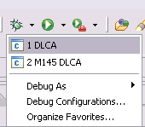

Upon starting the Debug session a list of applications will be displayed (see below). Find and select dlca.exe.

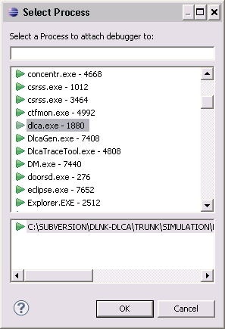

1. Click the OK button.
2. On the first time debugging is used, the following message will be displayed.

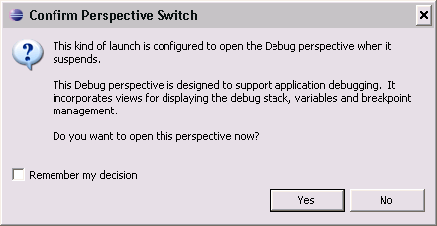

Enter a check in the checkbox for ‘Remember my decision’ and click the Yes button.

1. The Debug perspective will now be displayed.

*Note that in the screenshot below that ‘Project Explorer’ is visible in the Debug perspective. To show this window on your display click on ‘Window’ in the top menu bar and select Show View->Other… then select Project Explorer from the General folder.*

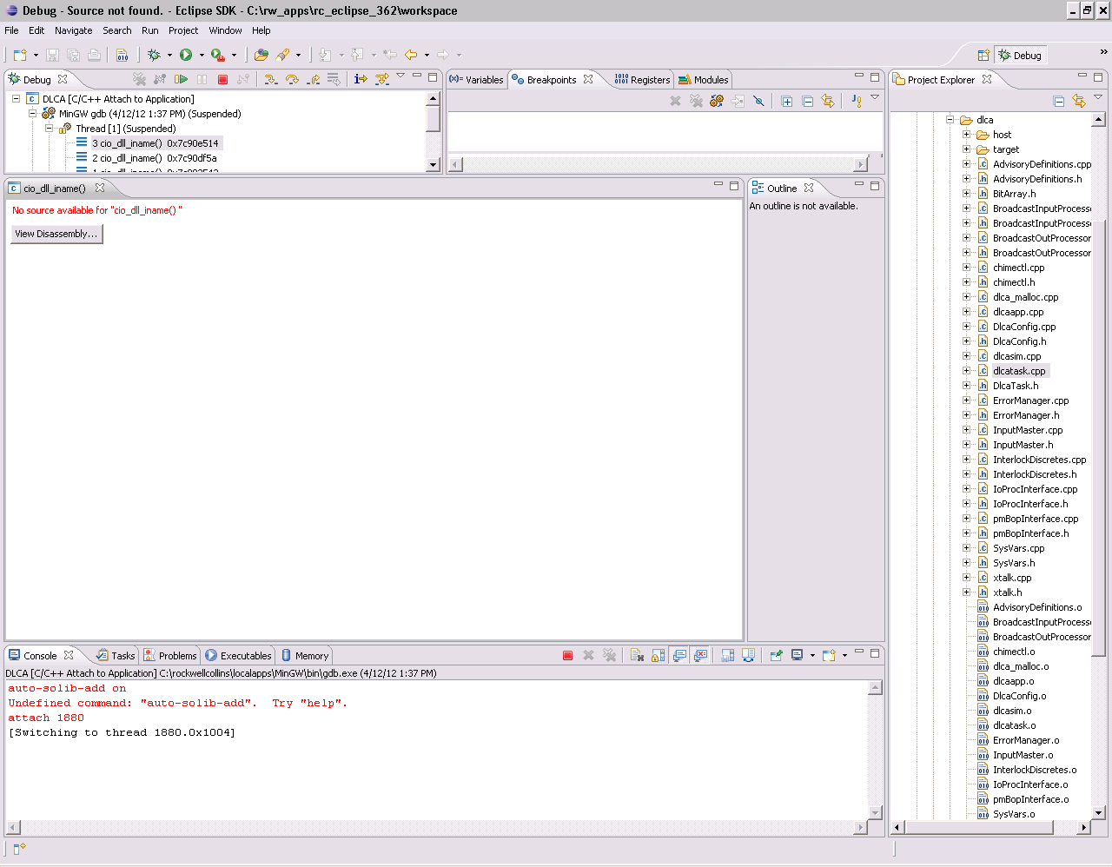

1. From Project Explorer (or the C++ perspective window) select a source file and add any breakpoints to your source code you need for debugging.

Pressing Ctrl+Shift+B will toggle a breakpoint on a selected source line. You can also toggle the breakpoint on a line by double-clicking the mouse on a selected line.

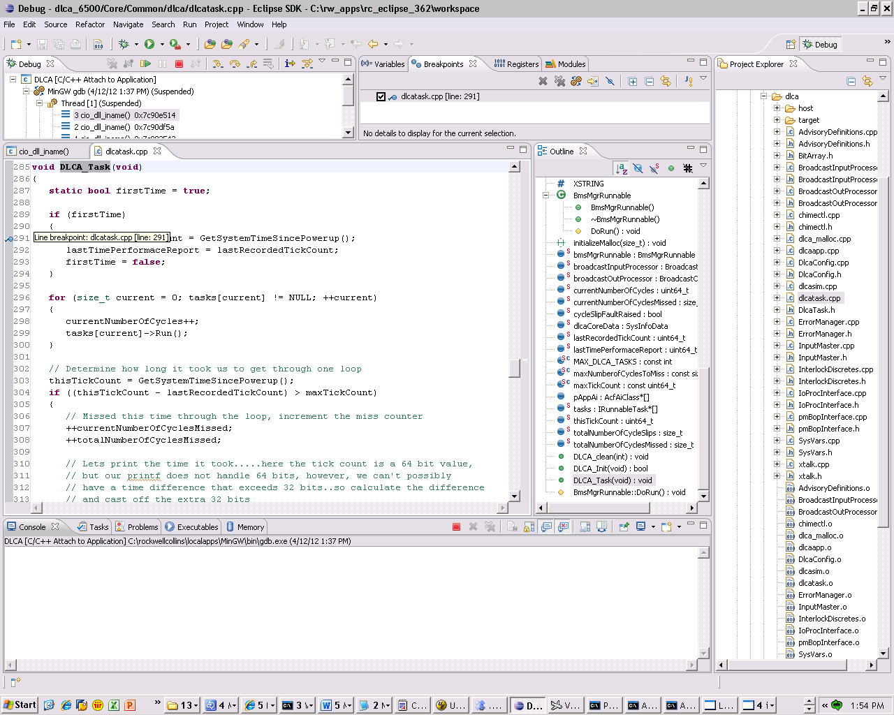

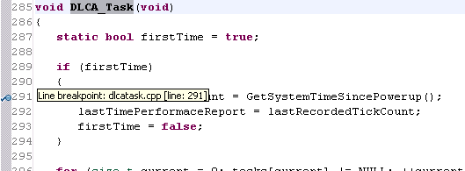

1. Navigate to Debug Window. Select the green run button  to start debugging.

For guidance on how to use Eclipse to debug your software refer to the Debugging Projects section of the Eclipse C/C++ Developer’s User Guide which is accessible from Eclipse Help->Help Contents.

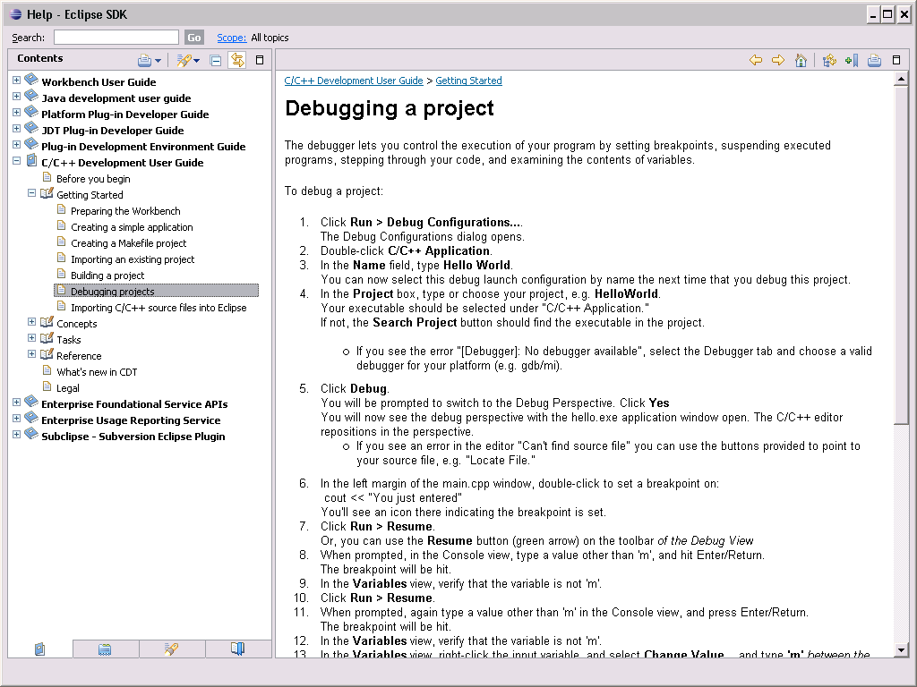

An example screen shot showing a breakpoint that was reached in the dlcatask.cpp file is shown below.

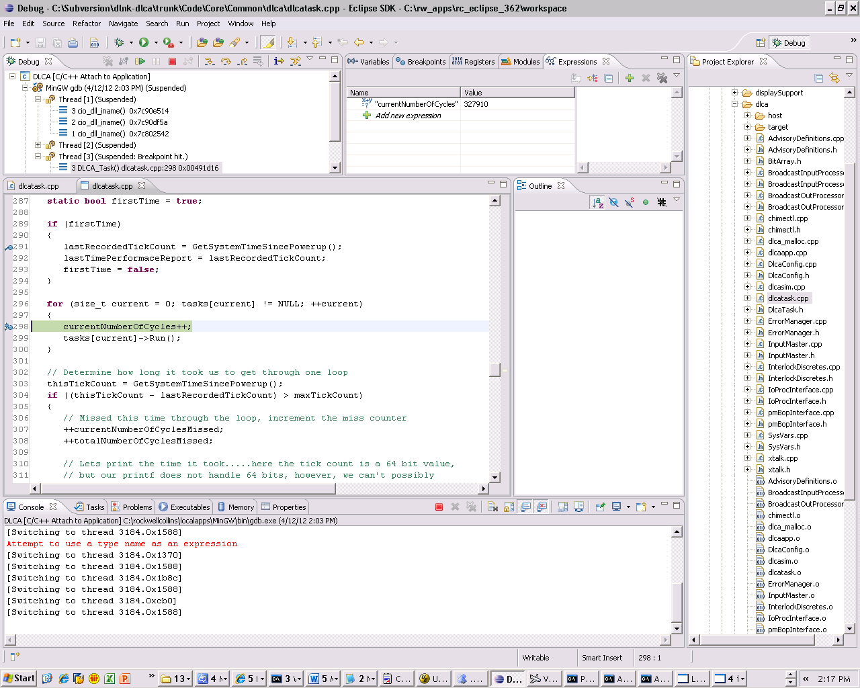

## Visual Studio 2008

Only install this software if you have a need for it and you have manager approval. There is a cost for this software. DLCA software developers use Eclipse not Visual Studio 2008.

### Software Installation

Go to the Software Center and install [**Visual Studio Professional 2008**](http://rwebapps.rockwellcollins.com/SoftwareCenterIntl/Software.aspx?ID=7250) software. You will need to get the license(s) for this software before it can be installed.

### General Configuration

Select Start Menu🡪 All Programs🡪 Microsoft Visual Studio 2008 🡪 Microsoft Visual Studio 2008

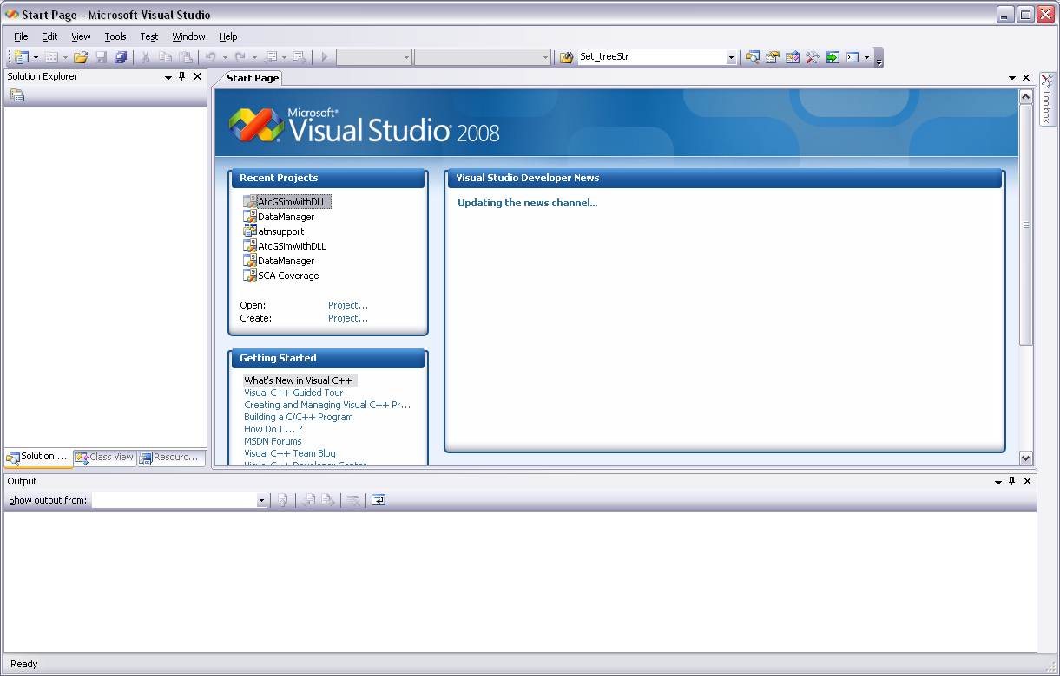

Select Tools🡪 Options.

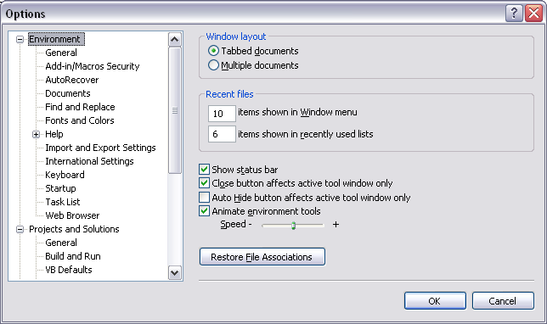

In “Options” Window, Select Project and Solutions🡪 VC++ Directories

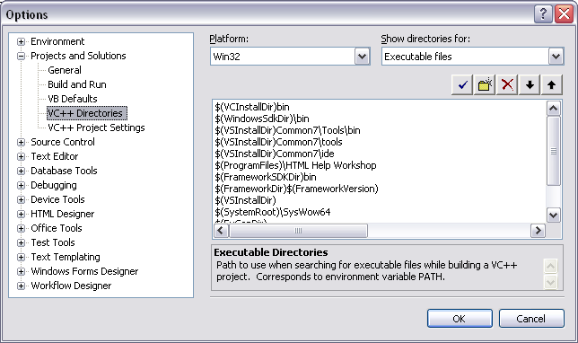

Under “Show directories for:” dropdown, Select ‘Include files’

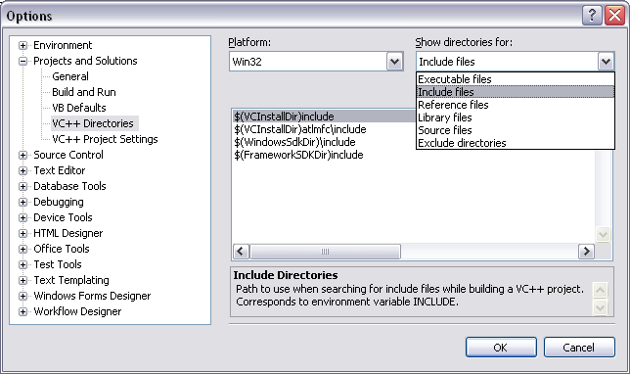

Select “New entry” option and then select “Browse” option

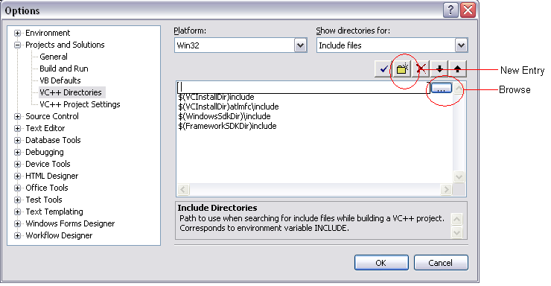

In Browse option, Select “msvc” folder from path “C:\rw_apps\dlca\Simulation\CSeriesVistasim\Vista_tools\SDK\vista\c” and select ok.

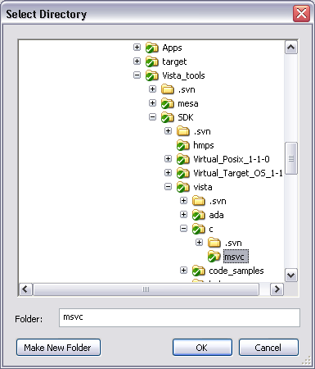

Select Tools🡪 Options. In “Options” Window, Select Project and Solutions🡪 VC++ Directories.

Under “Show directories for:” dropdown, select ‘Library files’

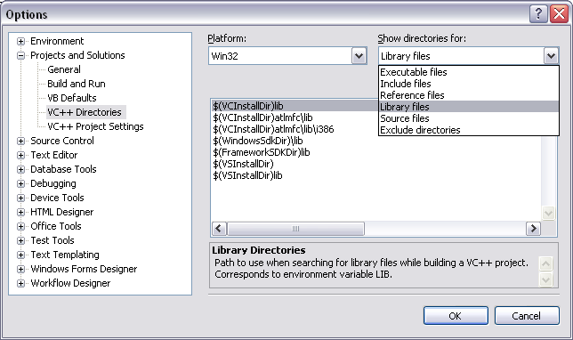

Select “New entry” option and then select “Browse” option

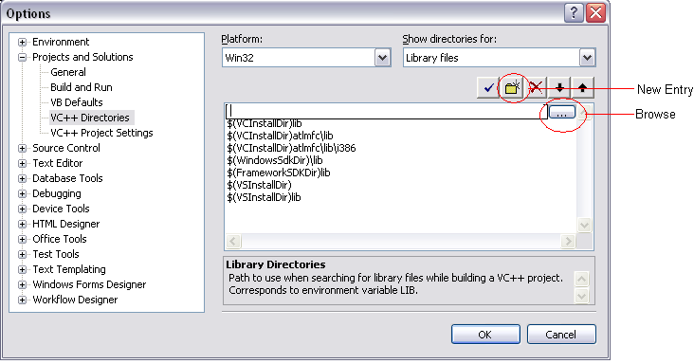

In Browse option, Select “lib” folder from path “C:\rw_apps\dlca\Simulation\CSeriesVistasim\Vista_tools\SDK\vista” and select ok.

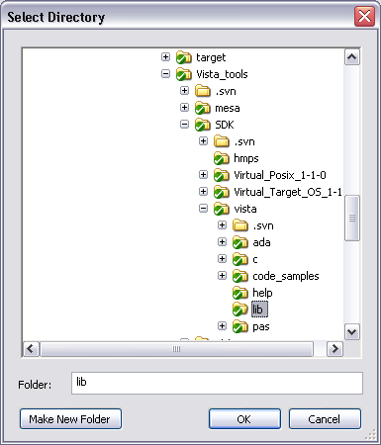

Select File🡪 Open 🡪 Project/Solution. Browse and select the project in

C: \rw_apps\dlca\Tools\Harmonized DataLink Tester\Harmonized_DLT\DataManager.sln

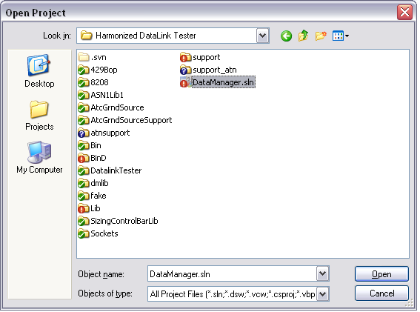

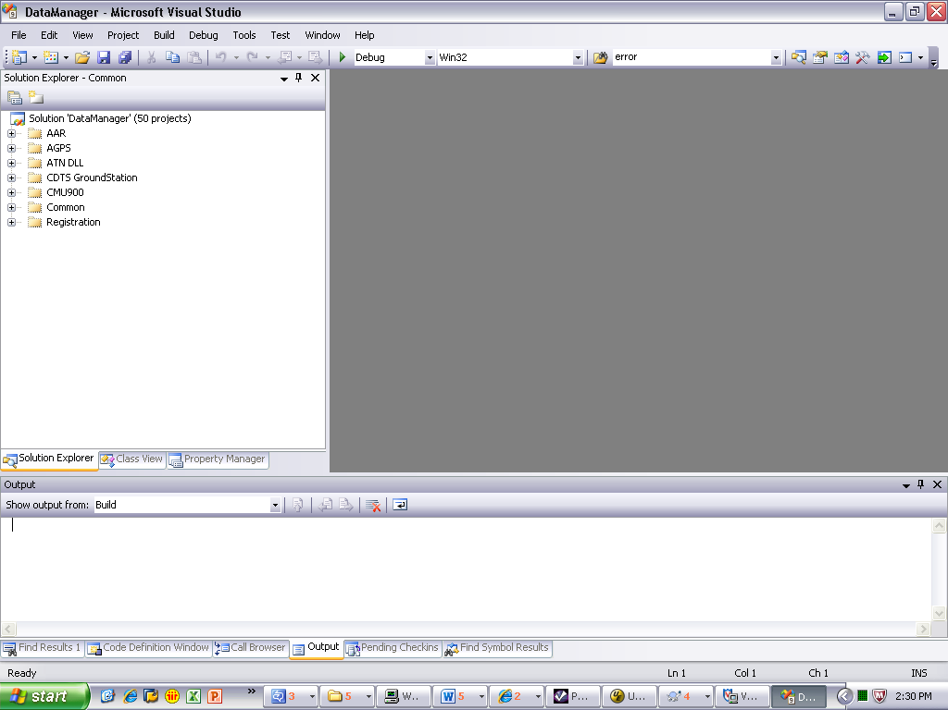

## VS Code

### Installing VS Code

Download and install the VS Code IDE from:

* 1. Software Center – Version
  2. OR <https://code.visualstudio.com/sha/download?build=stable&os=win32-x64-user>

After downloading follow the on-screen instructions to finish the installation.

### Extensions

Navigate to the “Extensions” tab within VS Code

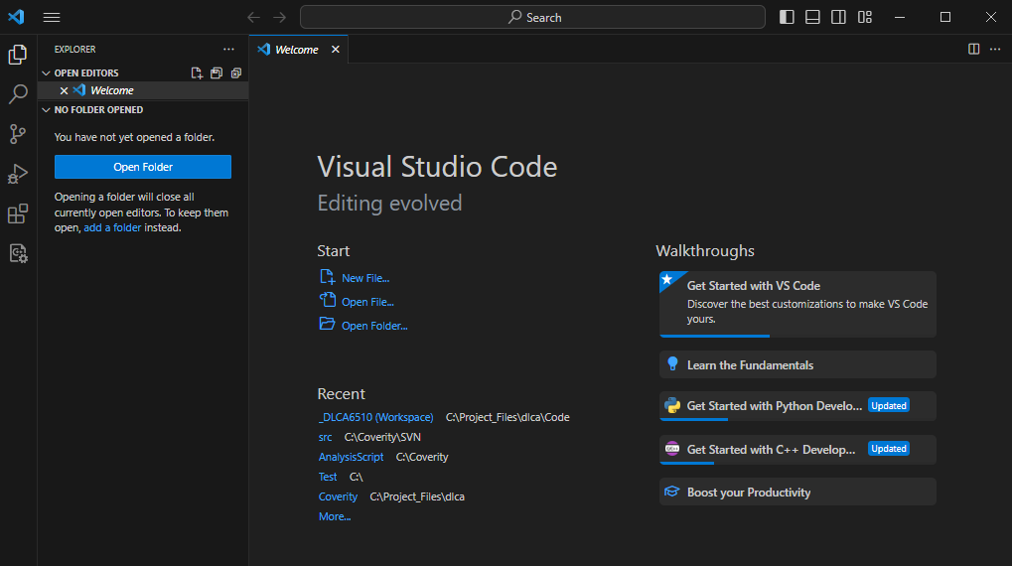

Once on the “Extensions” tab, use the “Search Extensions in Marketplace to find the desired extension and install. Useful Extension for DLCA are:

1. C/C++ - Developed by Microsoft and offers C++ intellisense and debugging features
2. C/C++ Extension pack – Developed by Microsoft and extends the capability of the standard C/C++ extension.
3. C/C++ Themes – Developed by Microsoft and allows for user themes to be applied without losing syntactic coloring i.e. light mode or dark mode.
4. CMake – Developed by twxs. Offers CMake support for VS Code
5. CMake Tools – Developed by Microsoft, extends the capabilities of CMake
6. Makefile Tools – Developed by Microsoft, provides support for Makefiles in VS Code.
7. ASN.1 – Developed by OSS Nokalva Inc, provides highlight, diagnostic, encoding and decoding support for ASN.1 files.

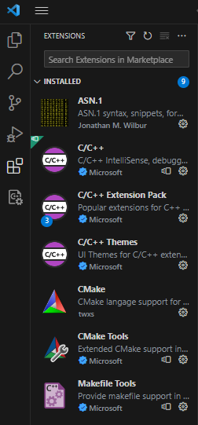

**\*NOTE:** VS Code will recommend extensions to you once you have a workspace open or begin coding. You may install these extensions preemptively or wait for VS Code’s recommendations.

### Opening the DLCA Project in VS Code

**\*NOTE – Section 7.2.1 must be completed prior to attempting this step. This section assumes that you have a working copy of the project on your local machine.**

In VS Code, navigate to File->Open Workspace from File

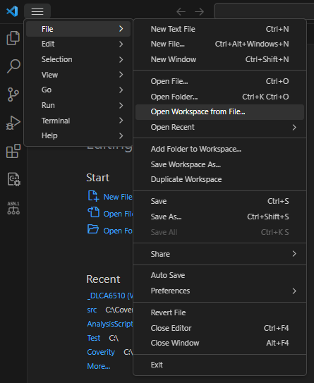2

Next navigate to the code folder of your project <YOUR DLCA PROJECT> / code

I.E. “C:/Project_Files/dlca/Code

From here open the project workspace “_DLCA6510”

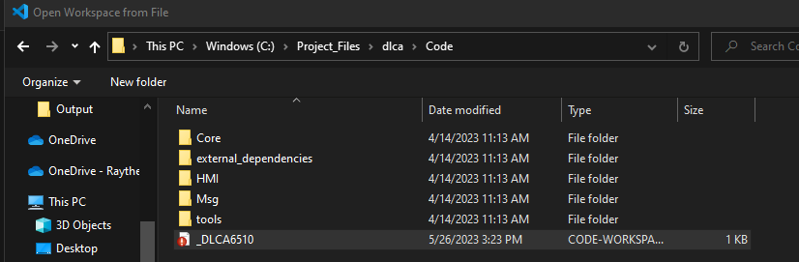

### Building the project in VS Code

With your workspace opened, navigate to the terminal window. If the terminal is not opened, you can open it by using the shortcut ctrl+shift+` or going to terminal->New Terminal. Inside the terminal type the command “.\BuildWithMenu.bat” and press enter. This will display the following menu:

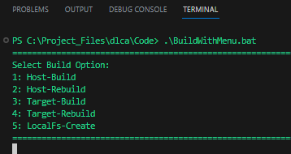

Next, enter the corresponding number for the type of build you want. i.e. type “2” and press enter to select “Host-Rebuild”.

# Running the DLCA Application

## Running the Simulation

Navigate to the simulation folder of your local working copy of the project files. <YOUR DLCA PROJECT> / Simulation i.e. “C:/Project_Files/dlca/Simulation”

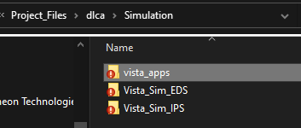

From here, there are three available folders. To run the simulation pick either “Vista_Sim_EDS” or “Vista_Sim_IPS” depending on the configuration that you wish to run.

### Vista_Sim_EDS

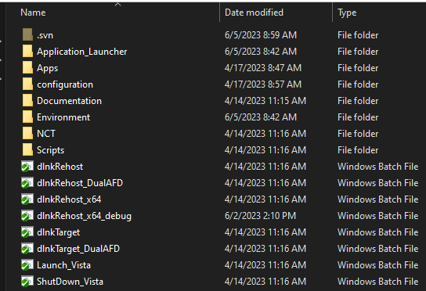

Within the “Vista_Sim_EDS” folder there are several options for running the simulation in both a target build and a rehost build. Use the “rehost” options to display the program on your PC. Use the “target” options for use on rigs only. All these options are accompanied by the “ShutDown_Vista” batch file used to shutdown the Vista application and the simulation. More details for each batch file are listed below:

dlnkRehost – Runs the DLCA Simulation in the standard EDS rehost configuration

dlnkRehost_DualAFD – Runs simulation in EDS with 2 AFD’s

dlnkRehost_x64 – Runs the simulation in the standard EDS rehost configuration in 64-bit

dlnkRehost_x64_debug – Runs the debug rehost configuration in 64-bit

dlnkTarget – Runs the simulation in standard EDS target configuration

dlnkTarget_DualAFD – Runs the simulation in the dual AFD target configuration

Launch_Vista – Launches the Vista application without running the simulation

Shutdown_Vista – Shutdown any Vista and/or simulation instances

**\*NOTE:** Always used the “Shutdown_Vista” batch file to ensure that all background process are terminated successfully.

### Vista_Sim_IPS

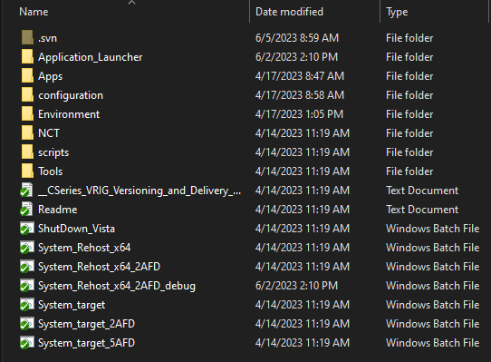

Within the “Vista_Sim_IPS” folder there are several options for running the simulation in both a target build and a rehost build. Use the “rehost” options to display the program on your PC. Use the “target” options for use on rigs only. All these options are accompanied by the “ShutDown_Vista” batch file used to shutdown the Vista application and the simulation. More details for each batch file are listed below:

ShutDown_Vista – Shutdown and simulation or Vista instances

System_Rehost_x64 – Runs the simulation in the 64-bit rehost configuration

System_Rehost_x64_2AFD – Runs the sim in the 64-bit rehost config with 2 AFD’s

System_Rehost_x64_2AFD_debug – Runs the sim in the 64-bit debug configuration

System_target – Runs the simulation in the target configuration

System_target_2AFD – Runs the simulation in the target configuration with 2AFD’s

System_target_5AFD – Runs the simulation in the target configuration with 5AFD’s

**\*NOTE:** Always used the “Shutdown_Vista” batch file to ensure that all background process are terminated successfully.

# Automated Instrumentation (WIP)

# VISTA

VISTA is used for running the DLCA application during verification testing.

For the DLCA-6500 project the VISTA software is included under folder <http://asvn/dlnk-dlca/trunk/Simulation>. No additional installation or configuration is required.

## Software Installation

Not Applicable.

## General Configuration

Not Applicable.

## Running VISTA

### Single DLCA – Host PC – M145_M170

To run a single DLCA on the Host PC for the M145_M170 environment:

1. Go to folder C:\rw_apps\dlca\Simulation\DLCA6500-VistaSim.
2. Double-click on the batch file named M145_Host.bat
3. In L_CCP, Click "<" button in DSPL SEL to select L_AFD
4. In AFD Navigate to MENU-->FMS(works until new windows manager is delivered), to Enter DLCA Page

### Single DLCA – Host PC – CSeries

To run single DLCA on the Host PC for the CSeries environment:

1. Go to folder C:\rw_apps\dlca\Simulation\DLCA6500-VistaSim.
2. Double-click on the batch file named CSeries_Host.bat
3. In L_CCP, Click "LWR" button in DSPL SEL to select Lib_AFD
4. In AFD Navigate to MENU-->CNS-->CPDLC, to Enter DLCA Page

### Activate KeyBoard and Mouse

To activate Microsoft Keyboard and Mouse, follow the below

Step 1: To enter mouse mode click ctrl+m.

Step 2: To select a display click the ctrl key and the number of the display

For CSeries: (LOB = ctrl+1) (LIB = ctrl+2) (Lower = ctrl+3) (RIB = ctrl+4) (ROB = ctrl+5)

For M145 : (L_AFD = ctrl+1) (C_AFD = ctrl+2) (B_AFD = ctrl+3) (R_AFD = ctrl+4)

Step 3: Use the mouse to over a text/numeric entry field and typing characters (using key board) should enter values in the field.

There is a buffer that saves keystrokes so if keys are entered while outside of a text entry field those values will be entered into a field after the operator hovers over a field and enters a key.

- The DEL key will clear the buffer when typed outside of a entry field.

- If the DEL key is pressed while hovering over a entry field the buffer will be cleared and the Delete command will be sent.

- The backspace will clear one character from the buffer.

- To save the value while hovering over an entry field type the Enter key

### AGPS Registration Key

1. When the ATC screen appears, it requires a AGPS registration key as shown below.
2. Enter the data requested.
   1. If you are working on a Rockwell Collins asset:
      1. Click the “Copy Request to E-Mail”
      2. A pop-up message will appear saying to paste in the email program.
      3. Go to your email program and enter Ctrl-C in the body of the message
      4. Send the email to [CollinsGroundStationSupport@rockwellcollins.com](mailto:CollinsGroundStationSupport@rockwellcollins.com)
   2. If you are not working on a Rockwell Collins asset:
      1. Provide the identification information using the data in the green box below.

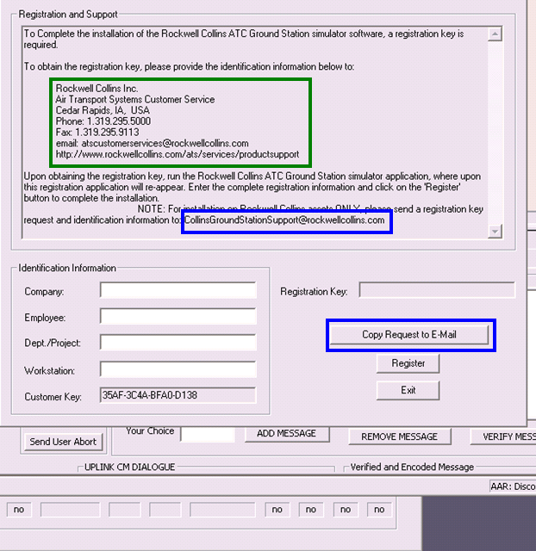

This is a sample email for requesting the Registration Key.

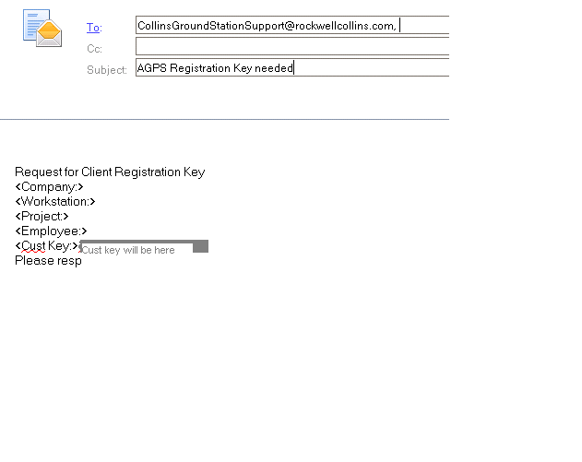

When the registration key is received, go to the ATC screen that is requesting the Registration Key and press “Register”.

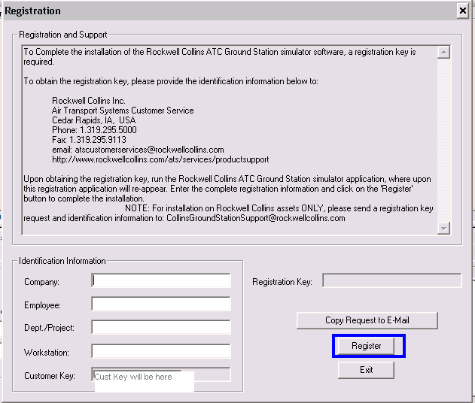

The pop-up screen, pictured below, will appear. Populate the registration key and press “OK”. A message will display indicating when the registration key will expire.

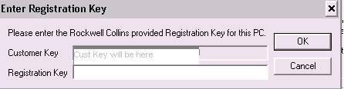

## Stopping VISTA

The easiest way to stop VISTA is to simply click on the [x] control in the upper-right corner of the VISTA console.

If, however, VISTA leaves some processes ‘hanging’ use the following steps to individually kill each process before quitting VISTA.

From the VISTA Python terminal (if not already showing, type Ctrl+B):

At the >>> prompt; type kill("*") and press enter

To kill individual application type the following for each process:

kill(“**application name”)**

Example: >>> kill(“dm”)

To Exit VISTA type the following:

quit()

# VAPS

## Installing PERL

Navigate to the windows search bar and type “Software Center.” In the software center type “Perl” in the top right

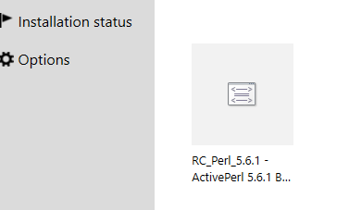

Select it and install RC_Perl_5.6.1

Next navigate to the windows search bar and type “Edit the System Environment Variables.” Click Environment Variables in the bottom right. Then select Path under “System Variables.”

Navigate in your file directory to the Perl install. For most it will install in the C drive as default. Navigate to the Perl folder and then bin folder. Copy the directory.

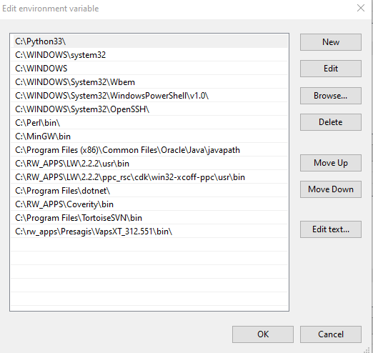

Select “New” and paste the directory in as well as move it up as shown above.

## Installing Python 3.3

Install Python 3.3 - <http://rwebapps.rockwellcollins.com/SoftwareCenterIntl/Software.aspx?ID=10981>

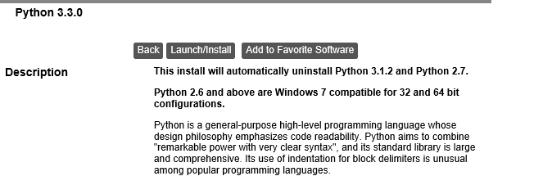

Click Launch/Install.

Once finished installing navigate to the install in the file directory. For most it will default to C:\Python33. Copy the directory.

Navigate to the windows search bar and type “Edit the system environment variables” and search. Click “Environment Variables” in the bottom right of the pop up.

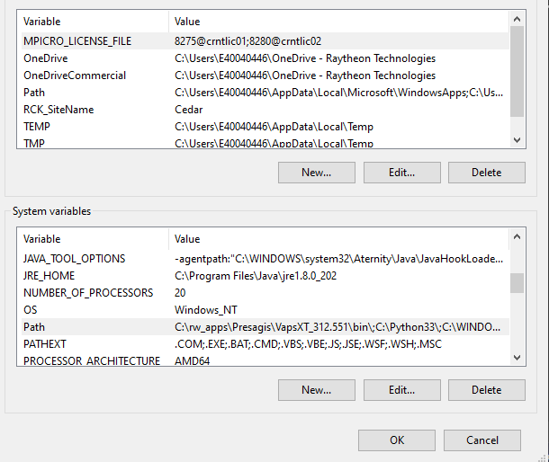

Then under “System Variables” select “path.”



If the Python33 directory is not already added. Then select new and paste C:\Python33 or your corresponding directory if different. Move it up if not already done.

## Widget Library

In your file directory navigate to <YOUR DLCA PROJECT>\tools\DLCA_Tools\A661_Support

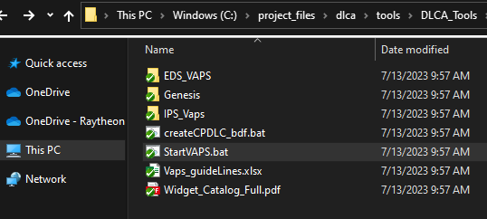

Right click on StartVAPS.bat and click edit

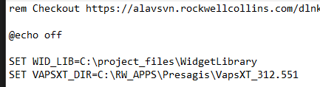

It is important to note that you will need to install the widget library in this location. You can change this location to your convenience.

Navigate to the directory set equal to “SET WID_LIB” excluding “\WidgetLibrary” as seen above. Right click and create a new folder.

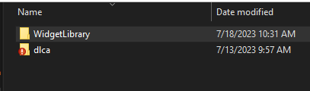

Be sure to set the name to WidgetLibrary, similar to what is in the batch script.

Right click on the folder “WidgetLibrary” and select SVN checkout.

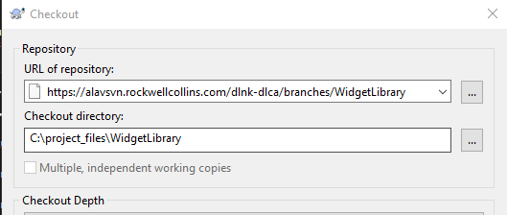

In the field titled URL of repository enter

<https://alavsvn.rockwellcollins.com/dlnk-dlca/branches/WidgetLibrary>

Click ok and the checkout should finish.

## Installing VAPS

Install VAPS - [Software Center - Software Center (rockwellcollins.com)](http://rwebapps.rockwellcollins.com/SoftwareCenterIntl/Software.aspx?ID=10130)

Click Launch/Install. The pop up screen below should appear

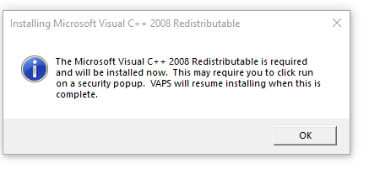

Click OK. This will install a lot of files in your C drive that can be deleted upon completion of installation of VAPS.

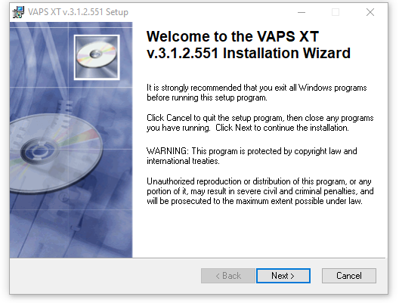

Select “Next” until the installation starts

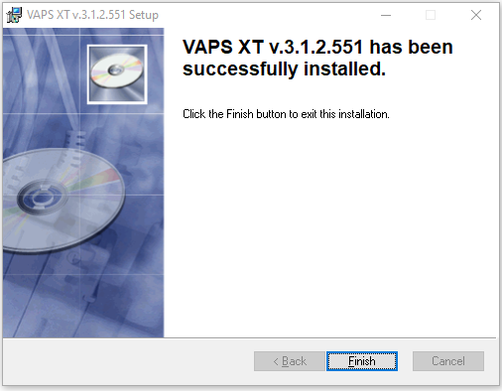

Once done installing this screen should pop up. Click Finish

Navigate to the windows search bar and search “Edit the system environment variables.” Click Environment Variables in the bottom right until you reach the screen below.



Select Path in the “System Variables.”

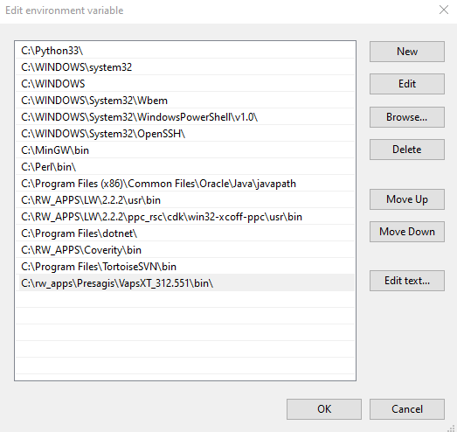

IMPORTANT: If not already added by default, add C:\rw_apps\Presagis\VapsXT_312.551\bin or your corresponding VAPS/bin file. This is specific to your device for most it will be the directory listed above. Important to move \rw_apps\Presagis\VapsXT_312.551\bin to the bottom of your environment variables.

Click Ok and close the environment variables.

## Start VAPS

Navigate to your DLCA6510 project in you file directory. From there go to <YOUR DLCA PROJECT> \tools\DLCA_Tools\A661_Support\.

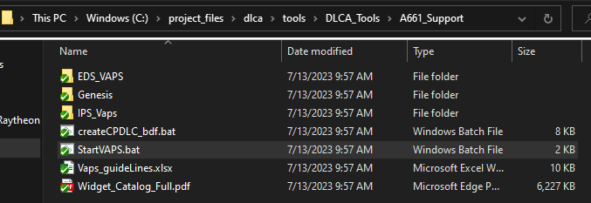

Your folder should look like this. Click StartVAPS.bat. Select 1 for the EDS version or 2 for the IPS version in the prompted terminal. VAPS should then start.

# SciTool’s Understand

This tool is used to supplement coding standard enforcement by automating the checking of some of the DLCA-6500 coding standard rules as well as informing the user of violations of various good coding practices.

Since the use of a tool for automated coding standard checking is relatively new it is expected that the selected rules will be modified over time (as well as custom DLCA-6500 rules added).

## Software Installation

The current version of the Understand tool being used for the team is Version 3.0 Build 613. First update your SVN folder containing the <http://asvn/dlnk-dlca/trunk/Tools/Understand> files.

Then, either double click the install file in that folder location (Understand-3.0.613-Windows-32bit.exe) or press Ctrl then click on the following SVN link:

<http://asvn/dlnk-dlca/trunk/Tools/Understand/Understand-3.0.613-Windows-32bit.exe>

Windows 7

<http://asvn/dlnk-dlca/trunk/Tools/Understand/Understand-3.1.660-Windows-64bit.exe>

*(The first few steps below only apply if you use the above link)*

Enter your SVN Password at the prompt if requested.

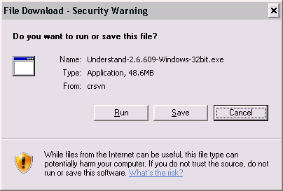

Click Run

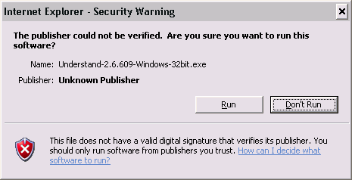

Click Run again

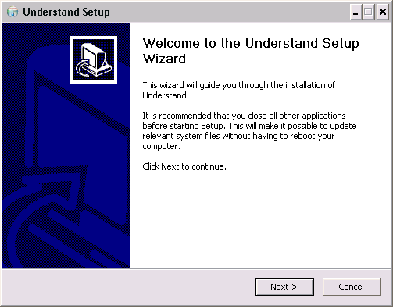

Click Next

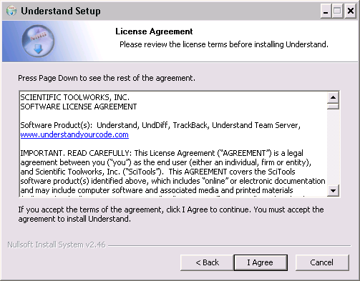

Accept the License Agreement

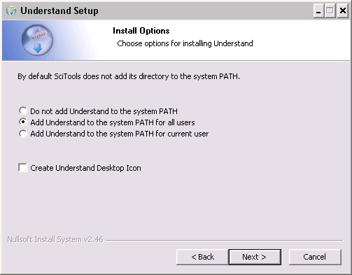

Select ‘Add Understand to the system PATH for all users’

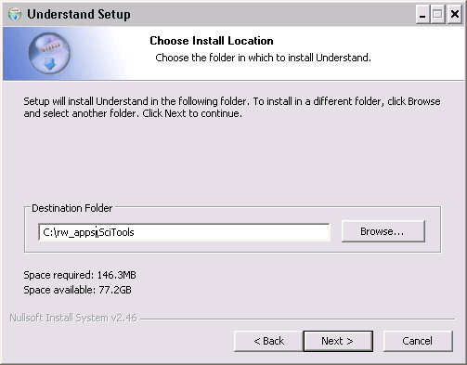

Modify the default path from C:\Program Files\SciTools to C:\rw_apps\SciTools and click Next

**\*Note: The understand tool needs to be installed in C:\rw_apps directory in order for the floating license to work**.

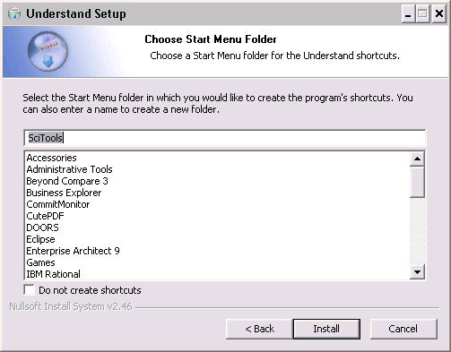

Click Install

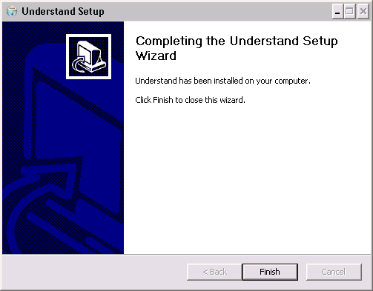

Click Finish

## Tool License

After installation, select the Floating License option (via the button ‘Specify License Server’) and point to server 'crntzr02'.

If the tool does not automatically request the license setting, select Help->Licensing and click ‘Add a License’ then proceed as noted above.

**Note**: As for all products with a floating license, please close the tool when you are not using it.

## Software Configuration

Launch the application (Start->All Program->SciTools->Understand) and then configure the tool as noted below.

### Load DLCA-6500 Project

From the toolbar, click File->Open->Project and browse to your SVN install location for the ..\trunk\Tools\Understand\DLCA-6500.udb file (if you used the standard install location this will be at C:\rw_apps\dlca\Tools\Understand\DLCA-6500.udb).

You will see a popup like the following as Understand attempts to resolve each of the files referenced in the project.

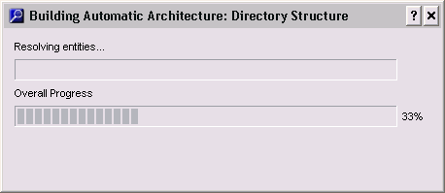

This project lists all the files that the Understand tool should use when performing its code checks. However, as files get added/removed from the datalink code folders the Understand project may get out of date. Periodically update and/or check in new updates to the project file if you modify the datalink folder content.

### Configure project portability mode

While C:\rw_apps\dlca is the ‘standard’ SVN checkout location referenced throughout this document, some may not have used that as their root location. To accommodate different root folders you will need to configure the project portability settings for ‘your’ SVN checkout location as follows:

On the toolbar, select ***Project->Configure Project->Files***

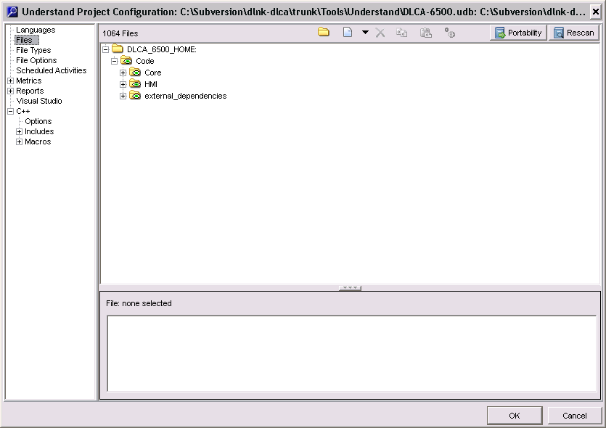

Click the Portability Button

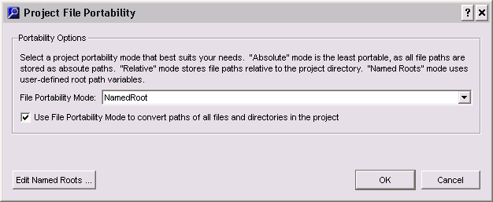

Enter a check in the checkbox “Use File Portability Mode to convert..”

Then click Edit Named Roots button

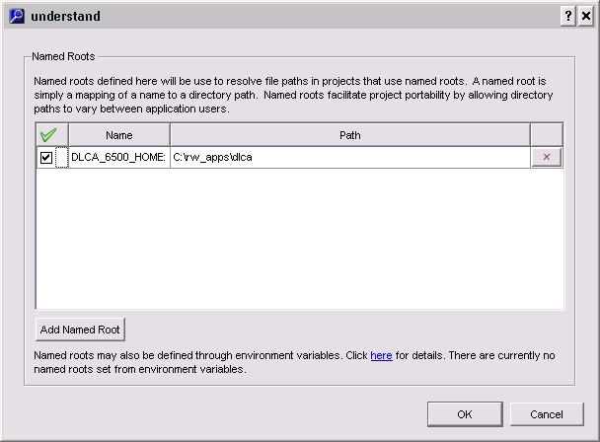

If DLCA_6500_HOME is not already showing, click ‘Add Named Root’ button and specify the path to your SVN root location. Otherwise modify the Path accordingly.

[Note, if your SVN installation differs from the above example then your Path data will also differ. For instance, if your **\Code** files are located at C:\rw_apps\dlca\trunk**\Code** then your Path should be entered as C:\rw_apps\dlca\trunk (i.e. everything up to, but not including, **\Code** should be entered as the path).]

Click OK when finished click OK again after returning to the prior popup.

### Configure C++ Options

After completing the previous step the following popup should be showing (if not, on the toolbar, select Project->Configure Project)



Select C++

Set the Compiler and Compiler include paths as shown below (all others are left at tool defaults at this time).

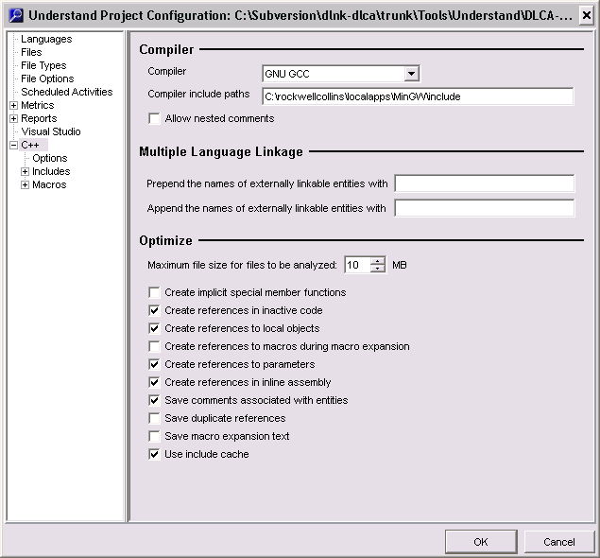

Click OK.

If you get the following popup, click Yes

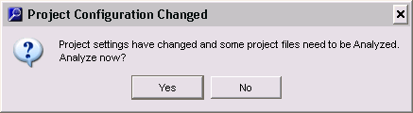

The analysis phase builds an internal model of the file inter-relationships. You will see popup like the following:

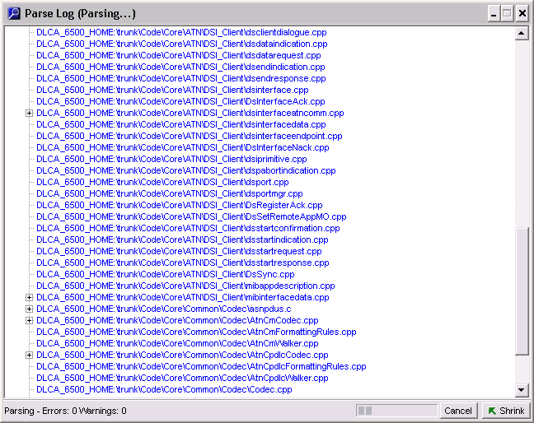

Once complete you should see something like the following:

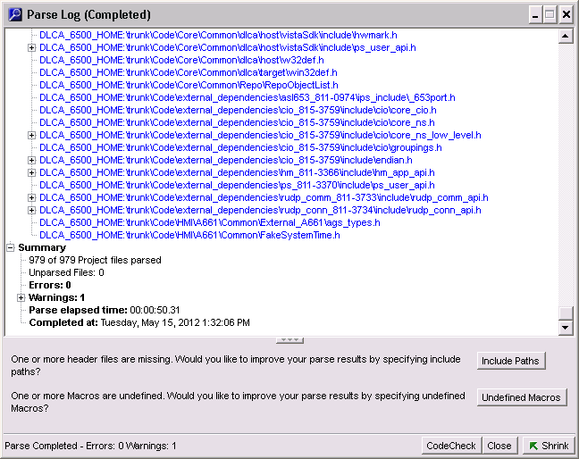

A few warnings are not unexpected and can be ignored if they are limited to Include Paths for files found in the \external_dependencies folder(s) as shown in the example below or pertain to files that are provided in the project folders but are not included in any ‘make’ files.

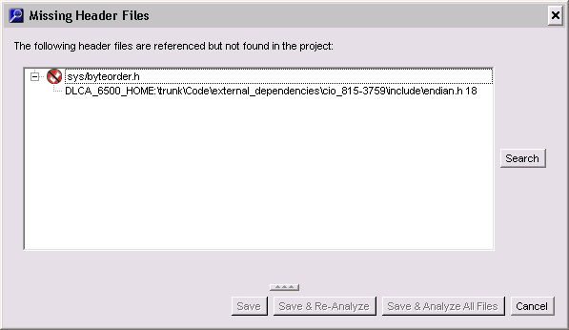

Click the Cancel (if the above popup is shown) and Close button(s).

### Adding/Remove Project Files

#### Automatically Updating the Project Files by Scanning Folders

The most ‘convenient’ manner to update the list of project files would normally be to use the menu bar’s function Project->Rescan Project Directories to update the files listed in the project. This can still be used but be aware that ‘all’ files under the root project folder could be added but for the datalink source code many of the files are locally resident for reference but are not actually referenced in any Makefile. For example – the following popup indicates which files the tool determined ‘should’ be added but many of these are in .._TO_BE_REMOVED_.. folders.

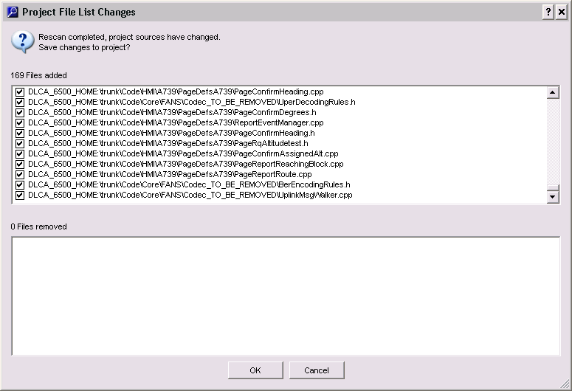

If you use this method then either deselect files you know you do not want to keep before clicking OK or be prepared to manually remove any files you later determine to not be used.

#### Manually Updating the Project Files

You can add or remove files to the project at any time. Adding files may be necessary (but only temporary) if you want to perform a CodeCheck against the files before they have been committed to the SVN repository.

##### Adding Files to the Project

To add a file, right-click in the project browser window and select Add Existing File

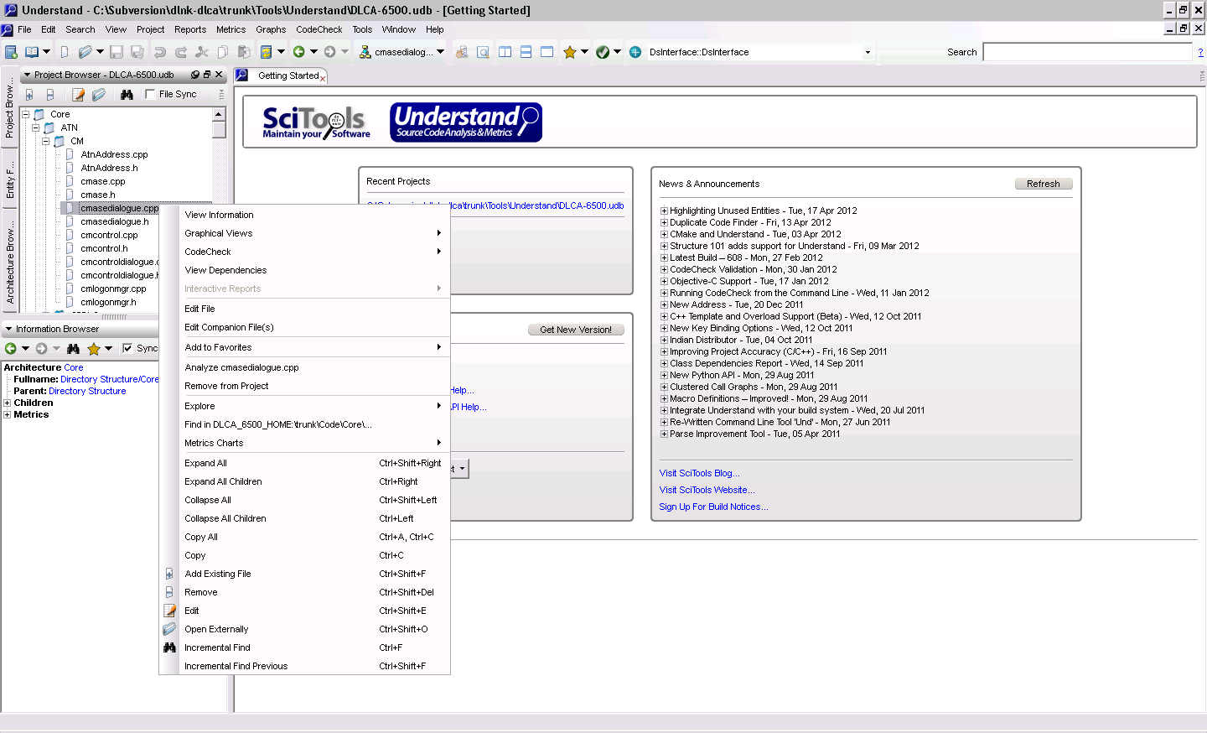

Then browse to the folder (normally under the same NamedRoot path as the existing project files) and select the file or files you want to add.

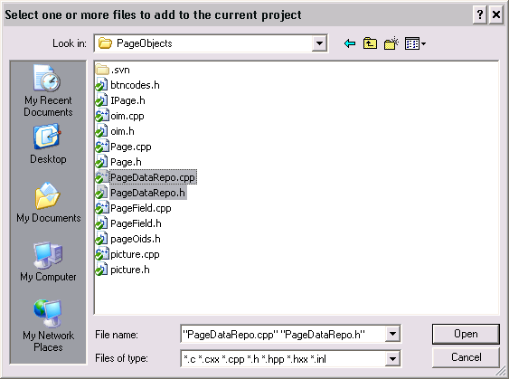

Click Open

You will get a confirmation popup as follows

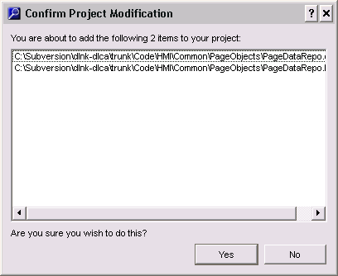

##### Removing Files from the Project

In the Project Browser window – select the folder\files you want to remove then click Ctrl+Shift+Delete

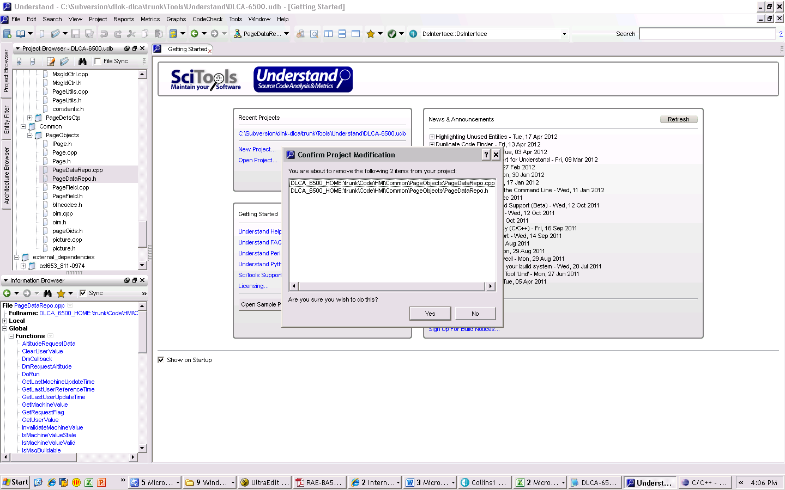

Click Yes to confirm removing the selected files (a popup may ask if you want to reanalyze the project files after this change).

### Adding Rockwell Collins Custom CodeCheck rules

Copy all the files under folder <http://asvn/dlnk-dlca/trunk/Tools/Understand/RockwellCollins> to C:\rw_apps\SciTools\conf\plugin\User\Codecheck\RockwellCollins.

### Configure CodeCheck ‘Files’ settings

You will typically only perform code checks on files you have modified, but to perform the checks against the default list of files perform the following steps:

On the menu bar click ‘CodeCheck->Open CodeCheck’

Make sure the project file folder view is being displayed (example below). If not, click the “Files” selection field in the left margin (blue background) of the ‘Understand CodeCheck’ tab.

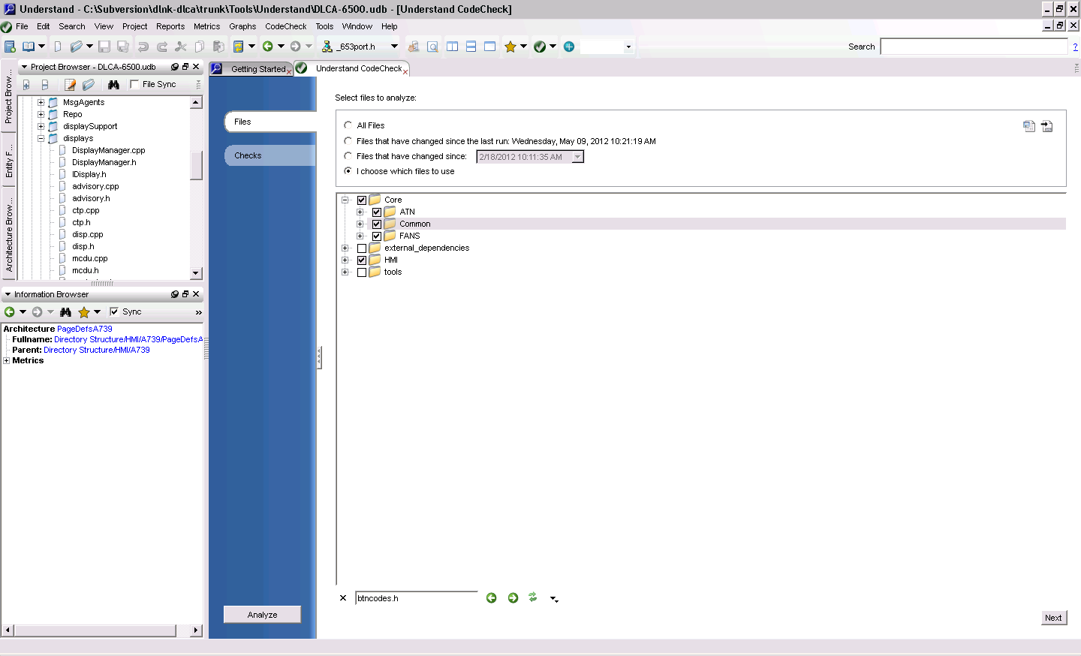

Click the Import button (see arrow above)

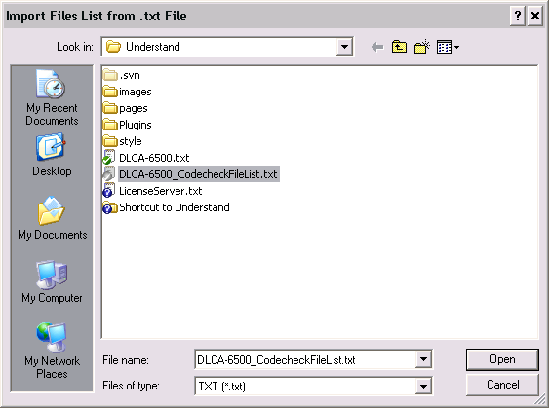

Browse to the \Tools\Understand folder and select DLCA-6500_CodecheckFileList.txt

Click Open.

Each of the folders in the CodeCheck project view will be expanded to show the selected files upon completion.

You can select/deselect any files you wish to either include or exclude from the subsequent checks (more files will require longer analysis time).

### Configure CodeCheck ‘Checks’ settings

Click the ‘Checks’ selection field in the left margin (blue background) of the ‘Understand CodeCheck’ tab.

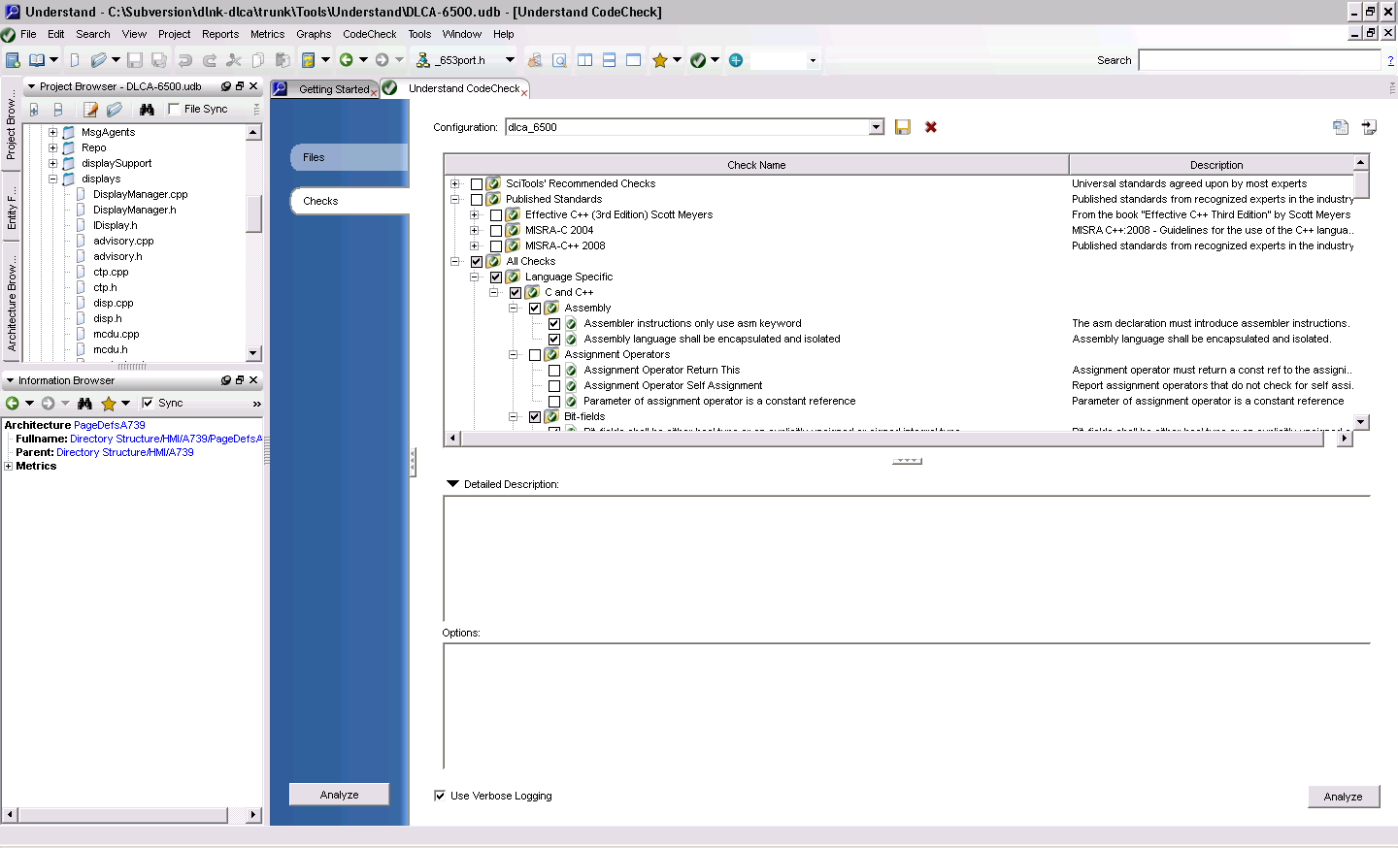

Click the Import button (see arrow above)

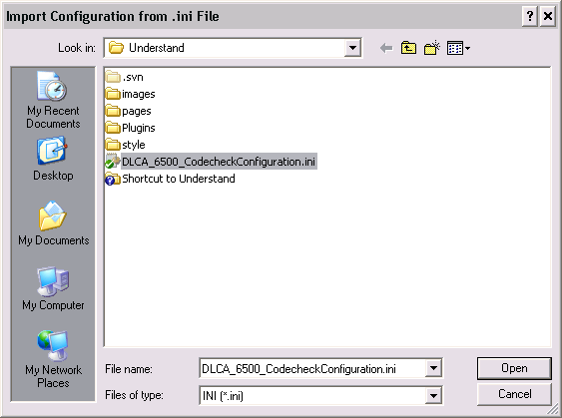

Browse to the \Tools\Understand folder and select DLCA-6500_CodecheckConfiguration.ini

Click Open.

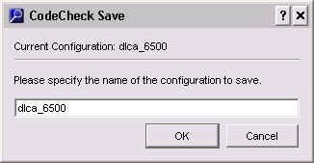

Click OK

## Running the CodeCheck checks using the IDE

If the ‘Understand CodeCheck’ IDE is not already being displayed; then from the menu bar click ‘CodeCheck->Open CodeCheck’

The ‘Analyze’ button is available from both the ‘Files’ and ‘Checks’ selection windows. On the ‘Files’ selection window select/deselect any files you wish to include in the checks.

**Note**: Only those files that are included in the Understand project are available for selection. If you are running the checks against a file (or files) you recently added to the datalink repository, and the Understand project (.udb) file has not yet been updated, then you will need to add the required files to the project. Refer to Adding/Remove Project Files for details.

Once you have finished selecting the required files, click the ‘Analyze’ button. *{This activity can be very lengthy if ALL of the project files have been included.}*

An example of the types of results you may see are shown below for a limited set of ATN\DSI_Client files (the number of ‘findings’ is fairly lengthy for these files due to their legacy status).

After selecting only files in the \Core\ATN\DSI_Client folder:

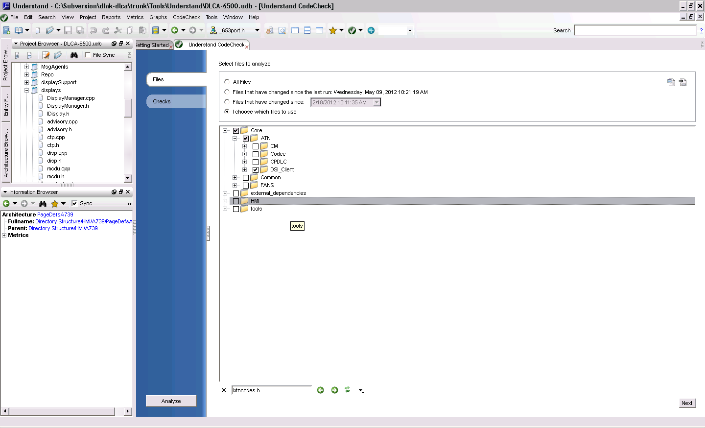

The following popup may appear the first time you run the checks to warn you that ‘all files’ might still be analyzed for subsets of the checks. Click the checkbox if you do not want to see this message again.

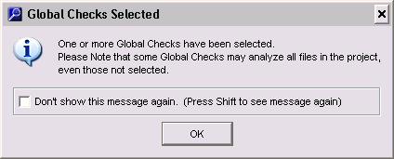

Example results:

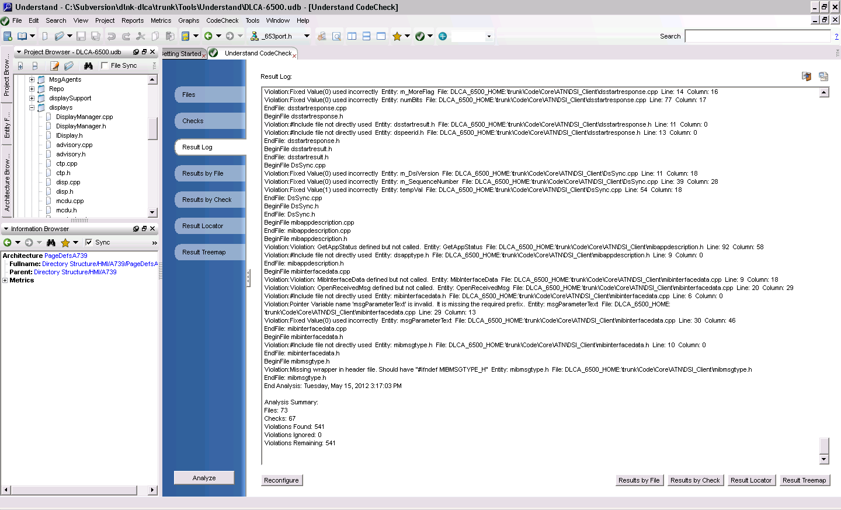

By clicking a different selection field in the left margin you can view the errors from different perspectives. For instance, in the ‘Results By Check’ you can browse through the failures by rule check and go to the specific file and line of code against which the failure is being reported.

Example error report:

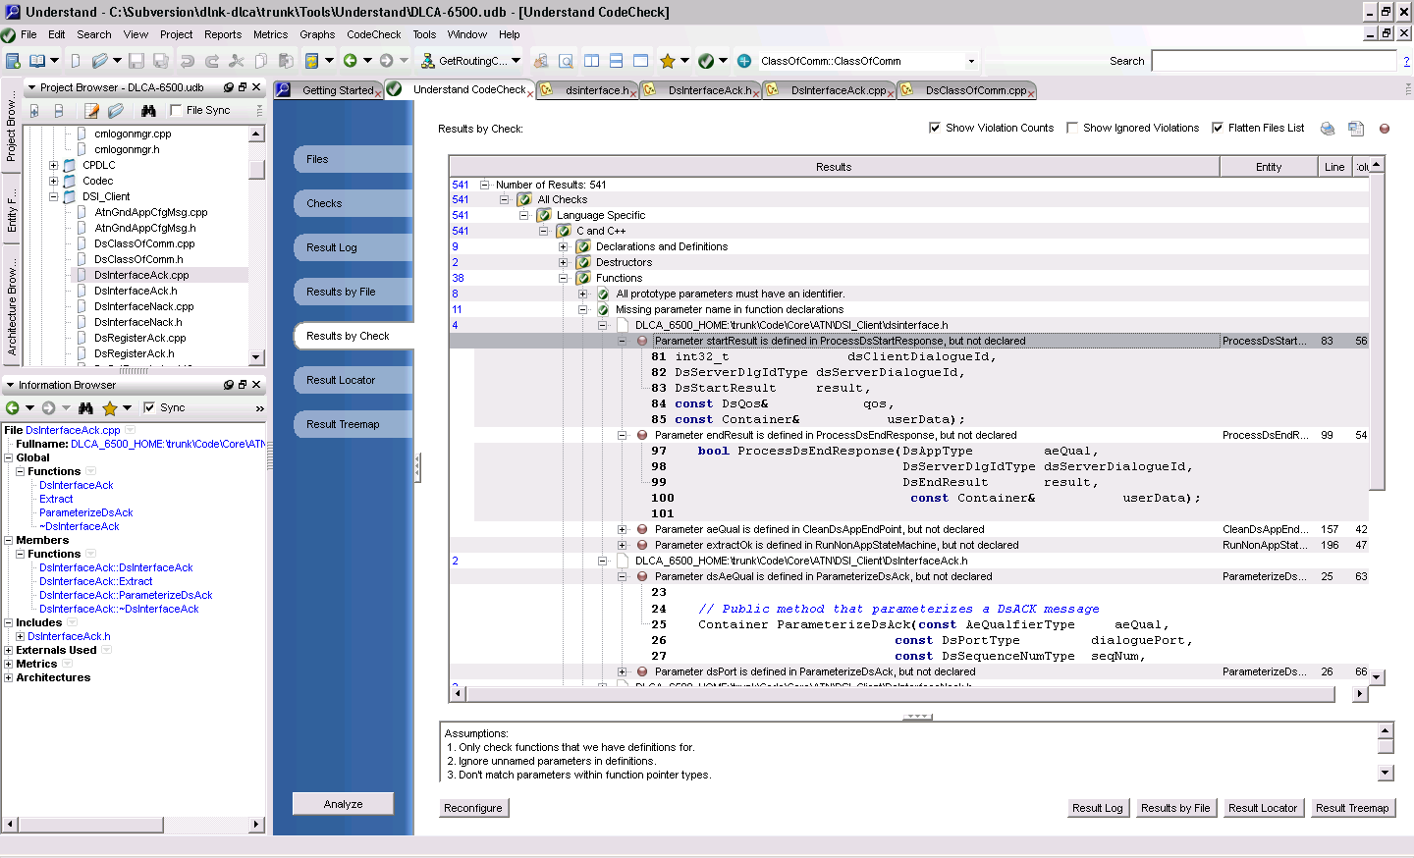

Clicking on the line will open the source file where the problem can be directly edited at that time (in this specific case the .h file’s parameter name (***result***) did not match the name used in the .cpp file (***startResult***) causing the error to be raised).

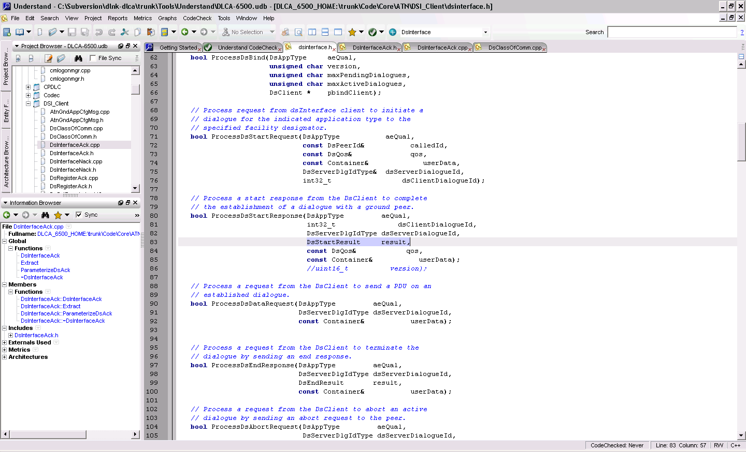

## Understand Checks vs Datalink Coding Standard Rules

No available tool can check all of the *Coding Standard for C++* (832-0536-xxx) rules used for the Datalink project but many of these rules are based on best industry practices and recommendations and the Understand CodeCheck tool supports checks many of those industry standards. At this time, only a subset of the possible rules in CodeCheck have been enabled while experience is gained with the utility of the tool for ***supplementing*** manual code reviews and for software developers to pre-screen their code prior to the source code reviews. The following table provides a cross-reference between the Coding Standard rules and the rules (both internal and custom Rockwell Collins rules) that are available and enabled in Understand.

|  |
| --- |
|  |

Key: Cross-hatched fields indicate opportunities for adding a new custom rule.

| **Coding Standard 832-0536-005 Rev B Tag** | **Standard or Guideline?** | **Description** | **Automated?** |
| --- | --- | --- | --- |
| **CastVBase** | **Standard** | Never convert pointers to objects of a derived class to pointers to objects of a virtual base class. | no |
| **AccessControl** | **Standard** | The public, protected, and private sections of a class shall be declared in that order (the public section is declared before the protected section, which is declared before the private section). | yes |
| **AssignStat** | **Standard** | The assignment statement shall not be used as a parameter in a function call. | yes |
| **AssignTypeCons** | **Standard** | Assignment statements shall contain type-consistent variables, i.e., mixed-mode expressions are not allowed. Any type differences shall be addressed by casting (explicit type conversion) to the correct type. | no |
| **AutoVar** | **Standard** | A function shall set the values of *storage class* autovariables before the variables are used. A function shall not return the address of an automatic variable. | no |
| **BitField** | **Standard** | Bit Fields shall have explicitly unsigned integral or enumeration types only. The bit field definition shall be platform independent. It supports both big endianess and little endianess. | no |
| **Bool** | **Standard** | The C++language introduces a compiler supported data type, bool. This type shall be used for all Boolean functions and operations | yes |
| **ClassDef** | **Standard** | An include file shall not contain more than one class definition. | yes |
| **Comments** | **Standard** | All comments shall be written in English | no |
| **ConstArgs** | **Standard** | Whenever an argument is being passed by reference or pointer ***for efficiency reasons only***, it shall be passed as a constant | no |
| **ConstDest** | **Standard** | Design of a class shall include destructor definitions for appropriate cleanup when the class is closed | no |
| **Copyright** | **Standard** | All code shall be copyrighted… | yes |
| **DataDef** | **Standard** | Data definitions shall be explicit, i.e. long, short, char. Do not use int or unsigned without an explicit qualifying long, short, char, etc. | no |
| **DelArray** | **Standard** | Always provide empty brackets (“[]”) for delete when deallocating arrays. | no |
| **DynMemAlloc** | **Standard** | Critical level functions shall not use dynamic memory allocation, and no functions shall use the legacy Clanguage memory functions, malloc, reallo**c** and free. The C**++** functions newand deleteshall be used in critical level applications only during initialization to allocate and free storage. | yes, part 1; no, part 2 |
| **ExeHandl** | **Standard** | Exception Handling shall not be used. Exceptions are another C++ feature which is not very widely implemented. Unfortunately, there is no good workaround that produces similar functionality. | yes |
| **ExplicitRet** | **Standard** | Return from a function shall be accomplished only by an explicit returnstatement, i.e., the code shall not use the default or implicit return. Not writing returnin a function relies on the default return. | yes |
| **ExtLink** | **Standard** | Entities shall not be defined with linkage in a header file | no |
| **FileNames** | **Standard** | Always give a file a name that is unique in as large a context as possible | no |
| **GlobalDataInit** | **Standard** | Global data shall be initialized before start of real time executive processing in a routine which is not part of the run time executable code and not in a variable declaration. Global data shall be initialized before start of the run time system with one unique invocation of the routine that does the setup. | no |
| **GlobalsInCtor** | **Standard** | Do not use global objects in constructors and destructors. | no |
| **ImpTest** | **Standard** | Implicit test for 0should not be usedother than Boolean variables and pointers. | no |
| **IncludeExt** | **Standard** | Include files in C++ shall always have the file name extension “.h”. | yes |
| **IncludeForm** | **Standard** | Use the directive #include “filename.*h”* for ALL include files (or #include <filename.h> for standard include files provided by the compiler. | yes |
| **IncludeH** | **Standard** | When the following kinds of definitions are used (in implementation files or in other include files), they shall be included as separate include files | no |
| **InitList** | **Standard** | Initialization shall be preferred to assignment in constructors | no |
| **Macros** | **Standard** | Preprocessor macros shall not be used to perform functional operations. Instead use inline functions. | no |
| **NameAbbrev** | **Standard** | Names should not include ambiguous abbreviations | no |
| **NameCase** | **Standard** | Do not use names that differ only by the use of uppercase and lowercase letters. | no |
| **Names (property_4)** | **Standard** | Member variables should be prefixed with “m_” and member pointer variables with “m_p”. Following the prefix, the rest of the variable should begin with an uppercase letter. (e.g. m_VariableName or m_pPointerName). | yes |
| **Names (property_5)** | **Standard** | The names of preprocessor Macros are to be entirely uppercase with the words separated by an underscore ‘_’. | yes |
| **Nested Templates** | **Standard** | Templates shall not be nested and each instance of a template shall be tested. Each instance of a template with a unique set of arguments should be tested | no |
| **NestIncludes** | **Standard** | Every include file shall contain a mechanism that prevents multiple inclusions of the file. | yes |
| **NewDelDef** | **Standard** | The implementation of new and delete operators shall be redefined by using manually handled pools, instead of standard compiler implementation. (This is a certification only.) | no |
| **NoMallocFree** | **Standard** | The <<C standard>> memory management functions malloc(), calloc(), realloc(), free(), . . . shall not be used in C++ programs. The C++ standard new and delete functions shall be used. | yes |
| **NoPubAttr** | **Standard** | A class shall not have public attributes | yes |
| **OpAssign** | **Standard** | An assignment operator that performs a destructive action shall be protected from performing this action on the object upon which it is operating | no |
| **Polymorphism** | **Standard** | All public and protected functions in a base class or an intermediate class must be declared as virtual or pure virtual | yes |
| **PrefixSeparator** | **Standard** | Prefixes will be separated from the name by an underscore (‘_’), if it is of the same case as the first character of the name. See Exception to rule Names. | no |
| **PtrArithmetic** | **Standard** | Manually coded Pointer arithmetic shall not be included. | no |
| **PtrAutoVariable** | **Standard** | Static pointers will not be assigned the address of a storage-class autovariable | no |
| **PtrDeclaration** | **Standard** | A Pointer declaration shall explicitly declare the data type, which shall be the same as every variable to which it points. | no |
| **RefByName** | **Standard** | Definitions of classes that are only accessed via pointers (*) or references (&) shall not be included as include files | no |
| **ResExhaustion** | **Standard** | A call to new, which encounters memory exhaustion, will cause the system to throw an exception. The code shall not invoke exception handling for memory exhaustion with the set_new_handlerfunction. | yes |
| **ReturnLocal** | **Standard** | A public function shall never return a reference or a pointer to a local variable. | no |
| **ReturnValueType** | **Standard** | Every function returned value shall have the same type as the declared function type. A function which does not return a value shall be declared type void. | no |
| **RTTI** | **Standard** | The dynamic_castkeyword shall not be used to accomplish Run Time Type Identification. Run-time type information is a relatively new C++ feature, and not supported in many compilers. | yes |
| **SourceExt** | **Standard** | Implementation files in C++ shall always have the file name extension “.cpp”. | yes |
| **StaticInit** | **Standard** | Do not assume that static objects are initialized in any special order. | no |
| **StdClass** | **Standard** | All classes shall have a default constructor, a copy constructor, an assignment operator (operator=()), and a destructor | no |
| **Switch** | **Standard** | Each casein a switch, which contains any executable code, shall be terminated with break. It is too easy to lose track of the correct program flow in code maintenance. However, it is acceptable to code a set of casestatements which all execute the same code. | no |
| **SwitchDefault** | **Standard** | All Default statements shall be left empty, contain an assert or print an error to the trace port | no |
| **TmpArg** | **Standard** | Constraint checks shall be applied to template arguments | no |
| **TmpCust** | **Standard** | Templates shall be customized intentionally and explicitly. | no |
| **TmpSpl** | **Standard** | A template specialization shall bedeclared before its use. | no |
| **TypeCast** | **Standard** | Type casting shall be explicitly coded with use of the C++ keywords or the standard C cast operator, and shall not be left as an operation only implied by the code (e.g., an assignment statement). | no |
| **Underscore** | **Standard** | Do not use identifiers which begin with one or two underscores (‘_**’** or ‘__’). | yes |
| **Union** | **Standard** | Any data type defined as a "union" shall be platform independent. Byte ordering shall be transparent to both endiness | no |
| **VirtDestr** | **Standard** | Base class destructors shall be made public and virtual, or protected and non-virtual | yes |
| **VirtualDtor** | **Standard** | All classes shall have a virtual destructor. | yes |
| **VirtualInCtor** | **Standard** | Avoid calling virtual functions in a base constructor | yes |
| **Accessors** | ***Guideline*** | Access functions are to be inline (*note that the exception for Level C makes this 'standard' of questionable value)* | no |
| **AddressTypes** | ***Guideline*** | The dereference operator **‘*’** and the address-of operator ‘&’ should be directly connected with the type names in declarations and definitions. | yes |
| **AssignReturn** | ***Guideline*** | An assignment operator ought to return a const reference to the assigning object | yes |
| **Braces** | ***Guideline*** | Braces (“{}”) which enclose a block are to be placed in the same column, on separate lines directly before and after the block. | no |
| **ClassDefFileName** | ***Guideline*** | An include file for a class should have a file name of the form <class identifier>.h. | yes |
| **ClassImpl** | ***Guideline*** | A class implementation should be in one file. | no |
| **ClassImpl2** | ***Guideline*** | A class implementation that is very large (greater than 3000 lines), should be reviewed for opportunities to introduce inheritance. | yes |
| **CompilerTemp** | ***Guideline*** | Minimize the number of temporary objects that are created as return values from functions or as arguments to functions. | no |
| **Constants** | ***Guideline*** | Constants are to be defined using const or enum; never using #define. | yes |
| **ConstMF** | ***Guideline*** | A member function ***that should not*** affect the state of an object (its instance variables) is to be declared const. | no |
| **ConstRef** | ***Guideline*** | Use constant references ‘const &’ instead of call-by-value, unless using a predefined data type or a pointer. | no |
| **ConstRetVal** | ***Guideline*** | Whenever a reference to internal data is to be passed back, it shall be declared as a const. Whenever a pointer to internal data is to be passed back, the data to which it points shall be declared as constant. | no |
| **COTS** | ***Guideline*** | If the **C++** Standard Template Library (STL) routines are used, which are delivered as part of a compiler package, or some other source external to the supplier is used, then it should comply with requirements ofSoftware Considerations inAirborne Systems and Equipment Certification, [DO-178B, RTCA Inc., March 26, 1999], which apply to COTS for those library routines | no |
| **CtorInitOrder** | ***Guideline*** | Do not assume that an object is initialized in any special order in constructor initialization list. | yes (partial) |
| **DataFormat** | ***Guideline*** | Data should be formatted to reflect the logical organization. | no |
| **Ellipsis…** | ***Guideline*** | Do not use unspecified function arguments (ellipsis notation). | yes |
| **EmptyFlow** | ***Guideline*** | The flow control primitives if, else, while, for and do should be followed by a block, even if it is an empty block. | no |
| **ExtConstMF** | ***Guideline*** | If the behaviour of an object is dependent on data outside the object, this data is not to be modified by const member functions. | no |
| **ExternalRef** | ***Guideline*** | For any class that requires a reference to an external object a public method shall be provided to set this reference instead of passing the reference as a parameter in the constructor argument list. | no |
| **Forwarders** | ***Guideline*** | Forwarding functions are to be inline | no |
| **FuncDef** | ***Guideline*** | When defining functions, the complete function definition will be on the same line including return type, function name, and any arguments. | no |
| **FuncOverload** | ***Guideline*** | When overloading functions, all variations should have the same semantics (be used for the same purpose). | no |
| **FuncTmp** | ***Guideline*** | Do not specialize function templates. | no |
| **Globals** | ***Guideline*** | Encapsulate global functions, variables, constants, enumerated types, and typedefs in a class. | no |
| **IdLength** | ***Guideline*** | The maximum length of an identifier is 32 characters. | yes |
| **IdPrefix** | ***Guideline*** | The identifier of every globally visible class, enumeration type, type definition, function, constant, and variable in a subsystem is to begin with a prefix that is unique for that subsystem. | no |
| **IncludeCpp** | ***Guideline*** | Every implementation file is to include the relevant files that contain … | yes |
| **Indent** | ***Guideline*** | Blocks of code will be indented one tab stop. | no |
| **InheritMult** | ***Guideline*** | Multiple inheritance will be considered a restricted design method | no |
| **InitVars** | ***Guideline*** | Member variables should be defined and initialized in the same order | yes |
| **InitVsAssign** | ***Guideline*** | If possible, always use initialization instead of assignment. | no |
| **LineLength** | ***Guideline*** | Each line of source code will be limited to 80 spaces. | yes |
| **LongtoShort** | ***Guideline*** | Type conversions made from a longer to shorter data types shall explicitly include documentation of what bits will be lost along with their definition. | no |
| **MagicNum** | ***Guideline*** | Avoid the use of numeric values in code; use symbolic values instead. | yes |
| **MulDef** | ***Guideline*** | Avoid multiple definitions of overloaded functions in conjunction with the instantiation of a class template. | no |
| **NameUsage** | ***Guideline*** | Choose variable names that suggest the usage. | no |
| **NullPtr** | ***Guideline*** | A pointer shall not be compared to Null or be assigned Null. Integer constant 0 will be used instead. | yes |
| **Paths** | ***Guideline*** | Do not specify relative paths in #include directives | yes (partial) |
| **Presentation** | ***Guideline*** | Indentation shall be three spaces (spaces, not tabs) for each level. Blank lines will be included to delineate major blocks of code from each other. | no |
| **Ptr2Func** | ***Guideline*** | Use a ‘typedef’ to simplify program syntax when declaring function pointers. | no |
| **Ptr2Ptr** | ***Guideline*** | Pointers to pointers should be avoided when possible. | no |
| **Ptr2Type** | ***Guideline*** | A typedef should not be used on structures, unions, enumeration, or classes to support forward references when declaring pointers. | no |
| **PtrIndirection** | ***Guideline*** | If the level of indirection exceeds one in the use of pointers, then verification of the code will include test cases specially documented to assure the robustness of the design. | no |
| **PublicReturn** | ***Guideline*** | A public member function shall never return a pointer or non-const reference to member data. | no |
| **PublicReturnExt** | ***Guideline*** | A public member function shall never return a pointer or non-const reference to data outside an object, unless the object shares the data with other objects | no |
| **RecFunct** | ***Guideline*** | If recursive functions are used then design should contain explicit safeguards to avoid stack over run from unlimited recursion | no |
| **Re-EntFunct** | ***Guideline*** | The use of re-entrant functions should be directly traceable to explicit software requirements, which are in turn derived from system requirements. Re-entrant functions shall not assign values to global variables. | no |
| **RefOrPtrArg** | ***Guideline*** | If a function stores a pointer to an object that is accessed via an argument or sets the value of the argument let the argument have the type pointer. Use reference arguments in other cases. | no |
| **Return** | ***Guideline*** | Always specify the return **type** of a function explicitly | no |
| **SimpleFlow** | ***Guideline*** | The expression controlled by the flow control primitives if, else, while, for and do should be placed on a new line. | no |
| **SplPtr** | ***Guideline*** | Specializations for pointer types **should** be made where appropriate | no |
| **SubExpr** | ***Guideline*** | Sub expressions of large expressions should provide natural breaks for formatting the expression. | no |
| **TempLife** | ***Guideline*** | Do not write code which is dependent on the lifetime of a temporary object. | no |
| **TmpDependence** | ***Guideline*** | A template definition’s dependence on its instantiation contexts should be minimized. | no |
| **VarDecl** | ***Guideline*** | Each variable is to be declared in a separate declaration statement. | yes |
| **VarInit** | ***Guideline*** | Every variable that is declared is to be given a value before it is used. | no |
| **VarScope** | ***Guideline*** | Variables are to be declared with the smallest possible scope. | no |

The complete Excel file for this table (with additional commentary) is available at <http://asvn/dlnk-dlca/trunk/Tools/Understand/CodeStandard_vs_Understand.xlsx>.

# Write a Change Request

## Guidelines to write a CR:

1. In CR Summary Mention name as "**FANSATN** -" (that is FANSATN in CAPS and a space and a "-") then New Reqs for L3 (problem description)- The **FANSATN** should be in front of your usual problem description.
2. Select **DLCS as subsystem** under CCB TAB (This is important, please don't forget to make this selection)
3. Since this is a CR for Harmonized DLCA-ATN effort select for Project/Program- ProductLine. If this Cr was for a specific program say EEJ, then select EEJ under this section.

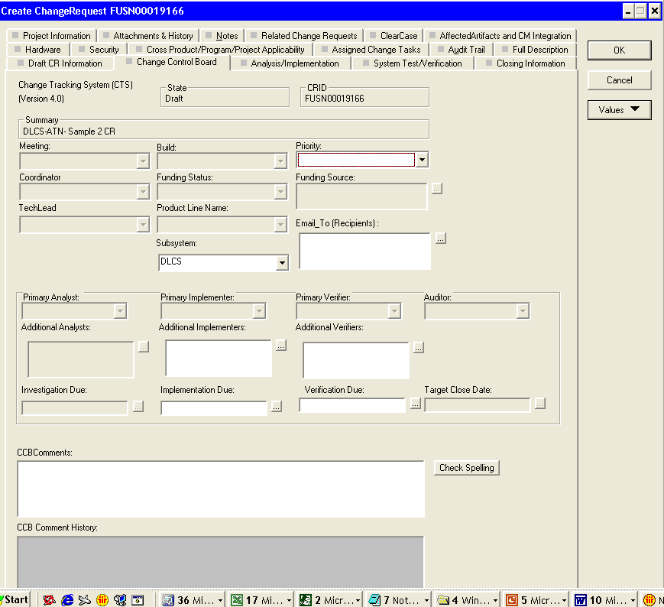

1. All the CRS that are created for the FANSATN project can be sorted under filter...Just double click on this filter (the one circled in the picture below) and all CR’s for FANS/ATN will be pulled up

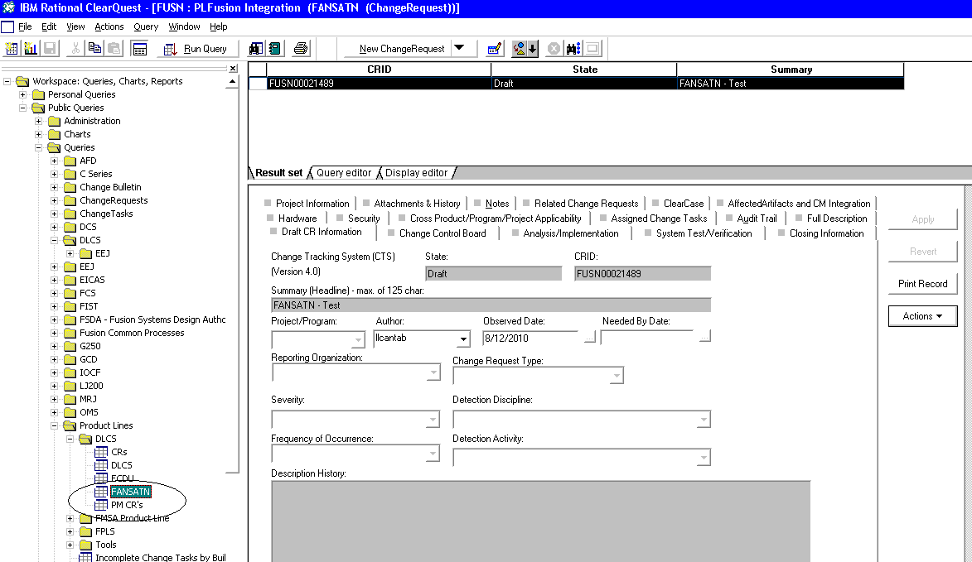

## Things To Do

1. Do Make sure the issue summary is a summary of the problem or change.
2. Do Include a clear description of the problem or desired change in the description field.
3. Do Stick to the facts when writing up the issue.
4. Do Include Steps to recreate the problem, because the issue may be around for months or years prior to final resolution.
5. Do Include information that the issue assignee needs to recreate the problem. For example the version of software, the rig configuration, any data that was collected when the issue was observed.
6. Do Keep in mind that the issue may be around for months or years prior to final resolution, so what info is important to understand the issue if you are not around to talk to or you cannot remember.
7. Do Keep in mind all the people who might see your message, even by accident, as you decide what to write
8. Customer, systems, developers, certification authorities.
9. Do Always use correct grammar, punctuation, and spelling.
10. Do When your message is long or complicated; include a summary of the message right up front.
11. Do Use the attachments for supporting detail if needed, this include software code.

## Things to NOT DO

1. Do Not put code in the Description History field
   * Our customers can see the Description History field; they cannot see the Implementation Description or an Attachment. Put code examples in Attachments or the Implementation Description field.
2. Do Not put personal commentary or opinions in the description of the issue
   * This includes using words “design problem”, “Software bug” in the description when you have not investigated the issue enough to know for sure what the root cause is.
   * Calling code “Dead” or software “Crash” is another case of this. Avoid these texts which have very specific meaning to the certification agencies. This is rarely used correctly in CRs
3. Do Not use specific aircraft type or OEM info in the Summary or Description History
   * Exception to this rule is the use as a rig or configuration the problem was found in
   * If the change is very specific to a single AC or OEM and will never be used on another the name can be used in the description
4. Do not bury the most important information in the middle of your message. State it first, like a newspaper article would do

## Writing a Good Change Request Summary

1. Remember that the Summary/Description History of an issue is the main item that will be used to represent an issue in many communications, official certification documents and customer correspondence
2. Avoid the temptation to use cute or funny subject lines that do not spell out what the issue is.
3. Do not misrepresent the content of the issue in the Summary
4. Use words in the Summary that the recipient will recognize
   * Think about whether industry jargon or acronyms will be understood
5. When describing the issue do not editorialize
6. Write a clear description of what the issue is and why it is a problem
7. Reference the requirement that is not being met
8. Justify why the requirement is not correct
9. Write a clear scenario of how to demonstrate the issue
10. Document where the issue was found and what version of SW
11. Suggest to use the templates defined for the project:

*OBSERVED BY: <list all testers, working group names, customer pilots, etc>*

*WHAT RIG / BUILD / TEST EQUIPMENT: <CTA / Host / Build ID>*

*OBSERVED ISSUE: <Repeatable / Intermittent / Occurrence>*

*<What is the observed issue?>*

*EXPECTED OPERATION: <SRS OID 12345 states requirement> <How does operation violate the requirement?>*

*SCENARIO: <Step by step instructions to reproduce issue. Sim setup>*

*TEST SCRIPT AND LOG LOCATION: <Name and location of the test script & log file that identified the issue>*

*RECOMMENDATION TO CCB: <Update requirements, child CR, update test script, doc only need in current cert version>*

## Project Data

1. When drafted all issues need to have the Flight Deck Effect fields filled out. Flight Deck Effect (Project defined Field 4) is a summary of what impacts will be noticed in the operation of the aircraft:

* Focus on the effect to the pilot
* What will they notice in the cockpit

Examples:

* FLIGHT DECK EFFECT: This causes the ETA displayed on the ROUTE REQ page to be INCORRECT, indicating that there is 1 hour less time than actual. The correct data is displayed on the VERIFY page.
* FLIGHT DECK EFFECT: The VERIFY page format momentarily flashes but then displays the correct information.

1. If possible the Safety Statement (project defined Field 5) should also be filled in when drafting an issue
2. If you do not know for sure leave it blank and it will be filled in during the investigation
3. The safety statement is a brief description of how the issue impacts the safety of the system

* This is not a personal opinion of safety
* It is an impact to the safety based on the DLCA’s / RIU’s contribution to the safety assessment of the system

## Change Request – Investigations

1. Focus on the effect to the pilot
   1. What will they notice in the cockpit
2. When describing the results do not editorialize
3. The investigation is meant to be a short task to understand the issue and it’s impact
   1. Prototyping or full solutions are not necessary as part of an investigation.

1. The investigation may require you to talk to other people
   1. Do not send the issue back to the CCB to get it assigned to the other person, go talk to them
   2. If the issue is with another domain (your P/E or TPM can help coordinate this), talk to a person in that domain before asking to have the issue moved
2. Include a recommendation as to what should be done with the issue
3. Identify the software build/configuration you used

## Change Requests - Legal Considerations

CRs are Legal Documents

1. Customers that review our CRs can make us pay for fixes that have words like “design problem”, “Software bug” in the description so avoid those terms in description unless you know for sure they are true
2. What you put in CRs becomes part of the Company's legal documents in case of a law suite, accident investigation etc
   * This is why it is very important to stick to the facts and do not put opinion or speculation in the CR
3. Adding comments like “major problem”, “this is a safety concern” on issues will be taken seriously and could get the company into legal trouble, so make sure it is absolutely true if you put items like that in your write-up
4. Overall make sure you can backup what you put in a CR

# Good Coding Practices

1. In case of less number of comparison try to use if else in place of Switch case.

Enum a {

left =0;

right =1;

center = 2;

}

Now we want to make decision according to requirement, then

As it is will have less number of comparisons so :

If( direction == left)

{

printf(“ left \n”);

}

else if(direction == right)

{

Printf(“right”);

}

else if (direction == center)

{

Priintf(“center”);

}

Note:

Try to keep obvious option first for checking, it will reduce the processing time.

1. Always try to keep Event Handler as light as possible. It will help in situation where fast processing needs to be done.

Note :Try to use inline coding in Event handler in place of calling other method, if the called method is small.

1. Avoid unnecessary use of “else”. Sometime else part might be unrealistic to be hit.

int GetIndex()

{

int index=0;

index = m_bufferSize / kNumberOfCharacterPerLine;

return index;

}

……

……

i = GetIndex();

if(i>=0)

{

setIndex(i);

}

else

{

setIndex(-1);

}

Now this else part will never hit, so will be a dead code. Do try to avoided unnecessary else part.

Note: Keep the unrealistic case as default. This will solve the error checking as well.

staus = false;

if( GetErrorCode() == Successful)

{

status = true;

}

or

status = (GetErrorCode()== Successful)? true : false;

1. Try to club same case in switch case. This will avoid uncovered code issue.

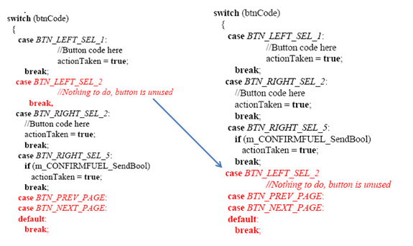

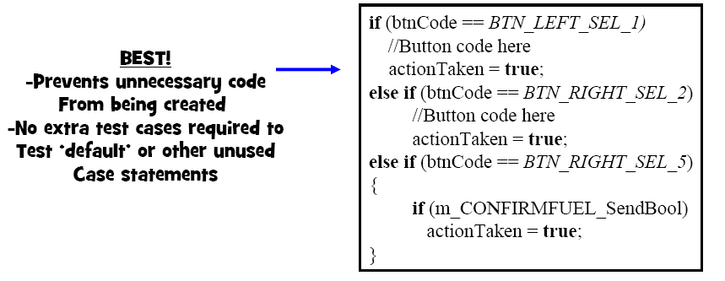

1. Use of multiple “returns” is bad coding practice. The code can be modified as shown in example

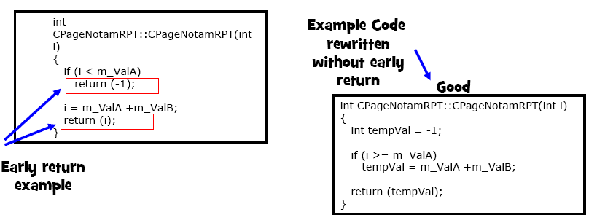

Note: It will give better chances of coverage in SCA

1. Implementation of same code multiple times should be avoided
   * Commonly on page code there are feature that should be put in a common method.
   * Result in verification needing redundantly test the same feature multiple times to gain coverage.

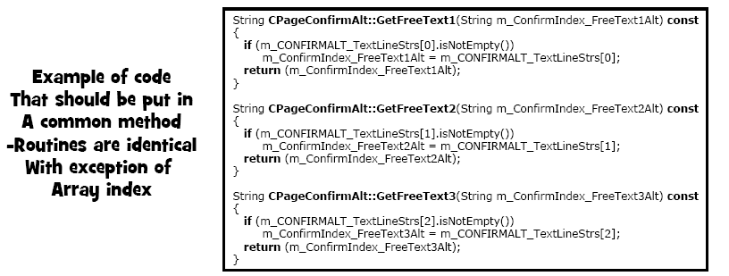

1. Avoid declaring class method that are never used.

Reusing code can often result in method existing that are never called. Check through entire workspace to see if a method is called, if not, remove it. It is unused code. If not removed justification must be added for why it is kept.

Note: Code may be commented out using “if def” method if unsued but kept for the reason like growth.

1. Use ASSERT , it helps to identify when your code has gone away.
2. Avoid using C-style cast for non-simple data type, since it will not check for the validity. Let the compiler do some work for you. Compiler is our friend, use it wisely.

For example,

We have

WDI_CpdlcConfirmPreferredAltInterface* respInterface = (WDI_CpdlcConfirmPreferredAltInterface*) m_pMsgHnd->GetHighestRespInterface();

It should be

WDI_CpdlcConfirmPreferredAltInterface* respInterface = **static_cast**<WDI_CpdlcConfirmPreferredAltInterface*> (m_pMsgHnd->GetHighestRespInterface());

1. Try to avoid using data directly in the code. Try to declare constants and then use it.

It will help be better traceability to requirements and also helps in understanding by someone else.

Example:

setMaxline(10);

in place of it should be

const int32_t kMaxLine =10;

setMaxline(kMaxLine);

1. Buffer should be at every place where it is going to be refilled. It will help to minize the bug created by junk data. Memset could be used to clear the buffer.
2. CopyString method defined in stringUtil should not be used, in place of it strncpy and CopyN can be used.

String::CopyString is often used in the following scenario:   
  
extern String sourceString;   
char destString[255];   
String stringUtil;   
stringUtil.CopyString( &destString[0], sourceString.Text(),sourceString.Length());   
  
Where String::CopyString is being used to copy from one string into another, and neither are the String from which CopyString was called. In this case strncpy would be equivalent, and would not allocate a default sized String (~32 bytes) onto the heap, causing fragmentation when it is deallocated shortly thereafter.   
  
extern String sourceString;   
char destString[255];   
strncpy( &destString[0],  sourceString.Text(), ( sourceString.Length() < **sizeof**(destString) ) ? sourceString.Length() : **(**  **sizeof**(destString) - 1 ) )   
destString[( sourceString.Length() < **sizeof**(destString) ) ? sourceString.Length() : **(**  **sizeof**(destString) - 1 )] = '\0';   
  
In case of copying from a string into a String, there is a String::CopyN method that is available for that operation.   
For example:   
  
char sourceString[] = "Source Text";   
String destString;   
destString.CopyN(  sourceString, strlen( sourceString ) );

# How To use DOORS

The DOORS Documentation Method for the System Architectures Department RCPN 945-9527-001[[1]] documents in detail how DOORS is to be used.

## Write Requirements in DOORS

The following is how the DLCA team is to edit any SRS module in DOORS. Instructions specific to DOORS L3 - REQ - SRS for FANS ATN HMI are found here.

There are 2 Categories to the type of requirement writing you will do:

**Category A**

* Creation/modification of requirements that result in a review of the entire SRS or an entire Section(s) of the SRS

**Category B**

* Creation/modification to a previously reviewed/baselined SRS that does not results in re-review of the entire SRS or Section(s) of an SRS

When making a change to the SRS, follow the guidelines below:

* Write a Change Request (CR) in ClearQuest Fusion database. One the CR has approved and is in the “Assigned” state, you may start you work. This step will be done even if you are creating a document from scratch and is original development.
* Write your requirement in the active voice using a “shall”. Only one “shall” will be used per requirment. If a requirement contains multiple conditions, list them with bullets in the same requirement. For example, “The SEND prompt shall be displayed when all of the following conditions are met: a)Application is In Comm b) FLT ID field contains a value c) DEST STA field contains a value”

Depending on if your change is a Category A or Category B change, your changes will either be made to the main line directly or to the Proposed Change column.

For changes made to the _Proposed Change column, prefix the changes with the CR number followed by a colon, ie. “FUSNxxxxxxxx:”

* Tip
  1. Review Section 16.5 Writing Good Requirements, you have not already. Do this prior to writing requirements for the first time.
* If you have written a requirement with a “shall”, set the _Req attribute = True. If you have written a recommendation , note, or diagram you will set the _Req attribute = False.
* Complete the “_CR number” column for all edits, even ones that are just an attribute change
* Do not fill out the _Safety attribute. This is to be filled out by your safety engineer. All derived requirements will be reviewed by Safety at which time they will decide what the attribute is set too. Your team lead will coordinate an overall document review of derived requirements by the safety engineer.
* Deleting Requirements
  1. Type CR number as FUSNxxxxxxxx:[DELETE] in _Proposed Change for all requirement you wish to delete.
* Adding/Modifying Requirements
  1. Object Text – if you are a Category B change you will type “New Requirement” in this field. For Category A changes you will directly add the text to this column
  2. Fill out all of the following attributes or review them to ensure they are correct. If you are changing an attribute and your change is a Category B change you must document this in the _Proposed Change column
     1. _Verification – Select how this requirement will be verified. This is your best guess. The verification team will review this attribute and may change it later if it is decided that the method selected is invalid.
     2. _Derived
        1. If you select “No”; you must link this requirement to a higher level requirement. This may be an SRD or industry requirement or both.
        2. If you select “Yes”; you must fill out the “_Assumptions/Rationale” field with a reason that it is derived. This might be “Derived by design” or another valid reason.
     3. _BaselineDelivered – List the build you believe this will be implemented in. If unsure, ask your P/E or lead architect.
     4. ~Network Type – Mark if the requirement is for “ATN”, “FANS” , or if applicable to both, select both boxes. This attribute is to be completed for requirements (_Req=True), non-requirements (_Req=False) and labels/headings (_Req=blank). If unsure, ask your P/E or lead architect.
     5. _Deviation – Mark this “yes” or “no”. It will always be “no” unless you are deviating from a higher level requirement. If you mark it “yes”, you need to add a reason why to the _Comments column.

## DOORS _Proposed change column usage

- If the requirement has not been baselined and delivered to verification, updates can be made directly to the Object Text column. The CR must be listed in the _CR Number attribute.

- If the requirement has been baselined, changes must be made in the proposed change column.

For the addition of a requirement use the following format

Mainline: NEW OBJECT

Proposed Change:

FUSN00055897:The DLCA shall operate …

i.e. CR number followed by a “:” following by the text with no space.

To delete a requirement

FUSN00055897:[DELETE]

To modify an attribute

FUSN00055897:[Set _Safety to TRUE]

Reference the DOORS process manual noted above for editing DOOR’s tables.

## DL-6500 Deviation

* Place the new requirement text in the Object Text.
* Place the CR number in the _Proposed Change column in the format <CR#>:[NEW].
* All other columns are handled as found in section *Update DOORS L3 - REQ - SRS for FANS ATN HMI*, below.

## Update DOORS L3 - REQ - SRS for FANS ATN HMI

Procedure to update the Requirements in the DOORS SRS Module (L3 - REQ - SRS for FANS ATN HMI)

1. VAPS –Picture’s created and placed in below path:

Repository [trunk\Tools\DLCA_Tools\A661_Support\M145_Vaps\Requirements Screenshots]

1. Once the above screen shots are reviewed and approved the picture will go through the below process:
2. One power point slide page for each VAPS page with annotations will to be created. ATN and FANS versions of a page can be in the same PowerPoint. Make sure the annotations are matching with the existing CSeries annotation which helps the requirement normalization.. Refer to Figure 1 Requirements Example for a sample:

trunk\Tools\DLCA_Tools\A661_Support\M145_Vaps\Requirements Screenshots \Annotations.

1. Open DOORS L3 - REQ - SRS for FANS ATN HMI module and select the view as “**Developer View**”
2. Once the annotation is created in Power Point, the slide needs to be copied (Ctrl+A , Ctrl+ C) then pasted into the Paint application (AllPrograms🡪Accessories🡪Paint) and cropped to the size of data and pasted in to the DOORS module in ‘_Proposed Change’ attribute as shown below:

Figure 1 Requirements Example

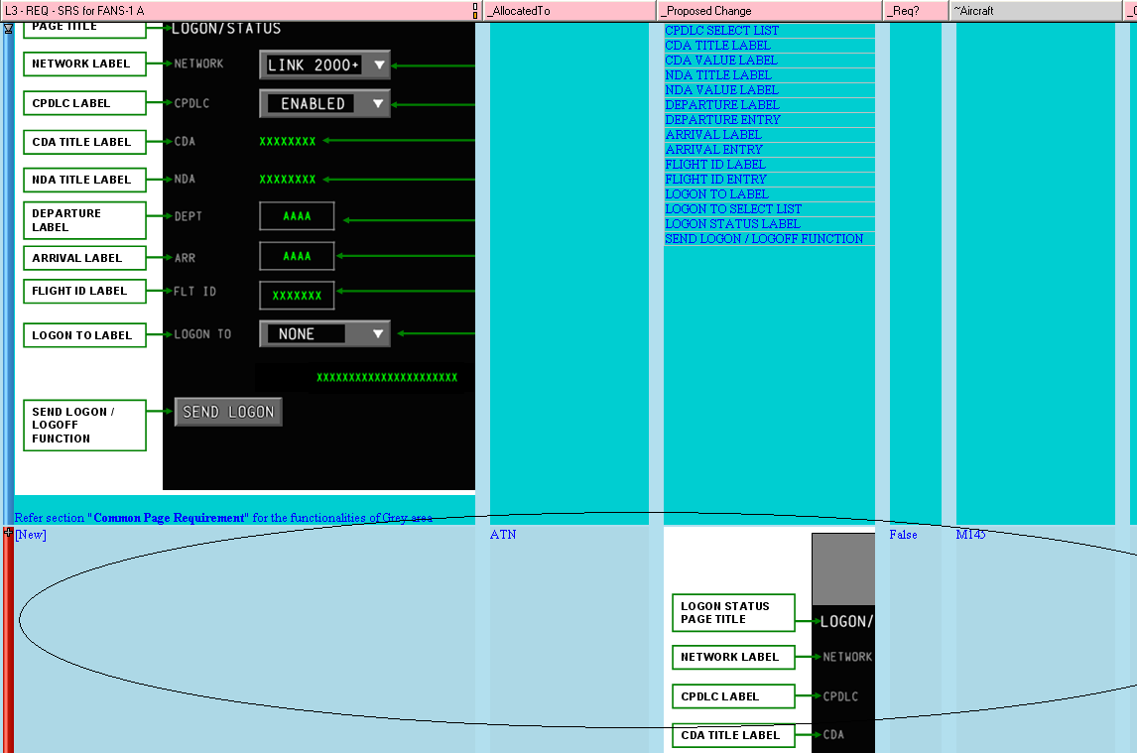

1. Once the picture has been added, make sure that the picture title matches the CSeries associated picture title. This allows us to reuse requirements related to the figure. The figure will have aircraft attributes assigned which clarifies the figure to be used for particular aircraft.
2. Procedure for updating the attributes :
3. **_Proposed Change:** This is the attribute is where all the requirement changes need to be updated. If Tables were in the requirement, create a new object and then the new table can be directly updated to Object Text Field and then add a note “_Propose change” attribute that this is a new or updated table.
4. **_AllocatedTo :** This attribute needs to be filled for all OID’s where _Req? is True. Refer to the Word SDD for an architecture diagram and descriptions related to each allocation choice. Select all items that apply within the following guidelines: 1) select allocations that we expect to have SDD links to this requirement, 2) In general, select the entry point into the code. Do not select each component that the entry point calls – unless that software calls a helper function that does not have requirements written directly for the helper function such as the agent/interface files in Message Manager. (Example: “FANS HMI”, “ATN HMI”, and “Common HMI”)
5. **~Aircraft:** Mark all M145 related OID’s with ‘M145 ½ page’ including section heading and commentary.
6. **_Req?:** This has to be filled **TRUE** for requirement’s and if it is marked as TRUE then make sure it contains a “**Shall**” in the requirement statement . Make sure all non-requirements are marked with **False**.
7. **~Derived:** This will be marked as ‘**Yes**’ if ‘_Req? is marked as TRUE and a link is not expected to the L2 SRD document. It should be marked as ‘**No**’ if a link exists or is expected to exist to the L2 SRD. If there is confusion about whether a link is expected to exist, please coordinate with Subsystem Engineering Team (including either Laurel Cantaberry, Justin Hahn, and Jon Knapp).
8. **_Assumptions/Rationale:** IF ‘~Derived’ is marked as ‘Yes’ then this attribute needs to be filled with the appropriate comment of why it is derived. An example of an appropriate comment may be “This requirement was written to ensure the HMI allows all DO-258A messages to be generated”.
9. **~Deviation:** If there is a link to high level module and this requirement is not in sync with the high level requirement then this attribute needs to be marked as “**Yes**” and“_Assumptions/Rationale:”attribute should be filled with the appropriate comment of why it deviated from the high level requirement.
10. **_Verification:** This should be marked with appropriate verification method if ‘Req?’ is marked as ‘True’.
11. **~Baseline Delivered:** If this attribute is marked with a baseline number for a requirement and if the same OID needs modification then it’s necessary to create a CR to modify the same OID. Do not change the baseline delivered attribute if it has been delivered (If there is Number in this attribute indicates that it’s delivered) to verification. If it was 1.3.0 and it is being updated for 1.5.0, this attribute will remain 1.3.0. The CR will identify that a change has been made.
12. **_CR number:** When the requirement has been delivered to verification previously then a CR is used to indicate the changes.
13. **~Widget Mapping:** This attribute needs to update during the “Design/Coding “ stage.
14. **_Safety:** This attribute will be updated by a Safety Engineer. This attribute is set to “TRUE” when the object links to an L2 SRD requirement marked “_Safety” = “TRUE”. Otherwise, “_Safety” will be set to “FALSE”.
15. **_Link_<XXX>:** This attribute is used to hold the outbound tracability from the module to its parent module. The absolute number of the object is used, without the prefix. For example if the parent module OID is HLSRS5129, the absolute number to be placed in the _Link column is 5129.

**“Our main goal is to reuse as many requirement’s as possible, we have to look for opportunities to write requirement’s that can be reused.”**

## Writing Good Requirements

1. One “shall” per requirement
2. Spell and grammar check your work.
3. Make requirements “testable”

* When writing a requirement you should always have an idea how to test it, if not you need to think of one.
* This may require creating a tool or adding debug logic

1. Never use ambiguous terminology

Example: The DLCA shall support multiple Displays.

Issue: How many is “multiple” and what Display?

Revised: The DLCA shall support up to 3 AFDs.

1. Never write a “negative” requirement

Example: If broadcast data is available for flight id, the application shall not allow manual data entry of FLIGHT ID.

Issue: Difficult to test a “negative”. Always write in the positive if possible

Revised: (Create 2 requirements)

The application shall preclude the user from entering manual data for the FLIGHT

ID when broadcast data is being received that prefills that field.

1. Define terminology

Example: The MSG LOG shall display up to 128 displayable messages.

Issue: How does the tester know what is “displayable”?

Revised: Same requirement, with text added to the Definitions section of the SRS

Displayable Messages shall be defined as a message marked with an “X” in Table- CPDLC Message Set

1. Add “Notes” when necessary to clarify a requirement.

Example: The Select List PROC TYPE shall allow the selection of one of the below options:

* NONE
* ARRIVAL
* APPROACH
* DEPARTURE

*Note: See details in section Select List for further information.*

1. Avoid using words like “always”, “never”, “rarely”, “hardly”, “frequently” or “all”. They are confusing for verification to prove that condition.
2. Color/Font

Never call out a specific font/color for pages. This should be covered by palette

Requirement. Often customer want different color schemes so requirements should call out field types that can be cross referenced to color/font palettes.

1. Figures & Section numbers
   * DOORS does not effectively support numbering. When creating figures/tables title them “Figure – CPDLC Connection” instead of “Figure 5.2.3”.
   * The numbers in figures/tables are unmaintainable.
   * In requirements, do not refer to Section numbers, refer to the title of the section instead. This way if a section is later removed and the numbering changes the reference is still correct
   * Do not refer to “the following table” call out the exact table name in the requirement. Locations of tables may move causing confusion.
2. Data Entry Ranges

When defining the ranges for entry and display format of data items, give examples with minimum, middle and maximum value for each supported units.

Example:

|  |  |  |  |  |
| --- | --- | --- | --- | --- |
| **Units** | **Prefix** | **Numeric Range** | **Example entries** | **Displayed As** |
| Feet (default) | <none> | 0 - 25000 | 0  12000  25000 | 0  12000  25000 |
| Flight Level | FL | 30 - 600 | FL30  FL300  FL600 | FL30  FL300  FL600 |

## Requirement Linking

Requirements are developed at different levels and at different times through the development of a product. For DLCA, the industry defined requirements along with program defined requirements are decomposed into High Level requirements. The High Level Requirements are decomposed into Low Level Requirements. The Low Level Requirements are traced to the code via the DOORS SDD proxy module.

The linking of requirements provides a clear path from where the requirements originated from, what the requirements have been decomposed into, and to where the requirements have been implemented. In addition, DO-178B **requires** linking from the High Level Requirements (HLR) to the Low Level Requirements (LLR) to the code.

Linking guidelines:

1. All requirements must be linked.
2. Always consider if the link is valid and complete.

### Linking from LLR to the HLR

Always link from the lower level requirement/code to the higher level requirement. These are called ‘out-link’s’.

Perform the following steps to link to HLR’s:

1. Open the lower level DOORS module for editing and Lock that section. Note: The HLR DOORS module does not need to be opened for editing.
2. Right click on the OID that needs to be linked to the higher level document and select ‘Link -> Start Link’.
3. Find the OID in the higher level document that the lower level document should link to and then right click on that OID and select ‘Link -> Make Link from Start’. This will create the link.
4. If an OID is in a pink-orange color and no linking needs to be done, select ‘Link -> Clear Start’ to un-highlight this OID.
5. When the linking is completed, save the document and set the Edit Mode to Read-Only.

### Linking from Code to LLR

The code is linked to the LLR’s via the DOORS SDD Proxy module. The DOORS SDD Proxy module contains all the .h files in a folder structure that represents the actual code folder structure. In general, the link from the LLR requirement to the DOORS SDD module should be to the entry point into the code only. For example, when selecting SEND, link to the code the starts the send process only. Do not link to all the other files that are involved with the send such as the message manager, codec, downlink queue’s etc.

Perform the following steps to link to HLR’s:

1. Open the DOORS SDD module for editing and Lock that section. Note: The LLR DOORS module does not need to be opened for editing.
2. Right click on the OID that needs to be linked to the higher level document and select ‘Link -> Start Link’.
3. Find the OID in the higher level document that the lower level document should link to and then right click on that OID and select ‘Link -> Make Link from Start’. This will create the link.
4. If an OID is in a pink-orange color and no linking needs to be done, select ‘Link -> Clear Start’ to un-highlight this OID.

When the linking is completed, save the document and set the Edit Mode to Read-Only.

# Software Code Information

## Comment Header Files

Function Comments:

/**

* Handles the events from EditBoxMasked

*

* This is a callback function that handles incoming widget events

* from AGS. This function gets called during a CDSConnections recvieve

* function.

*

* @param[in] widget The widget that caught the event

* @param[in] str The string that was entered in to the widget

* @param[in/out] outputText The hold input params and output buffer to store the results

* @return The number of lines in the output buffer

*/

**int** **func**(**const** Widget* widget, **const** **char**\* str, char* outputText);

/// This function does one time page operations on page entry

**void active();**

/// This function gets the current page

/// @return The current page

**int getCurrentPage();**

All functions have a short description line. If more detailed it needed a long description can follow after the short description. A empty line should separate the two descriptions.

Parameters and returns should follow the description[s]. Returns should always be last.

Member Comments:

/// Holds the current network type (FANS/ATN)

int32_t m_NetworkType;

Layer* m_pLayer; /// Current layer object for this page

All member variables need a description. The description can be above the member variable

or if the description is relatively short it can be beside the member variable.

Comment Example:

/////////////////////////////////////////////////////////////////////////////

// © Copyright 2011-2012 Rockwell Collins, All Rights Reserved

// Rockwell Collins Proprietary Information

/////////////////////////////////////////////////////////////////////////////

/**

* @file A661Page.h

* This is the base class for all HMI Pages.

*

* This class is the base class for all pages. It contains common

* functions and variables that all pages are required to have for the A661

* framework to work. A layer will activate a page and call its run function

* every cycle while the page is activated. Before a page is ran the layer

* will send itself to the page so that page can use the correct layer to

* update A661 widgets.

*/

**#ifndef** A661PAGE_H_

**#define** A661PAGE_H_

/// Forward declaration of classes

**class** CdsConnectionManager;

**class** Layer;

**class** A661Page

{

**public**:

//lint -e{1540} This destructor is not called. Suppress not freeing member

//variables

**virtual** **~A661Page**(){};

/// This function gets called once a cycle when the page is active.

**virtual** **void** **run**()

{

DLCA_DEBUG("[ERROR]display function is not overridden", "");

}

/// This function gets called when all widget parameters for

/// this page need to be sent to the CDS

**virtual** **void** **sendAll**() = 0;

/**

* This function gets called when the page is activated (aka entered).

*

* This function is called before the run function is called.

* The primary use of this function is to register page callbacks with a

* widget event handler.

* Other one time page setup is also done in this function.

*/

**virtual** **void** **activate**() = 0;

/// This function gets once when the page is deactivated.

**virtual** **void** **deactivate**() = 0;

/// This function gets call by the Layer to set this page's layer.

/// @param[in] layer The layer this page should use to interact with widgets.

**void** **setLayer**(Layer* layer);

/// This function returns this page's page id

/// @return This page's page id

**virtual** **const** **char**\* **getPageId**() **const**;

/// This function returns this page's widgetId

/// @return This page's widget id

**int** **getPageWidgetId**() **const**;

**protected**:

/// Hidden Constructor

//lint -e{1401} This constructor is not called. Suppress not initializing member

//variables

**A661Page**(){};

/// Hidden copy constructor

//lint -e{1704} Copy Constructor is hidden

**A661Page**(**const** A661Page&);

/// Hidden assignment operator

//lint -e{1704} Assignment operator is hidden

**const** A661Page& **operator=**(**const** A661Page&);

/// The current layer that this page should use.

Layer* m_pLayer;

/// Holds the pages ID

**const** **char**\* m_PageId;

/// Holds the widget name of the page container maybe set to -1 of N/A

**const** **char**\* m_PageCntWidgetName;

/// This function gets called when the page's layer is set.

/// The purpose of this function is to let the page set all the

/// widgets for the newly set layer.

**virtual** **void** **setWidgets**()

{

DLCA_DEBUG("[ERROR]setWidgets function is not overridden", "");

};

};

/// Typedef for pointer to A661Page

**typedef** A661Page* PtrA661Page;

**#endif** /* A661PAGE_H_ */

## Completing a Change Request for a Software Build

For each software build, developers will be assigned CR’s to complete. In the early stages of development, a single CR may be assigned for the entire build. The following process should be followed to complete the CR.

1. Write SRS requirements relating to the change(s) you are implementing. Document the CR in the SRS with the changes (See Section 20.4 for the process to follow to write requirements)
2. Link your SRS requirements to the SRD or an industry spec. If there is not a suitable link, the requirement is derived and should be marked so in DOORS.
3. Complete your design related to your change. Update the SDD with any diagrams that you have made. If you have determined that new classes are needed. Add these to the SDD. Link the class name to all applicable requirements including the new/modified ones that you did as part of the CR.
4. Create a Peer Review for all impacted artifacts.
5. Implement your code
6. Compile it for Target and Host builds
7. Run PC Lint on your code or Coverity
8. Ad-hoc test the software on the host and target
9. Peer review your code
10. Once all peer reviews have been Closed. Add required information to your CR and move the CR to “ImplementationComplete”.
11. Let your BuildMaster know that your CR is ready for merging/integration
12. Get another CR to work on.

## Delivery of Requirements

If you have created/modified requirements that have been delivered to Verification, any changes to those requirements following the delivery will result in a new CR. The findings on a requirements peer review that are created after the requirements are delivered to Verification can be closed with the new CR number. All findings should be documented and addressed in the new CR to ensure they are captured.

## Lint Guidelines

### Installation

At current time, PC Lint version 9.00 is being used. A copy can be obtained from the software center. A direct link can be found below: [**http://rwebapps.rockwellcollins.com/SoftwareCenterIntl/Software.aspx?ID=9370**](http://rwebapps.rockwellcollins.com/SoftwareCenterIntl/Software.aspx?ID=9370)

Follow the default installation instructions and allow the default settings.

### Using Lint on the Code

PC-Lint reads the DLCA.lnt lint configuration file. The configuration file is under version control (<http://asvn/dlnk-dlca/trunk/Reference/pclint/dlca.lnt>). The configuration file contains specifications specific to DLCA which includes, but not limited to, suppression of unnecessary messages.

The Lint output file (*.ln) can be found in the same directory as the associated source file.

The DLCA 6500 has PC Lint integrated in to its makefiles. A developer can create .ln files which is the lint output for the corresponding cpp file. All files are linted as if being compiled for the target hardware. So flags and defines are defined just like building for the target.

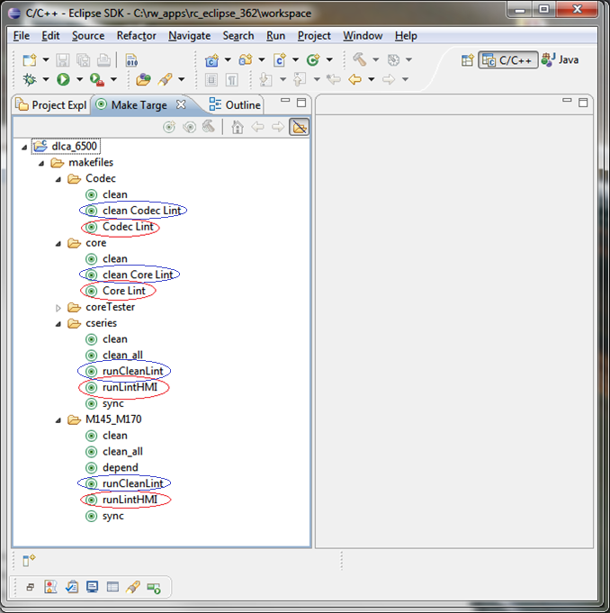

Clicking the “runLintHMI” target in the “Make Targets” view will create .ln files for all cpp’s in for the appropriate HMI. It will not make .ln files for any Core cpp files.

Running “Core Lint” and “Codec Lint” in the “Make Targets” view will create .ln files for all .cpp’s in the respective library.

Clicking the “runLintHMI,” “clean Core Lint,” and “clean Codec Lint” target in the “Make Targets” view will delete all .ln files for respective sub-project.

If you want to see the lint infos, warnings, and errors in the eclipse IDE you must delete the .ln file for the file(s) you want to see the lint results for. The .ln files will be in the “LintResults” folder . Then under the hammer select “Lint Core” and click the hammer.

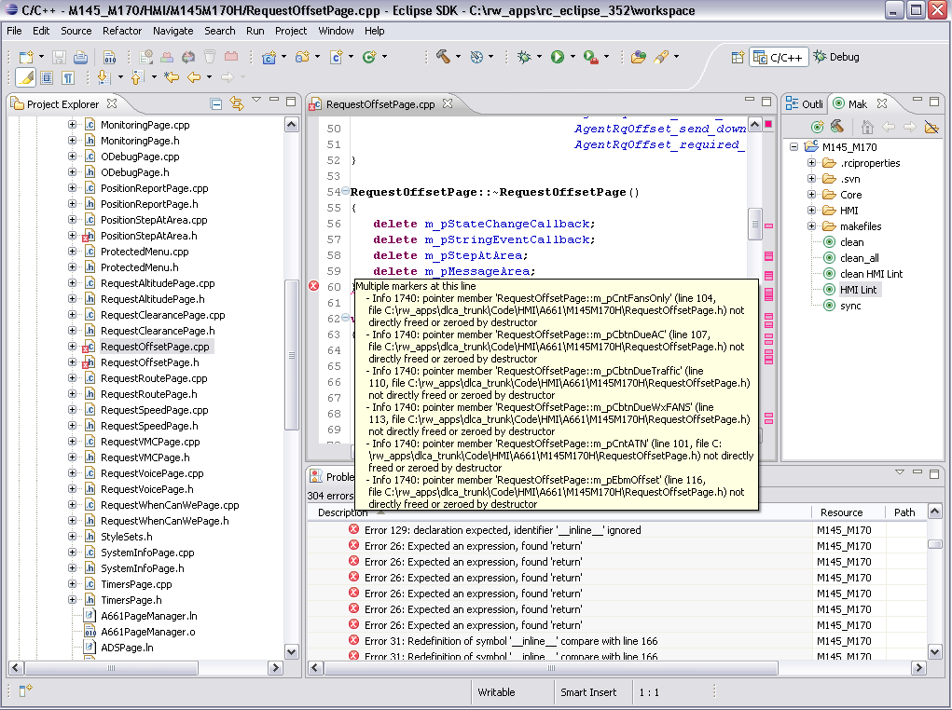

### When to Run Lint

Lint will need to be run on the following conditions:

1. If a change is made to a source file, Lint needs to be ran and any corrections need to be resolved before committing the files back to the repository
2. Any new source files that are ready for peer reviews. All warnings and Error messages need to be addressed before starting the peer review.
3. The Info messages need to be looked at. There may or may not be changes needed. The developer needs to analyze these messages.
4. If a Warning was analyzed, and was determined that no changes are required, the message needs to be suppressed. Directions can be found in the next section

### Suppressing Lint Errors/Warnings/Infos

Some Lint errors/warnings can be suppressed if it is either incorrectly reported or unavoidable.

#### Lint Suppression Examples

| **Number** | **Message Type** | **Lint Message** | **Valid Suppression Reason** |
| --- | --- | --- | --- |
| **429** | C Warning | Custodial pointer 'Symbol' (Location) has not been freed or returned | Pointer is stored and deleted later |
| **545** | C Warning | Suspicious use of & | Pointer to array is used |
| **593** | C Warning | Custodial pointer ’Symbol’ (Location) possibly not freed or returned | Pointer is stored and deleted later |
| **1502** | C++ Warning | defined object 'Symbol' of type Name has no non-static data members | Some singleton classes |
| **1539** | C++ Warning | member 'Symbol' (Location) not assigned by assignment operator | Not all members necessarily need to be initialized in a copy constructor. |
| **1540** | C++ Warning | pointer member 'Symbol' (Location) neither freed nor zero'ed by destructor | Members that are handled in another function can be suppressed |
| **1541** | C++ Warning | member 'Symbol' (Location) possibly not initialized by constructor | Members that are handled in another function can be suppressed |
| **1542** | C++ Warning | member 'Symbol' (Location) possibly not initialized | Members that are handled in another function can be suppressed |
| **1543** | C++ Warning | member 'Symbol' (Location) possibly not initialized | Members that are handled in another function can be suppressed |
| **1554** | C++ Warning | Direct pointer copy of member 'Symbol' within copy constructor: 'Symbol' | This is sometimes by design, and should be noted as such |
| **1555** | C++ Warning | Direct pointer copy of member 'Symbol' within copy assignment operator: 'Symbol' | This is sometimes by design, and should be noted as such |
| **1566** | C++ Warning | member ’Symbol’ (Location) might have been initialized by a separate function but no ’­sem(Name,initializer)’ was seen | Members that are handled in another function can be suppressed |
| **1579** | C++ Warning | Pointer member ’Symbol’ (Location) might have been freed by a separate function but no ’­sem(Name,cleanup)’ was seen | Members that are handled in another function can be suppressed |
| **1704** | C++ Info | Constructor 'Symbol' has private access specification | Singleton classes |
| **571** | C Warning | Suspicious Cast | only when casting to a type of a larger size |
| **774** | C Info | Boolean within 'String' always evaluates to [True/False] | ASSERT(false) |

#### Dangerous Lint Suppressions

Some Lint messages are more dangerous, and if issued may indicate a greater problem. Examples of such are included in the table below.

| **Number** | **Message Type** | **Lint Message** | **Reasoning** |
| --- | --- | --- | --- |
| **705** | C Info | Argument no. Integer nominally inconsistent with format | Inconsistent formats can cause buffer overflows and/or segmentation faults |
| **706** | C Info | (argument no. Integer) indirect object inconsistent with format | Inconsistent formats can cause buffer overflows and/or segmentation faults |
| **1412** | C++ Warning | Reference member 'Symbol' is not initialized -- A class member typed reference to class (or struct or union) is mentioned in a constructor initializer list. But the class (or struct or union) referenced has no constructor and so is never initialized. | This is a violation of the Datalink Coding Standard |
| **1506** | C++ Warning | Call to virtual function 'Symbol' within a constructor or destructor ­­ A call to a virtual function was found in a constructor or a destructor of a class. | This can result in virtual calls to functions before the virtual table has been created. |
| **1529** | C++ Warning | Symbol 'Symbol' not first checking for assignment to this – The assignment operator does not appear to be checking for assignment of the value of a variable to itself (assignment to this). | This is a standard |
| **1536** | C++ Warning | Return reference to private member ‘symbol’ | This is a violation of the Datalink Coding Standard |
| **1773** | C++ Info | Attempt to cast away const (or volatile) | Variables should have been made const on purpose, removing the const can cause inconsistent and/or invalid data |

#### Lint Suppression Methods

| **METHOD** | **EXPLANATION** | **EXAMPLE** | **REMARKS** |
| --- | --- | --- | --- |
| **-e#**  **+e#** | This method is use to **suppress** a particular lint issue within the scope of a **group of statements.** | //lint -e1704  BopMessageManager(const BopMessageManager& orig);  //lint +e1704 |  |
| **-e(*#*[,*#*]...)** | This will **inhibit** message number(s) *#* for the **next expression.** | a = /*lint -e(413) */ *(char *)0; |  |
| **--e(*#*[,*#*]...)** | This will **inhibit** message number(s) *#* for the **entire expression** before or within which it is placed. | a = /*lint --e(413) */ *(int *)0 + *(char *)0; | The scope of ­e(#) is just till the next expression whereas scope of --e(#) is for the entire statement |
| **-e{#[,#]…}** | **-e{ #[,#]…}** will **inhibit** message number(s) # for the next **braced region**. | static void f(int n, uint u)  {  //lint -e{732} suppresses "loss of sign"  if( n )  {  //lint --e{713} suppress "loss of precision"  n = u; // 713 not issued  u = n; // 732 not issued  }  } | The -e{528} suppresses the Warning 528 issued at module wrap-up, without affecting other modules. The ­­e{732} suppresses the 732 issued within the function without affecting other functions. The --e{713} suppresses the loss of precision message within its compound statement. |
| **--e{#[,#]…}** | **--e{ #[,#]… }** will **inhibit** message number(s) # for the **entire braced region** in which it is placed. |
| **!e*#*** | It serves to **suppress** the given message for **one line** only. | if( x = f(34) ) //lint !e720  y = y / x; | The difference between ­­e(*#*[,*#*]...) and !e# is for using !e# the line need not be an expression ended with semicolon whereas for ­e(#[,#]…) the statement should be an expression ending with a semicolon. |
| **­emacro(*#,symbol,..*.)**  **+emacro(*#,symbol,*...)** | This works **same as –e#, +e#**. A particular macro issue could be suppressed using this syntax by mentioning the issue number and macro for which the issue is to be suppressed. | //lint -emacro(778,TROUBLE) |  |
| **­emacro((*#*),*symbol*,...)** | **inhibits**, for a **macro expression**, |  | This works exactly like -e{#[,#]…} |
| **­­emacro((*#*),*symbol*,...)** | **inhibits,** for the **entire expression**, | This works exactly like -e{#[,#]…} and ­­e{#[,#]…} suppression methods |
| **­esym(*#, Symbol* [,*Symbol*]...)**  **+esym( *#, Symbol* [,*Symbol*]...)** | Respectively inhibits and re-enables error message *#* for the indicated symbols. | //lint -esym(613,dialogueEntry)  if ( dialogueEntry->GetConnectionIdentifier() == connectionId )  {  if ( !dialogueEntry->GetTerminate() )  {  dialogue = dialogueEntry;  break;  }  }  // Uses of dialogueEntry will not produce error | *Note:* -esym covers the whole scope of symbol within the function. Therefore there is no need to restore warning after the function ends. |
| **-save**  **-restore** | -save saves the current state of all error inhibition settings. This state then can be restored with a ­restore option. The -save option makes sense only within a /*lint comment. It can be used in a recursive option inhibition setting. | #define alpha \  /*lint -save -e621 */  *something* \  /*lint -restore */ |  |

Note: You need to use the following syntax //lint -e(XYX) not const safe (Or any message). Please specify a message.

To obtain a full list of lint option, simply run the executable (see screenshot below)

#### Example

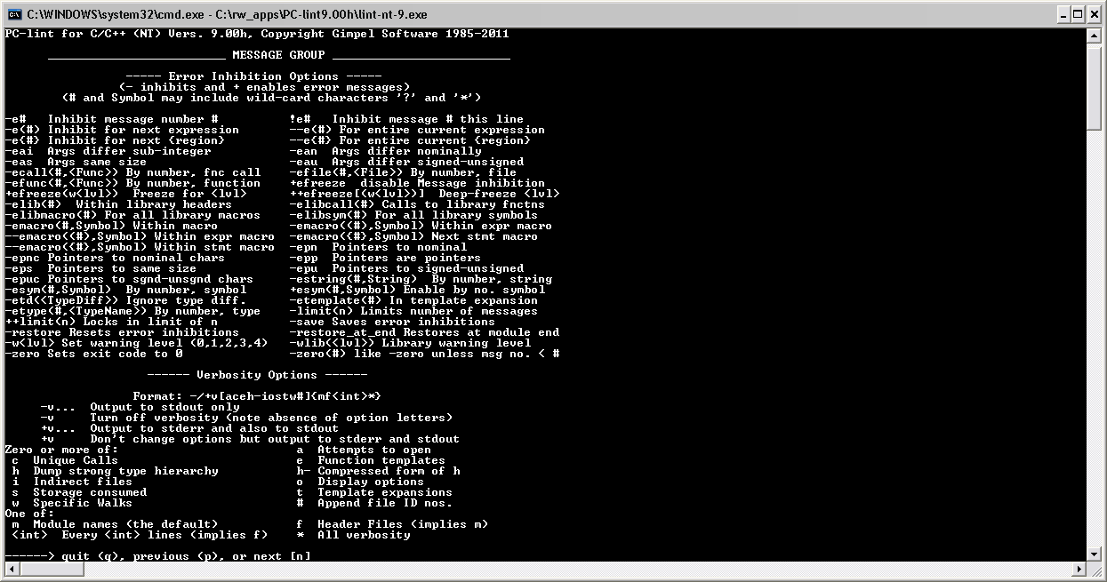

Fixing PC lint issues is explained below with the help of an example.

Example, the warning 534 has the following additional information:

*Ignoring return value of function 'Symbol' (compare with Location) A function that returns a value is called just for side effects as, for example, in a statement by itself or the left-hand side of a comma operator. Try: (void) function(); to call a function and ignore its return value. See also the fvr, fvo and fdr flags in §5.5 "Flag Options*".

To resolve this issue, we can simply change the following line of code from (as suggested above)

(*pPmBopInterface)->SendBopData(pTestApp->m_TestDownlinkBopMsg);

to

(void) (*pPmBopInterface)->SendBopData(pTestApp->m_TestDownlinkBopMsg);

Sometimes, lint will complain about a given issue which is at most times useful, but in some instances the issue is actually intended.

**For example, the following code issues the warning info:**

private:

//Copy Constructor

//This method should not be called

//To prevent calling this, no implementation code.

**BopMessageManager** (**const** BopMessageManager& orig);

Info 1704: Constructor 'BopMessageManager::BopMessageManager(const BopMessageManager &)' has private access specification.

Since this is fully intentional, the warning can be suppressed by using anyone of the following suppression methods:

### Resources

Lint warning message code decoder: <http://asvn/dlnk-dlca/trunk/Reference/pclint/PC-LINT90.chm>

Lint V9.00 Manual: [http://asvn/dlnk-dlca/trunk/Reference/pclint/Lint V9 Manual.pdf](http://asvn/dlnk-dlca/trunk/Reference/pclint/Lint%20V9%20Manual.pdf)

Lint Wiki: <http://epedia/wiki/PC-Lin>

## Coverity Setup

### Obtaining Coverity License

1. Add the following directory to your C: Drive:

C:\rw_apps\Coverity

1. Extract \\ccanet\approot\eti\sys\Coverity\Enterprise-Licenses\Analysis License.zip to C:\rw_apps\Coverity

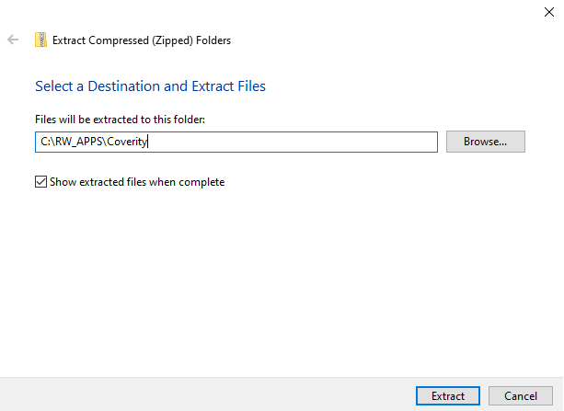

### Installing Coverity

1. Install Coverity:

\\ccanet\approot\eti\sys\Coverity\2022.3.1\cov-analysis-win64-2022.3.1.exe

1. Click “Next >”

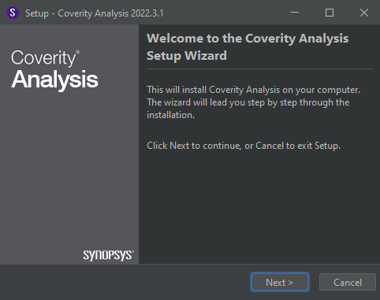

1. Select “Americas, Africa, and Israel”
2. Click “Next >”

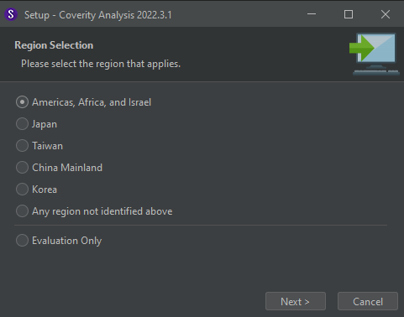

1. Select “I accept the agreement”
2. Click “Next >”

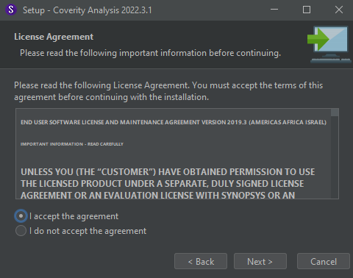

1. Specify install location to:

C:\rw_apps\Coverity

1. Click “Next >”

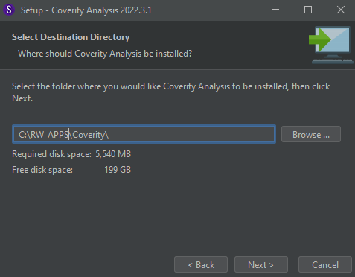

If you receive this popup:

Click “Continue”

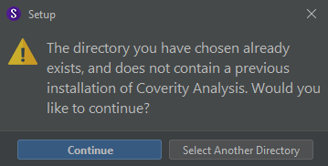

1. Select “English Documentation” Only,
2. Click “Next >”

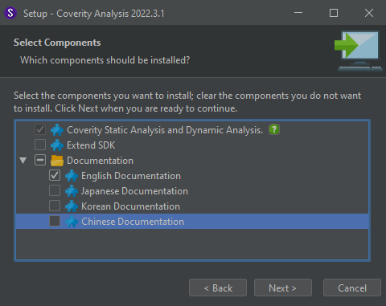

1. Select “Coverity (you have a .dat file)”,
2. Click “Next >”

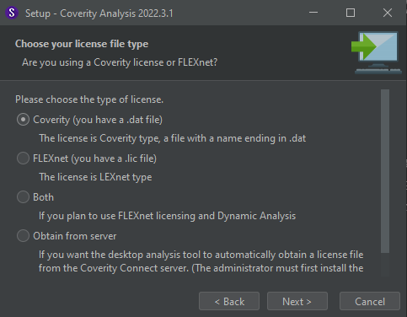

1. Set the location of your Coverity license file to:

C:\RW_APPS\Coverity\license.dat

1. Click “Next >”

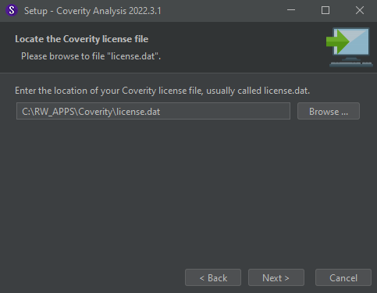

Optional: Create a Start Menu folder,

1. 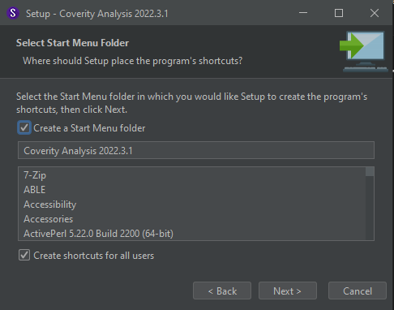Click “Next >”

Optional: Create a desktop icon,

1. Click “Next >”

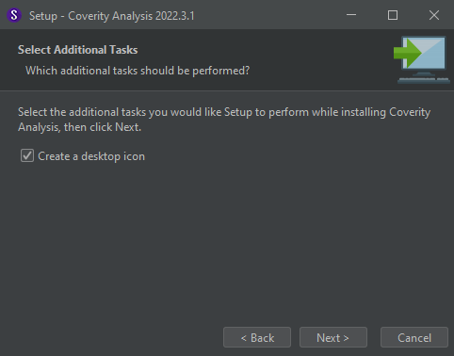

*Coverity should now begin to install, it may take a few minutes*

1. Deselect both options,
2. Click “Finish”

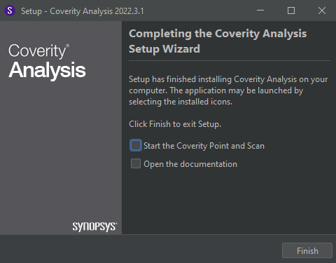

1. Delete the license.dat file from C:\RW_APPS\Coverity (DO NOT DELETE THE license.dat IN C:\RW_APPS\Coverity\bin)

### Configure Coverity Environment

Navigate to the windows search bar and search “Edit the system environment variables.” Click Environment Variables in the bottom right until you reach the screen below.



Select Path in the “System Variables.”

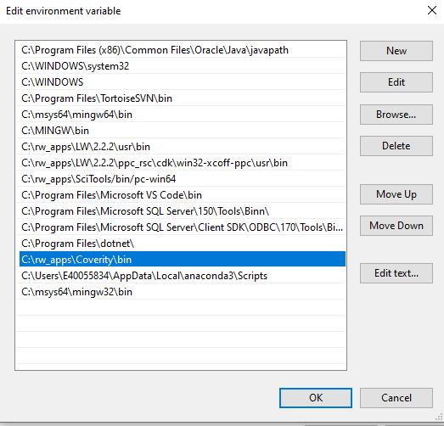

Add C:\RW_APPS\Coverity\bin as a new system variable.

After adding C:\RW_APPS\Coverity\bin to your system variables:

1. Open CMD as an Administrator
2. Navigate to <YOUR DLCA PROJECT>/Code

(e.g. C:\Project_Files\DLCA6510_dev\Code)

1. Run the command:

cov-configure –gcc

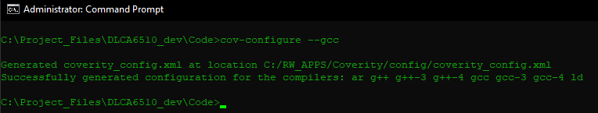

### Running Coverity

* NOTE: Coverity must be installed locally prior to running.

**NOTE: Your project must be able to successfully build or else the Coverity output will not be accurate.

1. Navigate to <YOUR DLCA PROJECT>/Coverity (e.g. C:/Project_Files/DLCA6510_dev/Coverity)
2. Run the batch file “RunCoverity.bat”

Important: All csv files and excel files opened in the Output directory should be closed. Failure to do so may cause the batch script to terminate.

### Getting the Coverity Output

* Coverity output is in the folder <YOUR DLCA PROJECT>/Coverity/Output.
* The Summary.txt file contains a high-level summary of the Functions and Files analyzed, and which errors have been detected.
* Each project file has one CSV output per file regardless of errors found. The File name will correspond to the .cpp or .h file that was analyzed.
* A file that has no found errors will have a CSV output stating that no defects have been found in the given file. For example, the following file has no found defects:

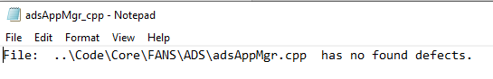

* A file that has associated errors will have a CSV output stating the ID, Checker, File, Line, Function, and Priority for all errors in the given file. For example, the following output has one found error in the ADSPage.cpp file:

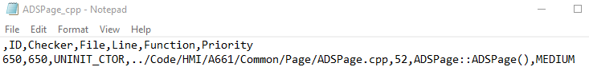

### Understanding the Coverity Output

**Important**: Coverity must be run before every code review. All high priority issues must be resolved!

Coverity will output one CSV file for every .cpp and .h file in the Project. This includes and files that do not have errors / defects associated with them. A File that has no found defects will state the file name and that it contains no found defects. A File that has found defects will have one row per found defect. i.e., a File that has two found defect will have a row for the axis names and two rows outlining the relevant information for the corresponding defects. Each defect will have an index, ID, Checker, File, Line, Function, and Priority. Below are the definitions for each of these columns:

Index – The index will match the ID number of the defect found.

ID - the ID of the defect relative to the entire Coverity scan. This is helpful to match errors with manually run Coverity analyses.

Checker – The checker indicates which test was failed and resulted in the defect. For example, the “UNIT_CTOR” defect / checker finds instances of a non-static data member of a class or struct that is declared with the class or struct, not in a parent class, and not initialized in a path in the constructor. For more information about a checker, refer to the Coverity Checker Documentation (<https://asvn/dlnk-dlca/branches/Coverity/Documentation/cov_checker_ref_M5iXcol.pdf>)

File – This column is the relative path of the file that the defect was found in. These will always start with “.\Code\” followed by the rest of the path.

Line – The line number that contains the defect.

Function – Indicates the function within the file that the defect was found in.

Priority – based on the overall impact of an error / defect, a priority level is assigned to indicate how pertinent fixing the error / defect is. Defects with a priority of “High” should be resolved as soon as possible. If an error / defect is indicating a priority of “Unknown” then this is a previously unencountered error / defect and does not currently have an assigned priority classification.

Coverity will create html files for every cpp and h file in the project that has had an error and will output it in the coverity_hmtl folder. All files that do not have errors will not be displayed in the html output. In the coverity_html folders, the folder titled index.html has all the detected errors in it. Each defect will have an ID, Checker, File, Line, Function, and Classification. Above are the definitions for each of these columns. All of which have been defined above. In the coverity_html folder if clicking the folder titled “1” it will have every single error detected in its own html file. The number is the ID followed by the file name in which the error occurred.

After successful execution of the Coverity batch script, located in the output directory, there will be a folder titled Summary. In that folder there is a file called summary.txt. It simply has the total amount of defects as well as how many defects are of each category. It also includes other miscellaneous information. More importantly in the Summary folder a excel file called Coverity_Analysis.xlsx is created. In the top right it has a summary of the total amount of errors and their classification. Similar to csv and html files, it has a field for the ID, Checker, File, Line, Function, and Priority which is color coded based on importance. Green is for low priority, yellow for medium priority, and red for high priority.

### Manually Build Project with Coverity

**\*NOTE:** This section is for reference only. To run and analyze Coverity, follow section 18.5.4

#### Building win32 with Coverity

1. Run the command:

make -j32 clean_all -C C:\<YOUR_DLCA_PROJECT>\Code\tools\dlca_6500\makefiles\Hmi

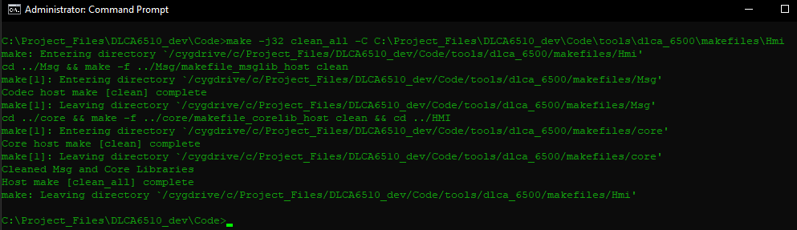

1. Run the command: (This may take a few minutes)

cov-build --dir C:\Coverity\coverity_i_dir make -j32 -C C:\<YOUR_DLCA_PROJECT>\Code\tools\dlca_6500\makefiles\Hmi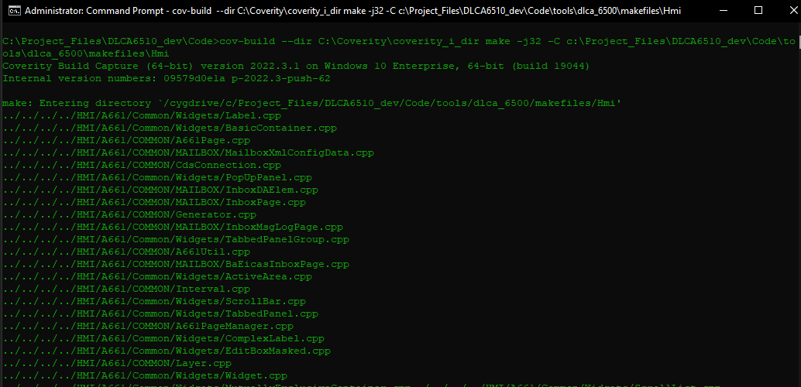

#### Manually Building Target with Coverity

1. Run the LynxOS license manager batch file as administrator
2. Run the command:

make -f target.mk -j32 clean_all -C C:\<YOUR_DLCA_PROJECT>\Code\tools\dlca_6500\makefiles\Hmi

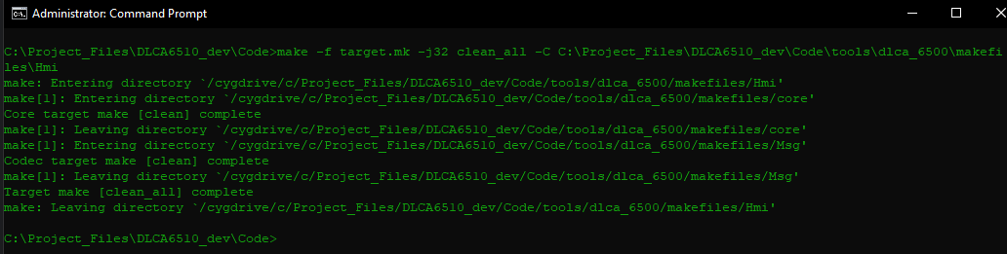

1. Run the Command: (This may take a few minutes)

cov-build --dir C:\Coverity\coverity_i_dir make -f target.mk -j32 -C C:\<YOUR_DLCA_PROJECT>\Code\tools\dlca_6500\makefiles\Hmi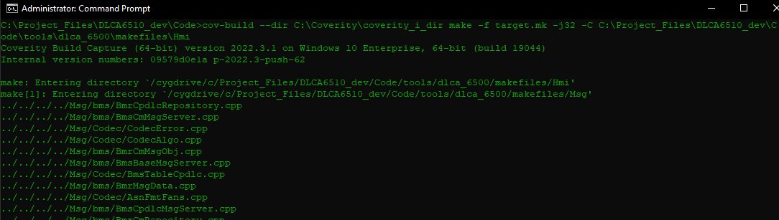

### Manually Analyze the Build

**\*NOTE:** This section is for reference only. To run and analyze Coverity, follow section 18.5.4

1. Run the command:

cov-analyze –-dir “C:\Coverity\coverity_i_dir”

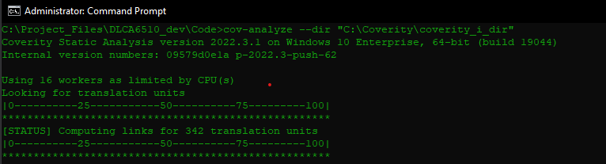

For a more aggressive analysis:

cov-analyze –-dir “C:\Coverity\coverity_i_dir” --all --aggressiveness-level high

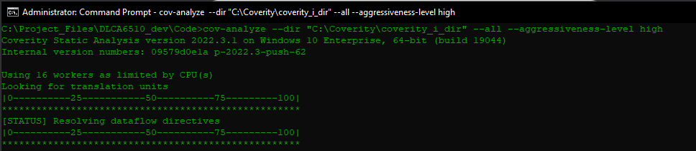

1. Convert the output to HTML using this command:

cov-format-errors –-dir “C:\Coverity\coverity_i_dir” –-html-output “C:\Coverity\coverity_html”

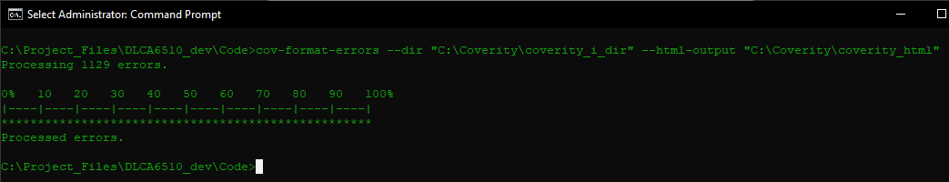

Note: if you receive the output:

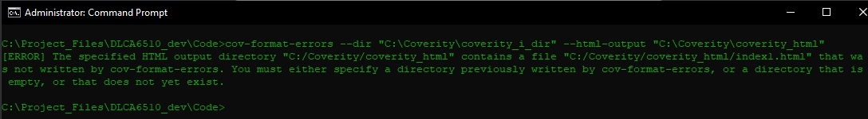

delete the contents of C:\Coverity\coverity_html

# Prep Review Guidance

## Official PREP document.

The document can be located in SVN under dlca\Project Documents\Process Documents. The document name is PeerReviewProcess-945-9104-001.pdf.

## General Guidance

1. DLCA will be conducting special safety reviews for our safety person.
2. Do NOT invite the entire DLCA team to your reviews. Invite your leads, your PE, quality, and then whomever else you think would be helpful on the review.
3. If you select "N/A" or "No" on a checklist, list why you stated this so the reviewer knows why you didn't do this step.
4. Include the CR in the PREP references section.
5. If you have a review that includes requirements and code in one single review, you MUST have a developer participate in the review. For example, if Subsystems participates in the review to check the requirements, you cannot close the review. You need to get a developer to mark time on the review for the code portion.
6. Do NOT select “other" on any peer reviews unless you are not reviewing something that is requirements/design/code.
7. If you review more than one artifact type (requirements, design, code), you MUST fill out a checklist for each type of artifact.
8. If you edit any artifact, you must update the copyright for the new format and for 2013. Be sure to include the previous year and add on 2013.

Example:

© Copyright 2011-2013 Rockwell Collins, All Rights Reserved

1. If the CR is a real CR (i.e. not developmental; it was written against baselined code or SRS), in ClearQuest update the Disposition tab with the template found at W:\ClearQuest\ClearQuest Templates\Impl.txt Note: this template is designed for verification to know what tests to update or re-run. Therefore, the emphasis is on requirements not code files changed.
2. Once the PREP review is sent out, please update the CR in ClearQuest from the Pending state to the Assigned state.
3. Once the PREP findings are closed, move the PREP review to completed and notify Allison Jones to close the PREP review.

### SRS Review

1. Update requirements in the standard format (see previously reviewed sections)
2. Make updates in the _Proposed Change column. Include CR number and “:” if there is a CR number
3. Complete all “_....” attributes
4. Complete linking to higher level documents i.e. L2, L0.
5. Add A661 picture and annotations. Recommend using Power Point. Widgets do not have to be added until the design/code review
6. Include James M. Wolff and Suresh Kannan Sasidharan to ALL requirements reviews, HLR or LLR. Verification must be included in requirements reviews to help reduce the number of CR’s from verification that could have been avoided by early inclusion in reviews.
7. Include Systems on the review. Jon Knapp for M145.
8. Run View filters to help ensure all attributes and links are completed. SDD links are not completed for SRS reviews.

### Design/Code Review

1. Add/update the widget mapping in the SRS for page figures in the ~Widget Mapping attribute column as needed.
2. If the widget mapping has changed, include the specific DOORS SRS OID in the review as an artifact. Be clear in the PREP review description that only the Widget Mapping for the specific OID is under review. Any findings on other items in the SRS are out of scope for this PREP review.
3. The .h file is part of our detailed design required for DO-178B. As a result all classes, member variables, and methods must have quality comments. The inputs and outputs must also be documented. For new files, please use the Doxygen style comments which include using three /’s i.e. /// Comment. The RequestOffsetPage.h is an example of this.

For existing files that were ported from another system such as DLCA-6000 or Link 2000+, there is no requirement to update to Doxygen format the existing format is sufficient.

1. Run pc-lint over all .cpp files and include lint results in the PREP review under references. Selecting "N/A" should never occur. All pc-lint errors and warnings must be resolved.
2. Ensure the names of the .h files for the review are listed in the DOORS SDD proxy file and that the description is accurate. The DOORS SDD proxy is located at /DLCA ATN-FANS/SDD/SDD.
3. Add links from the DOORS SDD proxy to the SRS. Ensure the links are accurate and complete.
4. If a .h file has changed for the review, include the SDD proxy file as an artifact in the PREP review. Be clear in the PREP review description that only the SDD sections related to the .h files in this review are within the scope of this review. Any findings on other items in the SDD proxy file are out of scope for this PREP review.
5. Ensure coding standards are met
6. Compile code for host and target and test code before sending out PREP review.
7. Complete the design and code checklists. If no design updates have been made i.e. no .h files or SDD included in the artifacts, the design checklist can be filled out as “N/A” for all items.

If the CR is a developmental CR, in ClearQuest update the Disposition tab with the following information as appropriate i.e. if it is a design/code review only include the DEFINITION, DEVELOPMENT, and DESIGN sections (do not have to include the SRS section).

DEFINITION - <initials><date>

Description:

<description>

SRS PREP Review #: <PREP#>

---------------------------------------------------------------------

DEVELOPMENT - <initials><date>

Description:

<description>

Code PREP Review #: <PREP#>

---------------------------------------------------------------------

DESIGN - <initials><date>

Description:

<description>

Design PREP Review #: <PREP#>

### Branch Process

1. A branch is generated from the latest trunk version. Each build (1.12C, etc) will be having a separate branch. (Note: The build branch should be performed by the build master. All subsequent merges should be administered by the build master as well)
2. All work toward a build is performed on the branch for that build.
3. All changes in PREP are done on the branch. The PREP is closed on the branch.
4. The Build PREP will contain and perform the merge to the trunk [possibly provide a delta/diff list as a reference]. If this has been the only branch being worked on, the merge is actually a copy from branch to trunk. If there are multiple branches being worked on, the merge to trunk becomes an actual merge.
5. For the Build PREP, the merge is performed prior to the review, with the Previous Version being the Branch and the review version being the Trunk Version
6. The Build PREP is closed on the Trunk, effectively creating the release build candidate.

#### Branch Folder Naming Convention

1. The Branch will have a name that is indicative of the build being worked on (ex. 1.12C)
2. SVN tags are used to deliver program base line version from development trunk.

#### Importing branch in Eclipse

1. Refer Section “8.3 Import Existing DLCA project” of this document for the process of importing project into Eclipse.
2. To import the project from branch, change the path to

C:\DLCA-6500\<BuildID>\Code (Local branch folder checkout path).

Note: While importing, make sure that in import prompt, “Copy projects into workspace” is not selected. Also, select the option “Add project to working sets”

## Leader Checklist Guidelines

The process document, Peer Review Method Using PREP for the System Architectures Department RCPN 945-9104-xxx[[2]], defines the role of the leader as:

**Leader:** This may be an Engineering Manager, Project Engineer or Technical Lead who is tasked

with technical and process management of the project. The Leader ensures the peer review is

completed in a timely manner, all applicable processes have been followed, and fills out the Leader

Checklist. The Leader may also fill out the Producer Checklist, if needed.

One of the tasks of the leader is to complete the Leader Checklist. The following items can be used as a guideline for what should be reviewed when completing the Leader Checklist on a Prep Review.

|  |  |
| --- | --- |
|  | **Items to Check** |
|  | 1. Review each tab on prep review |
|  | 1. Ensure correct participants per Prep Review process were invited and participated. (If participant has a finding then time has to be entered) |
|  | 1. Check CR/CT for correct information |
|  | 1. Determine artifacts are dispositioned properly (version numbers and artifact status are correct). For requirement reviews, latest version of pdf of LL SRS (with proposed changes applied) is on the artifacts tab |
|  | 1. Checklists filled out properly (any No or N/A responses have appropriate commentary) 2. If the PREP was a code review check that the Unit test procedures are in the Reference tab |
|  | 1. Check References tab. If DOORS Requirements are listed. Should be either: DOORS Baseline, if that is what is being reviewed against or DOORS Baseline, and in addition the PDF of the peer reviewed requirements that is being reviewed against |

# VectorCAST 6.2F and Build Instrumentation

## Download and Install VectorCAST Version 6.2f

Please run setup.exe from S:\eti\sds\VectorCAST\6.2f\vcast.win32.62f

Run setup.exe

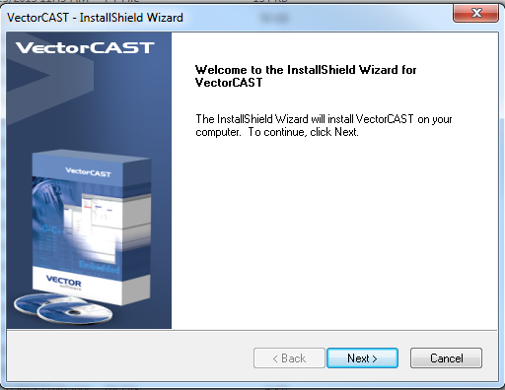

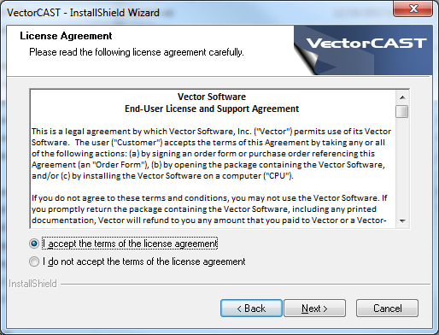

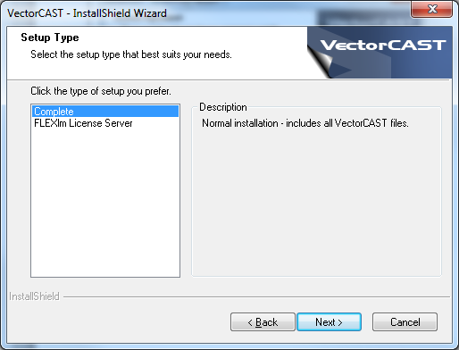

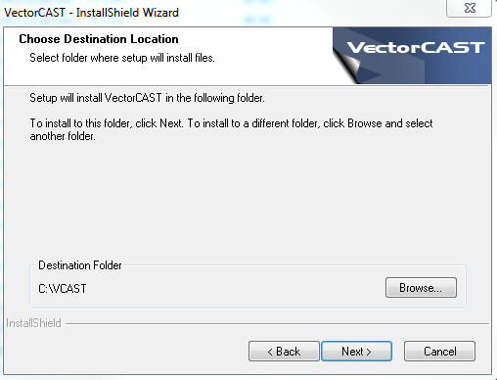

After the Installation is complete, below pop up message will be displayed

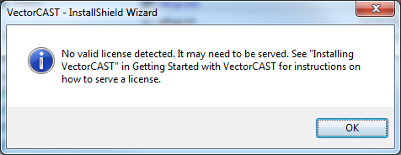

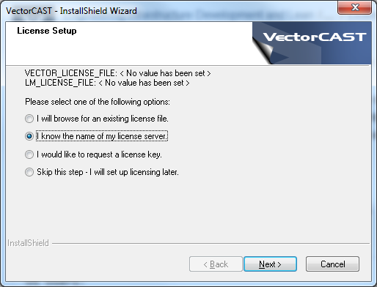

Enter the license information:

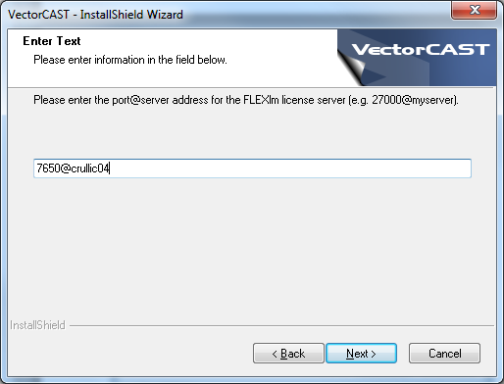

Note: License Server information is available in <http://alm.rockwellcollins.com/wiki/display/EIDLW/VectorCAST+License+Servers?src=search>

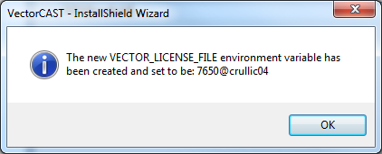

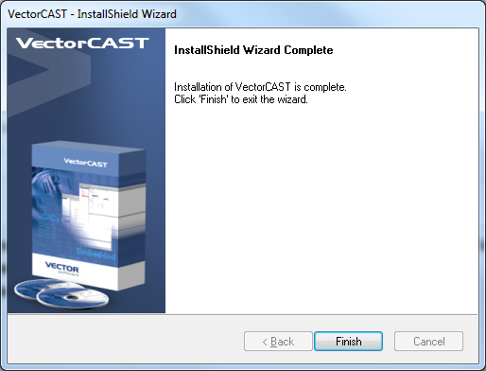

After Installation is complete, the next step is export the tag, and starts the instrumentation process.

## SVN Export the Build

Choose a directory under ro_apps or rw_apps and create a directory for the SVN export. For this example, **C:\Project_Files\DLCA\dlnk-dlca\branches\1.13.1_dev\** was used.

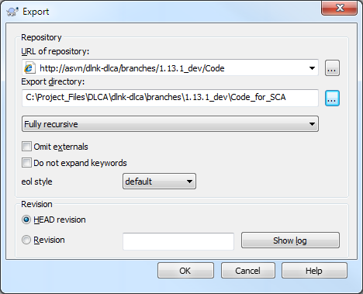

Note: This may take 5-10 minutes. After the export is complete, Make sure to remove the read only property for all source files under the .\Build1.11.0C folder.   
  
Note: The instrumentation process can take place in the normal development directory that a user already has, however the instrumented code will need to be un-instrumented prior to the resumption of regular development.

## Launch VectorCAST

* Set your *Working Directory*

File->Set Working Directory to **C:\rw_apps\SCA_Instrumention**

* Select File->New->Coverage Environment

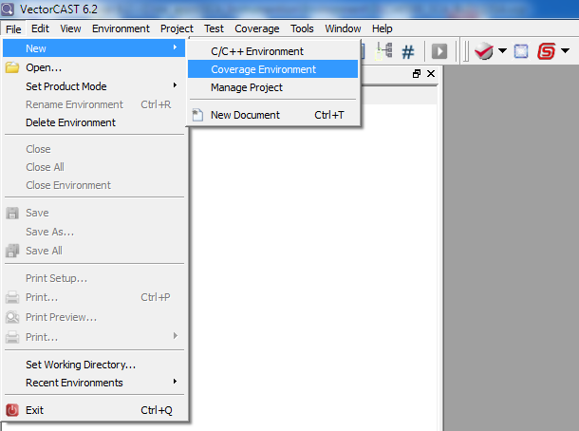

* Enter the VectorCast Project name and click Next:

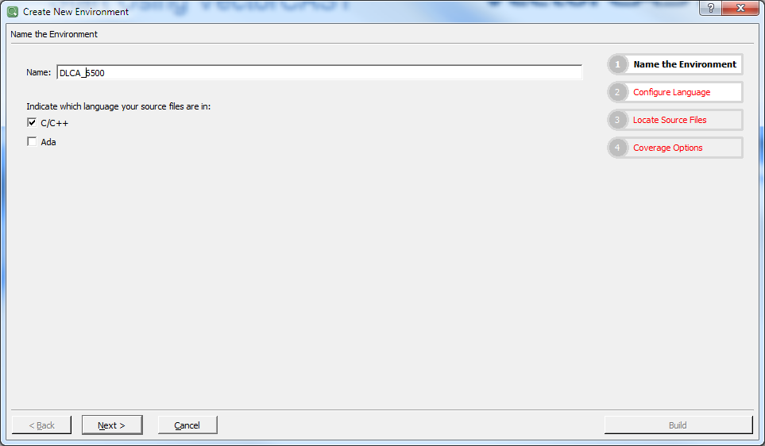

* Change the Compilers to “GNU 4.8 (C++)”.

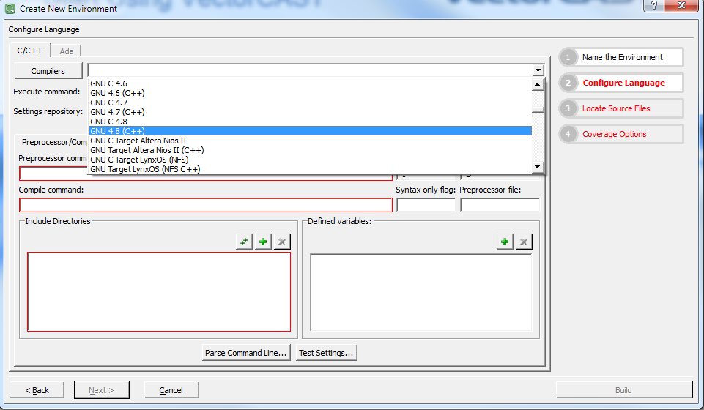

* Select the Add Search Directory Recursively option to add source file director:

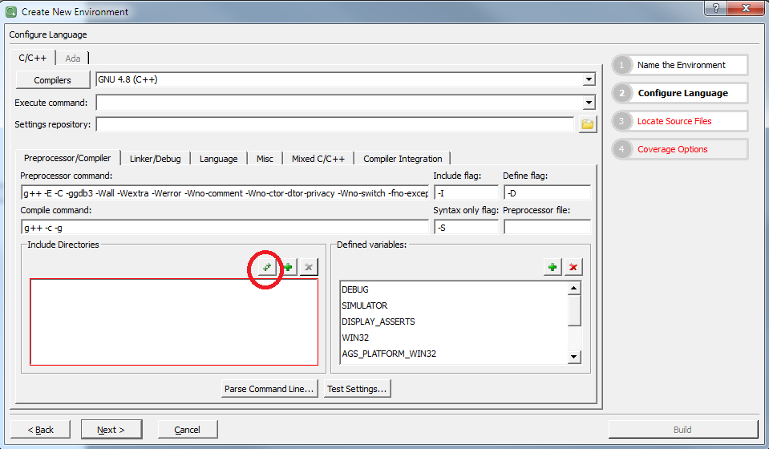

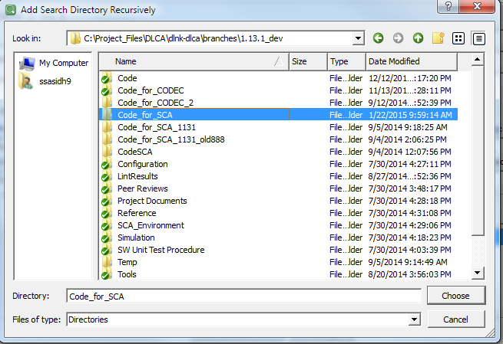

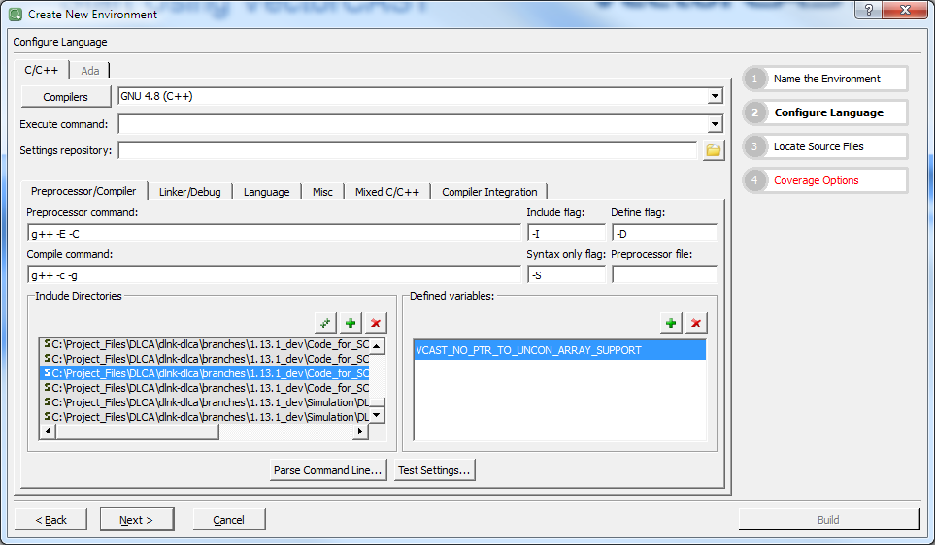

* Click on the Add Search Directory (+ button) to include the below 2 folders:
* C:\Project_Files\DLCA\dlnk-dlca\branches\1.13.1_dev\Simulation\DLCA6500-VistaSim\Vista_tools\SDK\hmps
* C:\Project_Files\DLCA\dlnk-dlca\branches\1.13.1_dev\Simulation\DLCA6500-VistaSim\Vista_tools\SDK\vista\c\msvc
* Then remove the below folders from the include directories:

C:\rw_apps\dlnk-dlca\trunk\Code\tools\NVM

C:\rw_apps\dlnk-dlca\trunk\Code\tools\dlca_6500\makefiles\Footprint\src

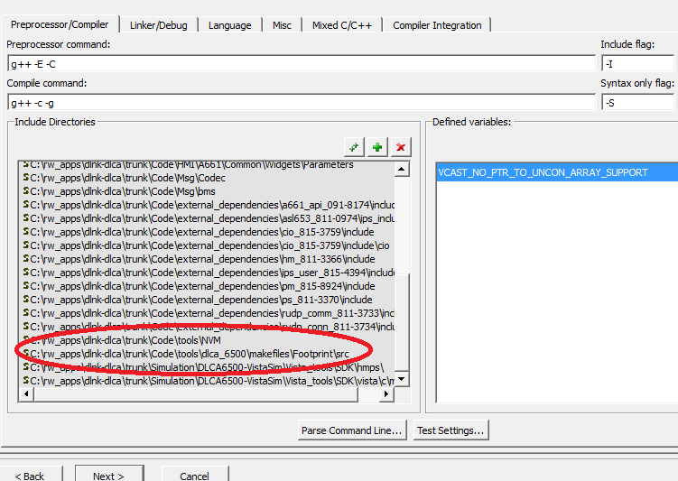

* Add the below Preprocessor variables in Defined Variables section

SIMULATOR

DISPLAY_ASSERTS

WIN32

AGS_PLATFORM_WIN32

COPYRIGHT=$(RC_COPYRIGHT)

CPN=$(CPN)

TLCPN=$(TLCPN)

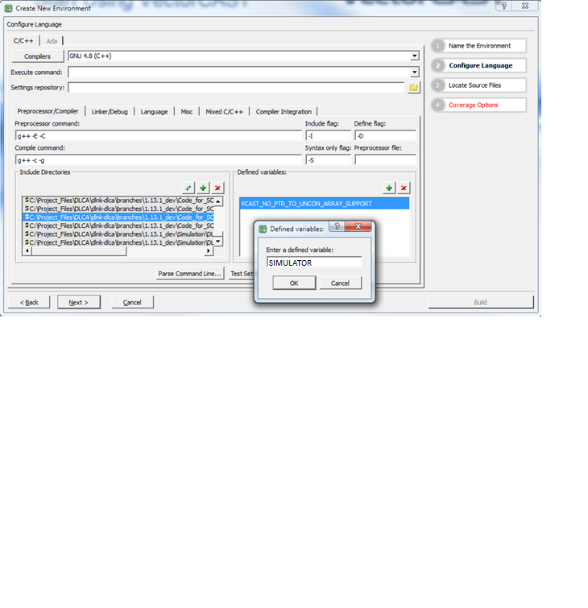

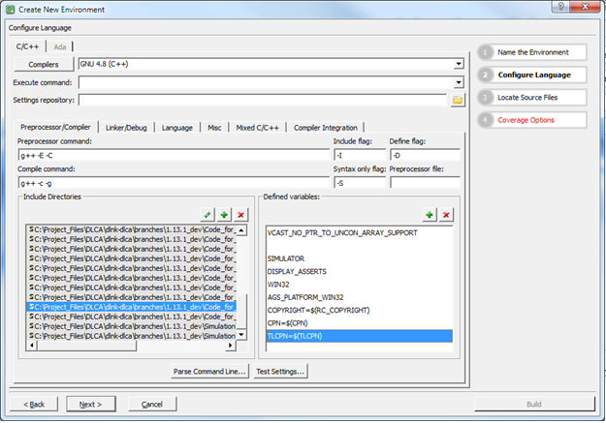

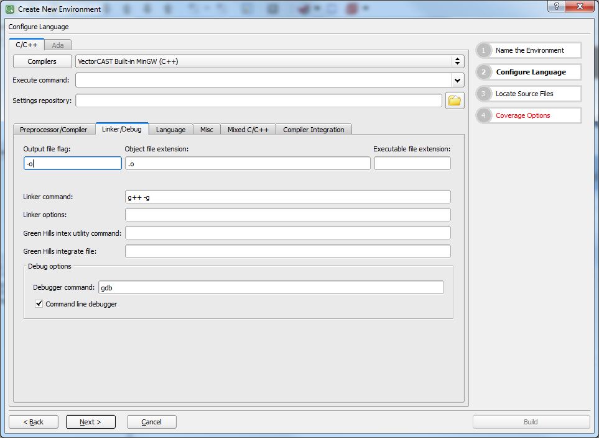

* Select Language tab and in C++ extensions, include .h and .H extensions. Add this only if executable lines are present in the .h files.

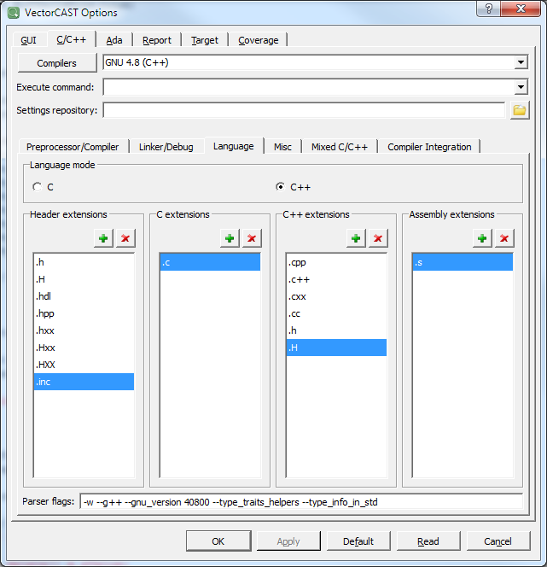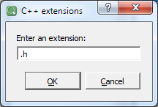

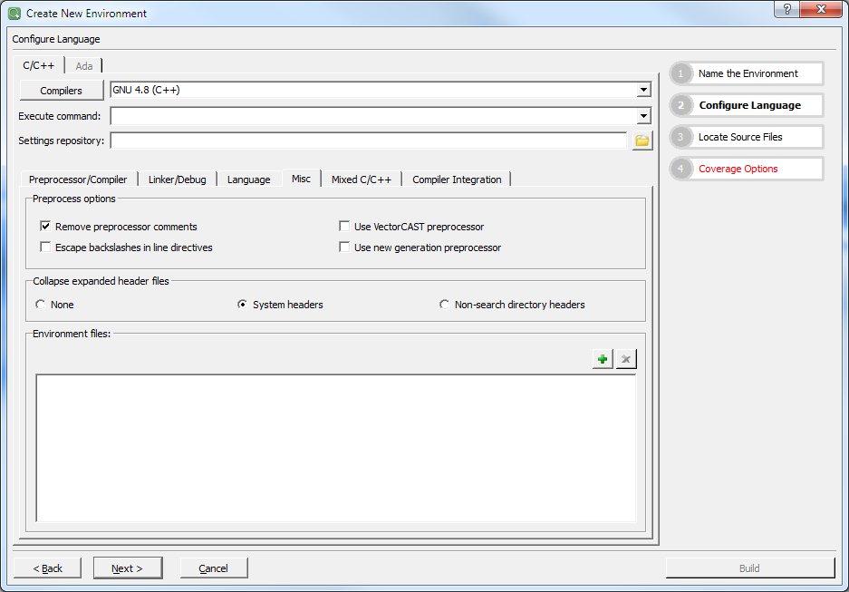

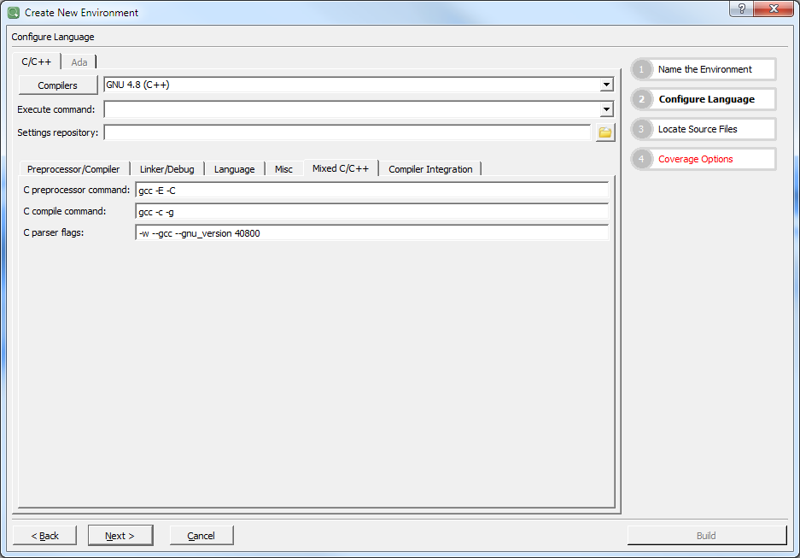

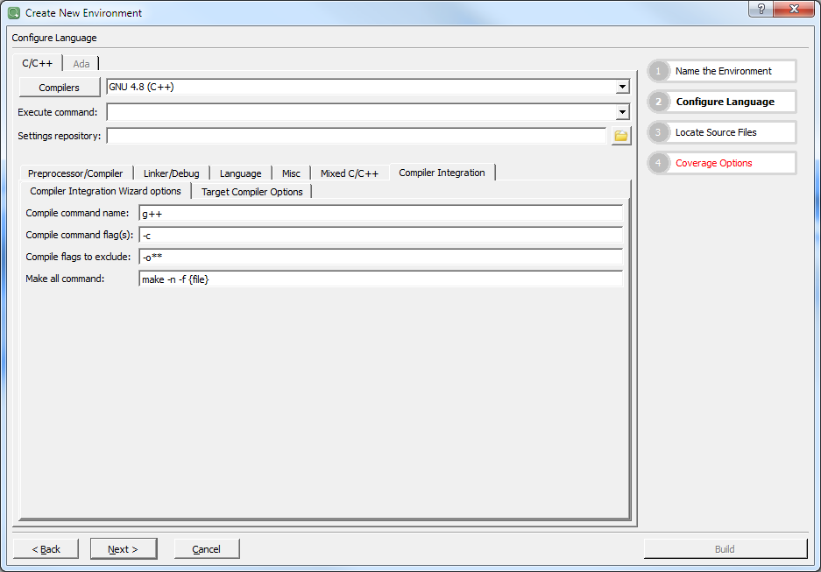

* Select NEXT

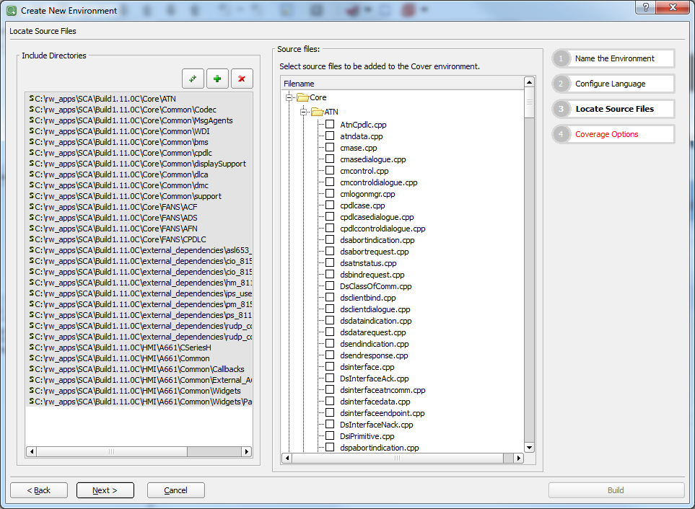

* Right Click on ‘Core’ folder and choose ‘Select’ option. Similarly select HMI and Msg/BMS folder

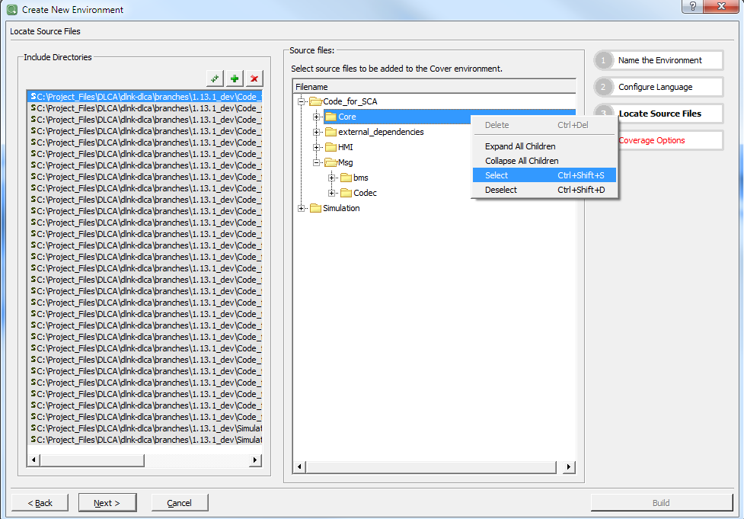

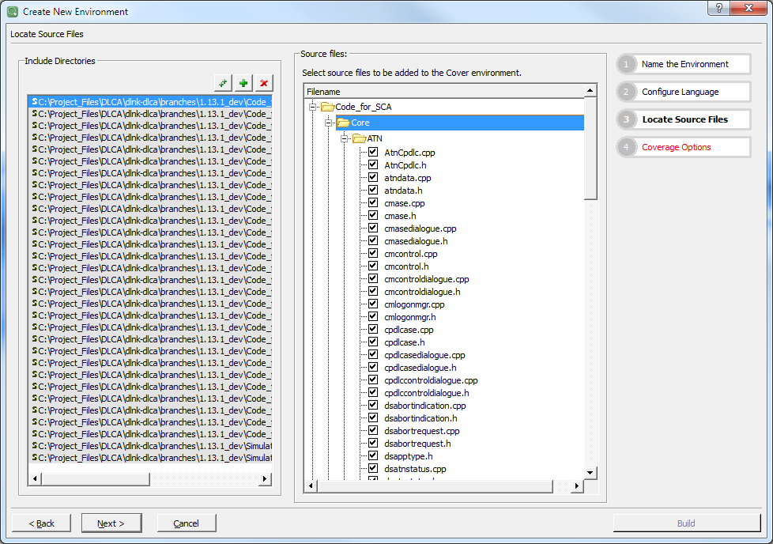

* Select NEXT for Coverage options

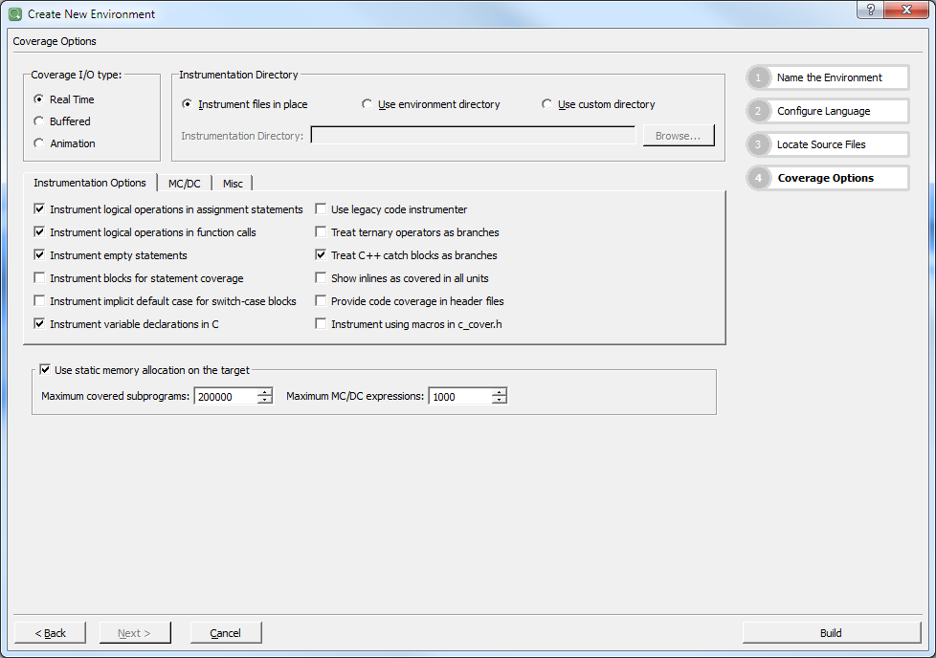

* Select BUILD option to create the project.

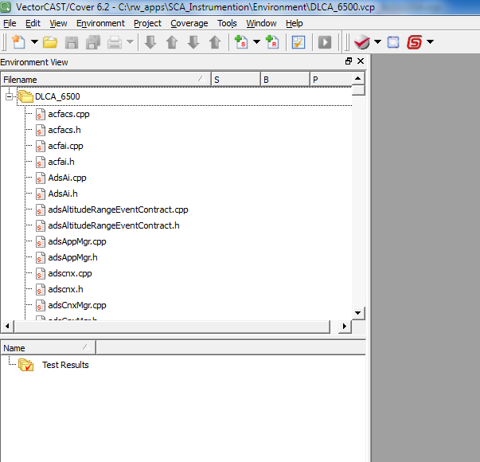

* Once Build is Completed, Select Tools🡪Options

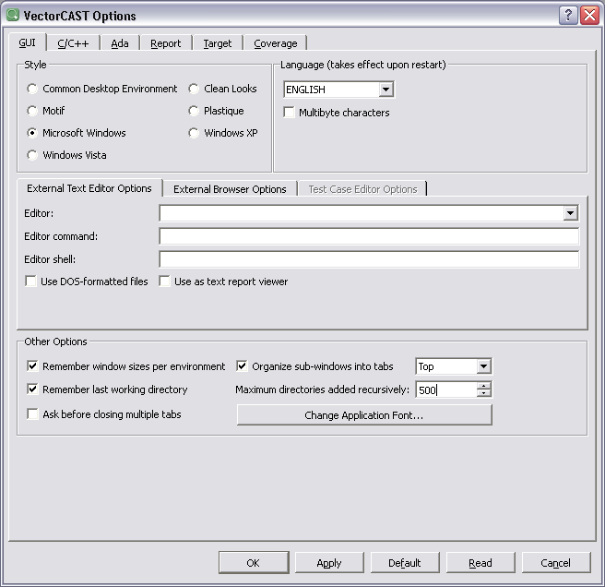

Report Tab (Content)

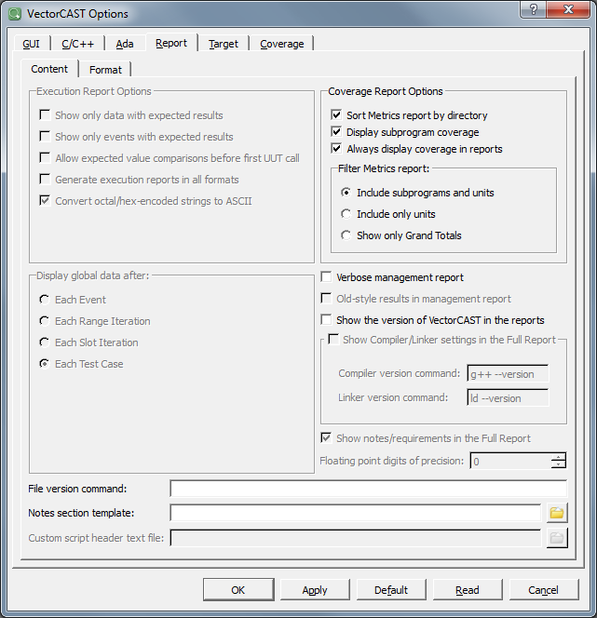

Coverage Tab (Cover Environment)

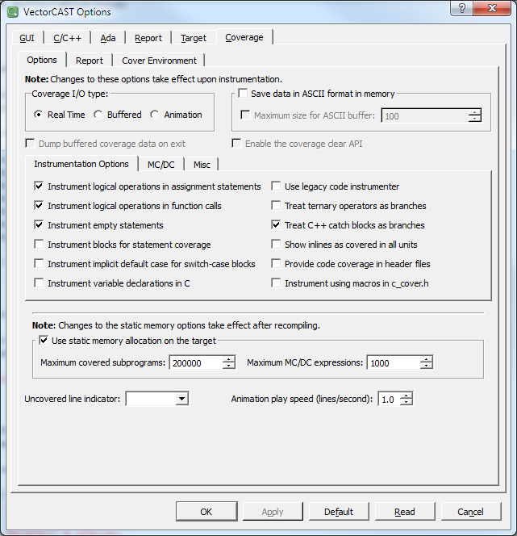

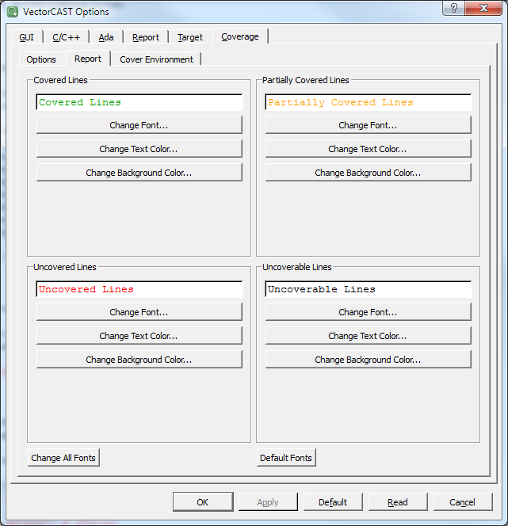

* Remove the Preprocess before instrumenting source files (C/C++) and selection Other options.

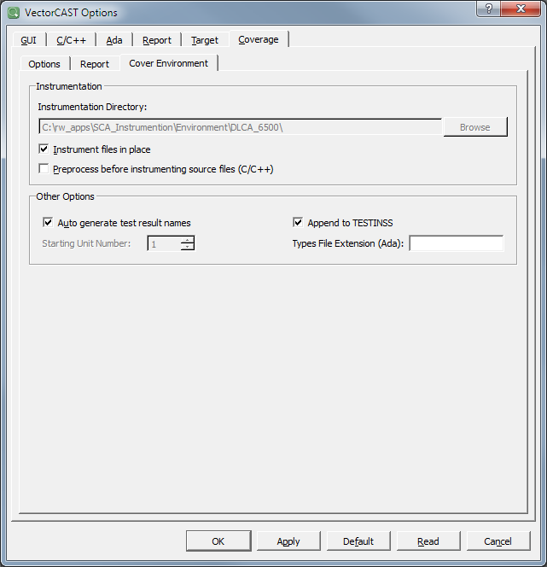

Select OK to apply the settings.

## Instrumenting files

* Select Tools->Industry Mode🡪 DO178B/C (Avionics)
* Right Click on the Project DLCA6500, Select Instrument->Instrument DO178B/C (Avionics) Level C Coverage

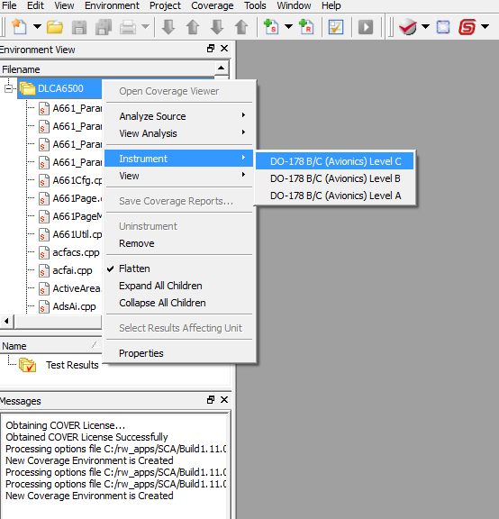

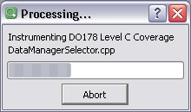

* After this process is complete, minimize VectorCAST

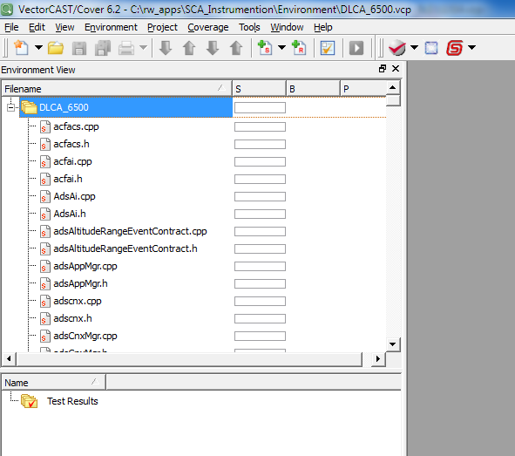

**Note:** If the below error is displayed in vector cast, go to the respective file and type the statement in single line instead of using multiple lines.

*Failed to parse C:\rw_apps\dlnk-dlca\trunk\Code\Core\FANS\ADS\adsParser.cpp. You must resolve this error before proceeding."C:\rw_apps\dlnk-dlca\trunk\Code\SCA_Environment\DLCA6500\vcast_preprocess.cpp", line 103: error:*

*expected an expression*

*;*

^

## Creating the executable

In the ..\Code\tools\dlca_6500\makefiles\cseries directory open file cseries_src.mk, and add the line: C:/rw_apps/SCA/Build1.11.0C/SCA_Environment/DLCA6500 /c_cover_io.cpp \ to the file as shown below and then save. This file is required for the instrumented build to compile. Note the UNIX style slashes are used here.

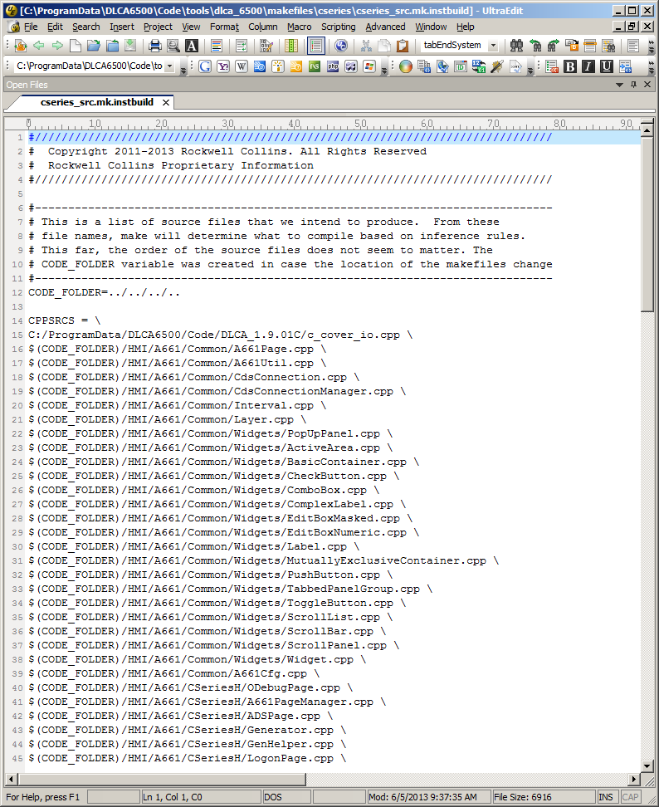

Do a host ‘clean_all’ and build as usual

The Instrumented executable will be in the current working directory (dlca.exe)

**Note:** If below error is displayed, Need to comment out the unused variables

*../../../../SCA_Environment/DLCA6500/c_cover_io.cpp:1065:5: error: unused parameter 'unit' [-Werror=unused-parameter]*

Ex: In C_Cover_io.cpp*, int VCAST_STATEMENT_INSTRUMENTATION_POINT_BUFFERED(char* covdata, int /*unit*/, int id)*

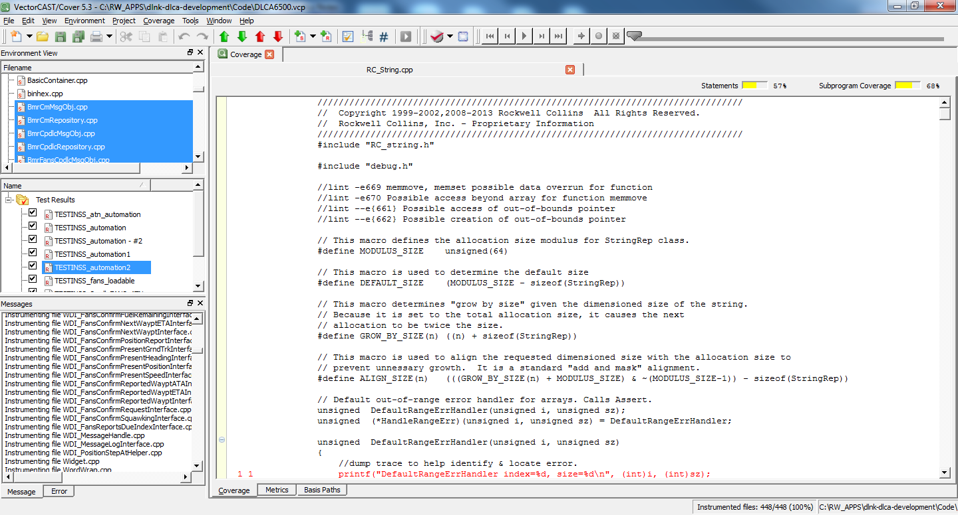

Adding the Test Results and Generating Results:

Environment -> Add Test Results

Select the .dat files that were earlier generate using the instrumented folder.

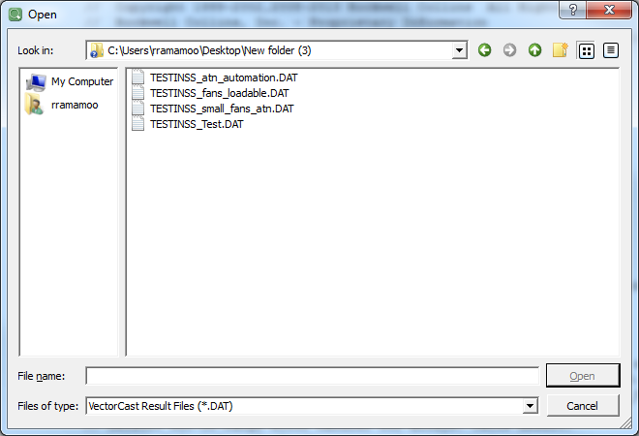

Select all the DAT files under Test Results.

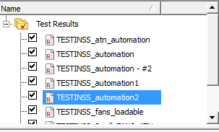

Under the Source files select all the source files for which the report needs to be generated.

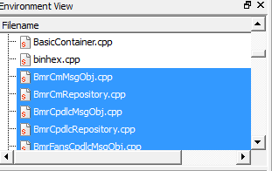

Right click and select save coverage reports.

In the pop up box enter the path where the report needs to be saved and select ok.

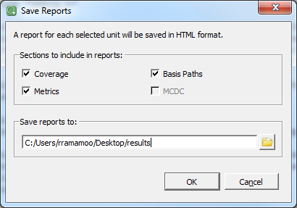

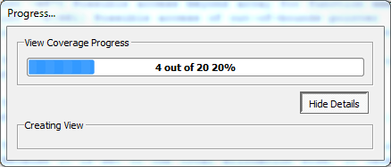

.html report files are generated in the directory.

Sample report file.

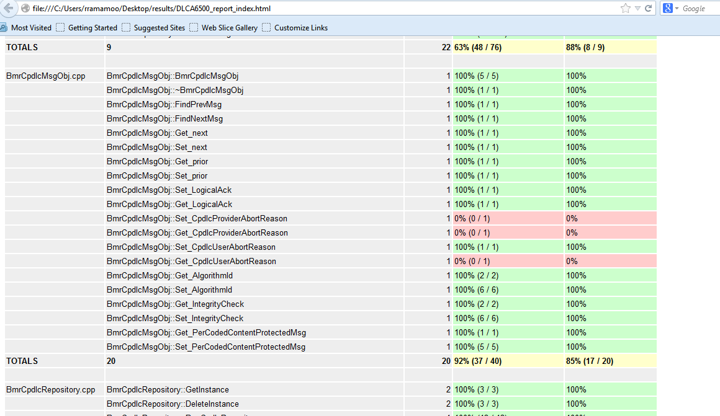

## Source Code Analysis (SCA) Tips

### “If” Statements - Avoid unnecessary use of “else”

1. **Example of unnecessary “else”**

if (m_BoolLine1[C_DL_MAN])

{

m_BoolLine1[C_DL_SHAR] =false;

}

else

{

m_BoolLine1[C_DL_SHAR] =true; **//Remove ‘else’ - Keeping forces Testing to gain**

**//the true/false conditions**

}

1. **Example with else removed**

m_BoolLine1[C_DL_SHAR] =true;

if (m_BoolLine1[C_DL_MAN])

{

m_BoolLine1[C_DL_SHAR] =false;

}

1. **Best code – Most efficient**

m_BoolLine1[C_DL_SHAR] = !m_BoolLine1[C_DL_MAN];

### “Case” Statements

* + Avoid breaking Case statement apart

1. Example of code with case statements unused in the bottom

**switch** (btnCode)

{

**case** *BTN_LEFT_SEL_1*:

//Button code here

actionTaken = **true**;

**break**;

**case** *BTN_LEFT_SEL_2 //* ***Move this code to the bottom of the switch statement***

*//Nothing to do, button is unused*

**break,**

**case** *BTN_RIGHT_SEL_2*:

//Button code here

actionTaken = **true**;

**break**;

**case** *BTN_RIGHT_SEL_5*:

**if** (m_CONFIRMFUEL_SendBool)

actionTaken = **true**;

**break**;

**case** *BTN_PREV_PAGE*:

**case** *BTN_NEXT_PAGE*:

**default**:

**break**;

1. Avoid breaking unused Case statement apart. Group them together

**switch** (btnCode)

{

**case** *BTN_LEFT_SEL_1*:

//Button code here

actionTaken = **true**;

**break**;

**case** *BTN_RIGHT_SEL_2*: **//BETTER: Code moved to the bottom of the switch**

**//statement to avoid Uncovered code issue**

//Button code here

actionTaken = **true**;

**break**;

**case** *BTN_RIGHT_SEL_5*:

**if** (m_CONFIRMFUEL_SendBool)

actionTaken = **true**;

**break**;

**case** *BTN_LEFT_SEL_2*

*//Nothing to do, button is unused*

**case** *BTN_PREV_PAGE*:

**case** *BTN_NEXT_PAGE*:

**default**:

**break**;

1. Use and use “if/elseif” instead of “case” statements
   * Removes needs for extra test cases to hit the “default” break statement.

**if** (btnCode == *BTN_LEFT_SEL_1)*

//Button code here

actionTaken = **true**;

**else if** (btnCode == *BTN_RIGHT_SEL_2*) **/*BEST: Prevents unnecessary code From being**

**Created -No extra test cases required to Test**

**‘default’ or other unused Case statements*/**

//Button code here

actionTaken = **true**;

**else if** (btnCode == *BTN_RIGHT_SEL_5*)

{

**if** (m_CONFIRMFUEL_SendBool)

actionTaken = **true**;

}

### Early outs

* + Using a “break” in a “for” loop or “if” statement can result in uncovered code
  + Multiple “returns” is bad coding practice
  + Note: Ternary operator can be used by might result in uncovered code in future if SCA tool changes (Vector cast)

**Early return example:**

int CPageNotamRPT::CPageNotamRPT(int i)

{

if (i < m_ValA)

return (-1);

i = m_ValA +m_ValB;

return (i);

}

**Example Code rewritten without early return:**

int CPageNotamRPT::CPageNotamRPT(int i)

{

int tempVal = -1;

if (i >= m_ValA)

tempVal = m_ValA +m_ValB;

return (tempVal);

}

### Implementing same code multiple times

* + Commonly on page code there are features that should be put in a common method
  + Results in verification needing redundantly test the same feature multiple times to gain coverage

**Example of code that should be put in a common method - Routines are identical With exception of Array index:**

String CPageConfirmAlt::GetFreeText1(String m_ConfirmIndex_FreeText1Alt) const

{

if (m_CONFIRMALT_TextLineStrs[0].isNotEmpty())

m_ConfirmIndex_FreeText1Alt = m_CONFIRMALT_TextLineStrs[0];

return (m_ConfirmIndex_FreeText1Alt);

}

String CPageConfirmAlt::GetFreeText2(String m_ConfirmIndex_FreeText2Alt) const

{

if (m_CONFIRMALT_TextLineStrs[1].isNotEmpty())

m_ConfirmIndex_FreeText2Alt = m_CONFIRMALT_TextLineStrs[1];

return (m_ConfirmIndex_FreeText2Alt);

}

String CPageConfirmAlt::GetFreeText3(String m_ConfirmIndex_FreeText3Alt) const

{

if (m_CONFIRMALT_TextLineStrs[2].isNotEmpty())

m_ConfirmIndex_FreeText3Alt = m_CONFIRMALT_TextLineStrs[2];

return (m_ConfirmIndex_FreeText3Alt);

}

### Declaring class methods that are never called

Reusing code can often result in methods existing that are never called. Check through entire workspaces to see if a method is called, if not, remove it. It is unused code. If not removed justification must be added for why it is kept “completeness” or “future growth” are common reason.

# Loading a build onto target

There are two methods for loads a DLCA build onto our target test stations. The 615A dataload is an industry standard way to load software onto a target platform, utilizing the ARINC615 specification. For development purposes, a ‘Lauterbach load’ is also commonly used, as it loads the target much quicker, which is useful when trying to debug and several build/load iterations are needed to arrive at a fix. Both methods require a preparation step prior to loading.

## Loadset Preparation

1. Ensure that your system is configured to support this process. Check your U:\ drive and confirm that there are three directories there; \lauterbach, \CSeries_dlca, and \M145_dlca. If they do not exist on your system, copy them from <http://asvn/dlnk-dlca/trunk/Build/Common/CopyBelowToU_Drive> to your U:\drive.

***Note***: The ‘copied’ folders should not contain .svn folders. To copy the contents without these SVN folders it is recommended that you use the SVN ‘Export’ function to create the folders on your U: drive. One example is shown below:

Right click on the ..\trunk\Build\Common\CopyBelowToU_Drive\CSeries_dlca folder and select Tortaise SVN->Export…

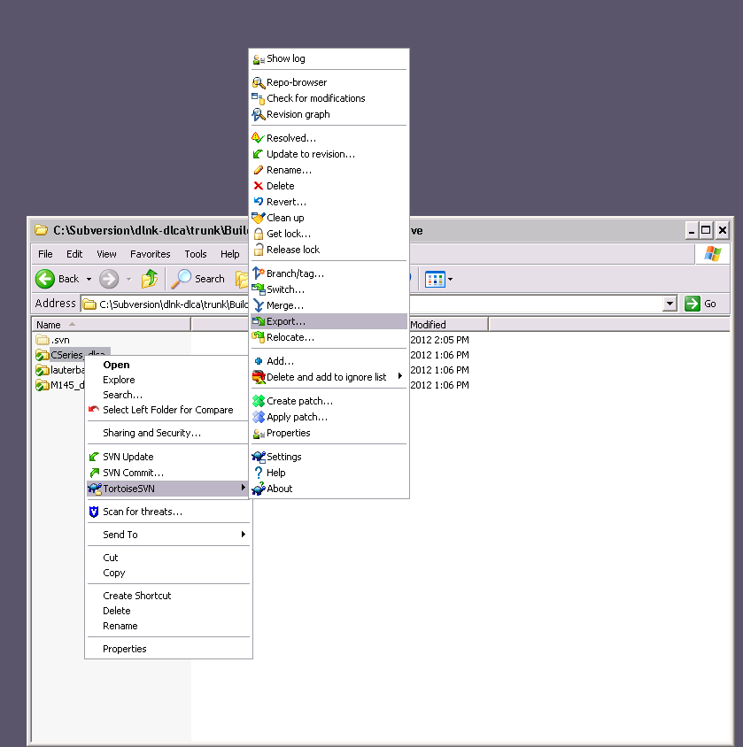

Then select home on 'EMC-SNAS (crnas02)' (U:) and click OK.

Repeat for the remaining two folders.

1. Launch the Lynx OS License manager and then perform a ppc build in Eclipse.   
     
   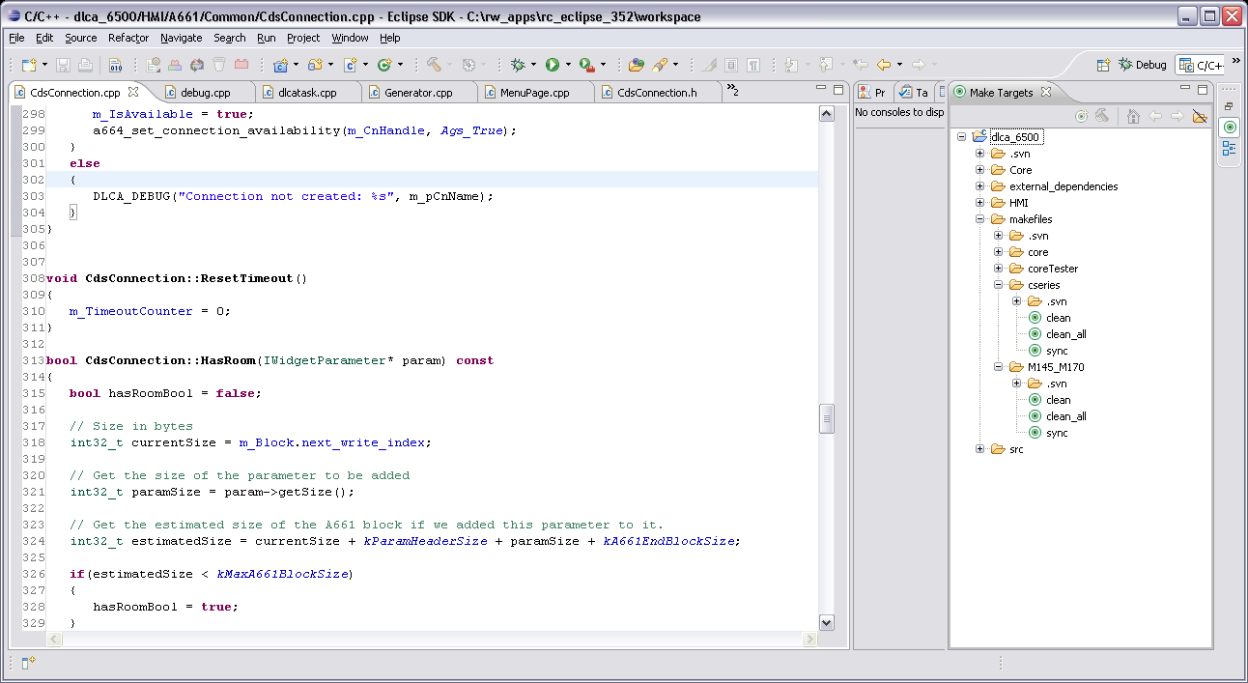
2. In the Make Targets tab in Eclipse, click the ‘sync’ target at the bottom of the tab (see the following item for building dual-DLCA loads). If no ‘sync’ target is available in Eclipse, add one by selecting the ‘New Make Target’ button at the top of the tab. Configure as shown below.

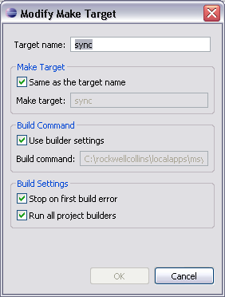  
  
Select OK to save. Execute ‘sync’ by double clicking on it. This will create a file with the debug symbols stripped out, ‘dlca.stripped’, and then move 2 executables to the U:\ drive. It will also build and copy localfs_dmtester and the source files needed for debugging to the U:\ drive as well. The localfs_dmtester file is built using ‘build_fs’, an executable that is part of LynxOS, and is configured using the file \Build\<program name>\etc\targetlocalfs.spec.

For the case where the build is to be loaded onto a dual-DLCA configuration, choose the ‘sync_dual’ instead of ‘sync’. This will create to file systems, one left and one right, which can then be loaded on to the corresponding test station.

## 615A Load

This method is the same process that is used to load a build onto an actual aircraft. It complies with ARINC 615A for loading data over an ARINC 664 network.

1. Open the Rockwell Collins Dataload Mediaset Creator (W:\DLCA\Tools\RCDMC\RCDMC.exe). Open a mediaset configuration file (File|Open|Open Mediaset Config File…). Media set configuration files are located in <http://asvn/dlnk-dlca/trunk/Build/RCDMC>, DLCA_autostart.xml and DLCA_bash.xml. These files point to the correct files needed for building a mediaset. They use relative paths and should work from any SVN location.

Note: While creating loadset for target testing ensure that DLCA_AtnAppData_Test.XML is renamed as DLCA_AtnAppData.XML. This needs to be done only for target testing purpose not for delivery.

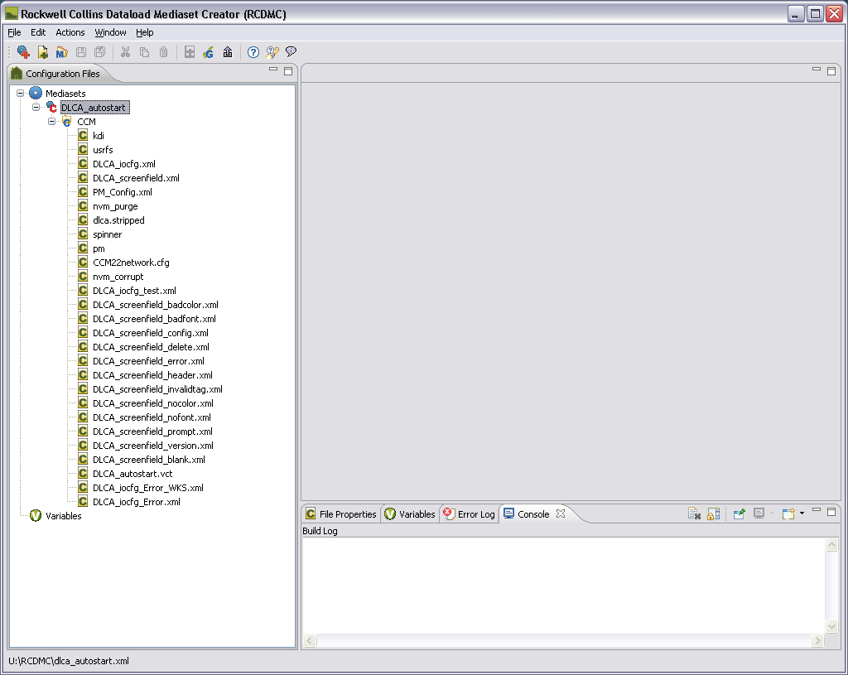

1. Check mediaset for errors (Actions|Check Mediaset Generation) and address any issues shown in the Console or Errors tabs. If no errors are generated, create the mediaset
2. (Actions|Generate Mediaset). The files in this directory will be used to perform the 615A load.
3. Open TeraTerm Pro for COM3 and COM4, configured as shown below (depending on the test station configuration, COM4 and COM5 may be used instead).

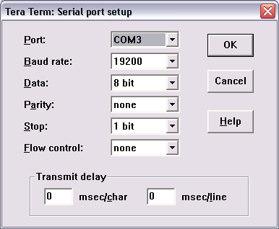

1. Open cpa_disc.exe and configure as shown below depending on the CPA Discrete version.

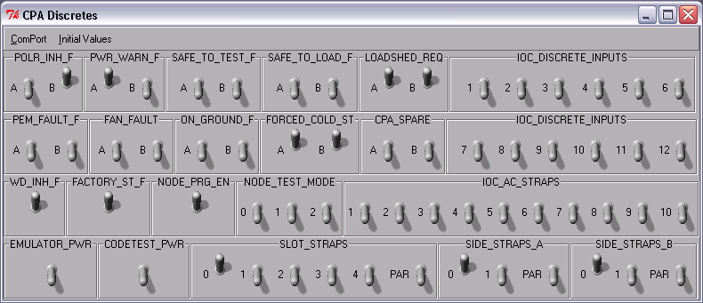

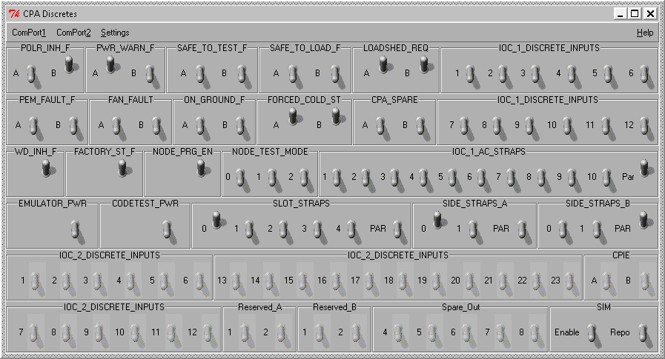

1. Open the 615A Dataloader. This should be loaded to the C:\ drive of the lab test station.

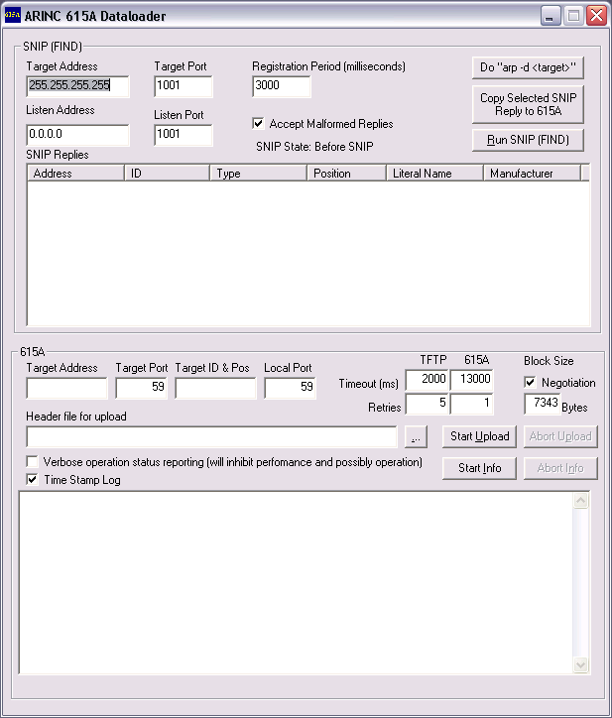

1. In CPA_Discretes window, switch OFF and ON, POLR_INH_F 🡪 B and PWR_WARN_F 🡪 A to cycle power with 5 seconds delay between OFF and ON.
2. In Com4 window, given the command “cinit cnc” when “Singleuser” prompt is displayed.
3. In A615, Listen Address box type the filter driver ip address 10.136.24.0, Select Negotiation check Box and Type value 7343 Bytes.
4. Press the “Run SNIP (FIND)” button. This will return several lines in the ‘SNIP Replies’ box. Click the IP address of the line item that has the CCM_ID_33 ID to load the target address into the 615A fields. Choose the ‘Header file for upload’ that was created in the previous step ( *.LUH ). Ex: SVN path <http://asvn/dlnk-dlca/trunk/Build/releases/EngBuild_1.8.0C.8127-2012-11-20/target/Loadsets>.
5. Select ‘Start Upload’. If the Selected build is a bash prompt build, Type the command “cinit cdc” in Com4 window within 20 seconds after selecting Start Upload option.

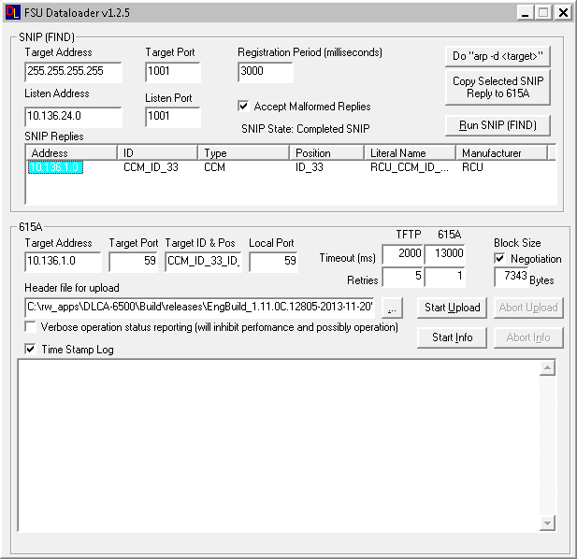

1. The upload takes about 10 minutes and will return a number of messages about no data loaded

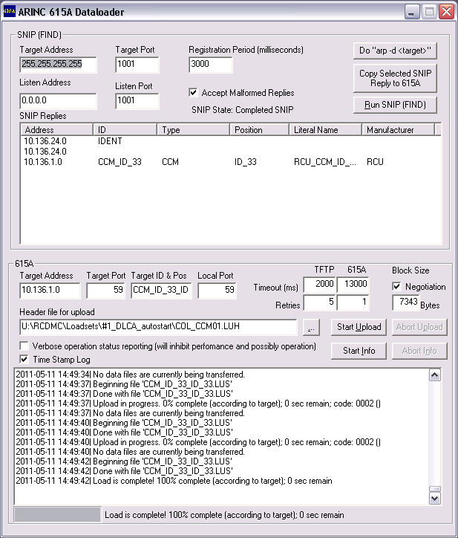

1. The text “Load is Complete! 100%” will be displayed in “Arinc 615A Dataloader” application and Singleuser prompt is displayed in Com4:
2. In Com4 window, type the command “sw_val_complete” and press enter.
3. In CPA_Discretes window, switch OFF and ON, POLR_INH_F 🡪 B and PWR_WARN_F 🡪 A to cycle power with 5 seconds delay between OFF and ON.
4. In Com4 window, type the command “cinit cnc” when “Singleuser” prompt and press enter.
5. Start target and Launch VISTA

## Lauterbach load

1. The Lauterbach load utilizes the Lauterbach In-Circuit Debugger to load all of the file systems directly onto the CMM. In particular, the localfs_dmtester file that is created in the ‘sync’ set above, which contains the dlca executable and the related configuration files.   
   Note: While creating loadset for target testing ensure that DLCA_AtnAppData_Test.XML is renamed as DLCA_AtnAppData.XML. This needs to be done only for target testing purpose not for delivery.
2. To perform a Lauterbach load, a target build will need to have been successfully completed, and the ‘sync’ process will have to have been run in Eclipse development environment.
3. Open two TeraTerm terminals, one for each of the VM’s on the load. Typically PM and HM will output to COM4 and DLCA will output to COM5.
4. Open CPA_Disc.exe, as shown.



1. Open Trace32 ICD PPC USB on a lab PC. This is the software that connects to the Lauterbach In-Circuit Debugger.
2. **Default load, w/’core-api’ ClearCaseVOB** - Ensure that the U:\lauterbach\t32\userstartup.cmm has run. If you see a blank TRACE32 screen it has not run and will need to be launched manually. If you see “Please enter Clearcase view drive letter (e.g. Z):” then it has successfully run. Choose the drive letter that Clearcase is mapped to that will allow you to see the Core-API VOB. The screen should look like this:

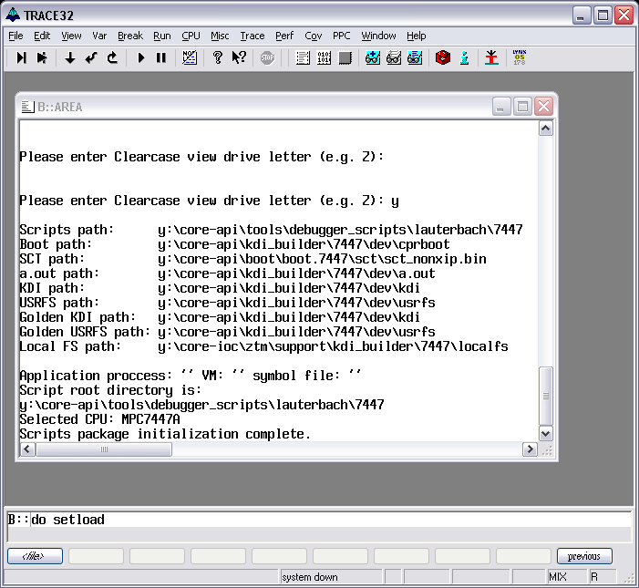

1. **DLCA6500 load, w/o Clearcase VOB** – Ensure that C:\ProgramData\DLCA6500\Tools\Lauterbach_support\6500userstartup.cmm has run. This startup script will point towards the DLCA-6500 SVN repository for all the required load files. If the path to the DLCA-6500 SVN is not the same as the default, the user is able to change the path. Note file locations from the setload dialog below.

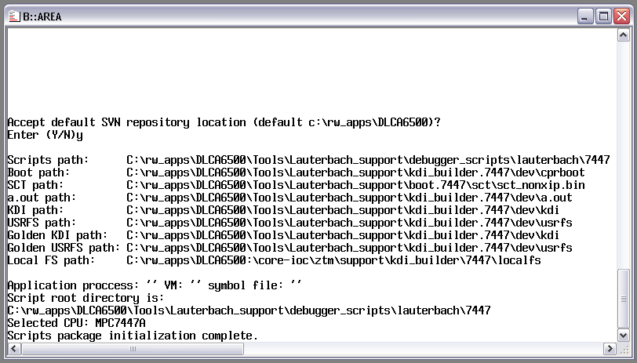  
  
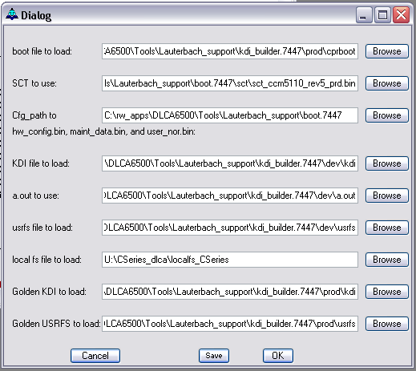

1. Execute ‘do setload’ from the command prompt. Choose ‘Yes’ to the Reload last Session settings popup, and browse to the setttings file, and select OK.
2. Confirm the proper files are selected. There are a couple of things to note on this screen. Use the Rev 5 SCT with our CCM boards. All our CCMs should be mod 20, and these require Rev 5 SCT, Mod 19 and earlier boards (as used in 739 style DLCA) use Rev 4 SCTs. Also if you are using a BASH prompt enabled load (as determined in the ‘sync’ step) ensure that kdi, a.out and usrfs are pointing to dev versions, as prod versions will not work with BASH prompt loads. Check ‘local FS’ is pointing to the correct location for the load you are doing. Currently there are unique locations for CSeries and MSeries loads. Select OK.

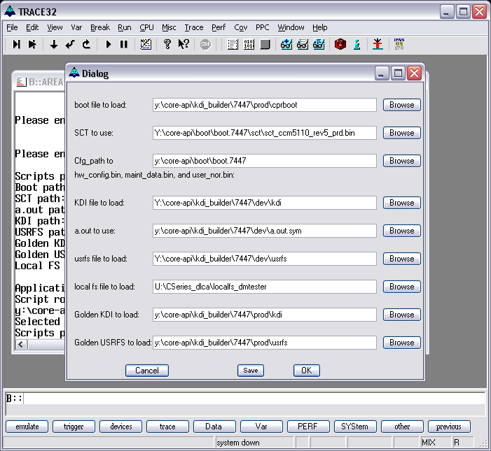

1. Turn off watchdog on the CPA_Disc screen (WD_INH_F).
2. Execute ‘do load a’ from the command prompt.
3. When the screen looks like the following the, CCM is successfully loaded.

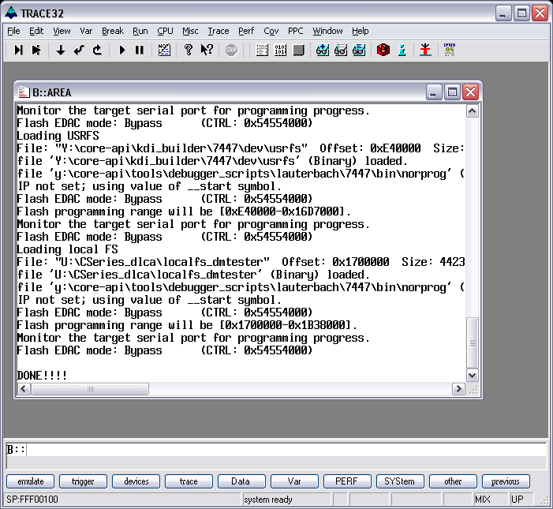

1. Turn watchdog (WD_INH_F ) back on. Cycle CTA power by toggling PWR_WARN_F switch A and POLR_INH_F switch B.
2. Start target.

## Starting Target

1. Enter ‘sw_val_complete’ at the ‘[singleuser: /] $ ‘ prompt in the TeraTerm console.
2. Enter ‘cinit cnc’. This will bring up the BASH prompt, if available.
3. Enter ‘pm’ in the TeraTerm console to start Protocol manager.
4. Enter ‘dlca’ in the other console to start DLCA. The startup process will initialize all of the data flows and return ‘Init done’ when successfully completed.
5. Start the VISTA environment in the \Simulation\DLCA6500-VistaSim directory of SVN to start all of the hosted applications that connect to DLCA and PM.

## EDS Remote dataloader

Refer the guideline document from the below svn path for setting up EDS TAM Station and doing the dataload remotely for EDS system.

https://asvn/csdlnkver-dlca-a661/branches/5.0.0_Ver/tools/Target_Tools/A615_Dataloader/Guideline_document_to_setup_EDS_TAM_Station_for_Remote_Dataload.docx

# The Role of the BuildMaster

The BuildMaster is responsible for ensuring that software builds are released on schedule. They confirm that builds compile correctly, are able to load correctly, run on their intended platforms, and are tagged and published correctly.

## Preparation

1. Three days prior, and again on the day prior to the build, send an email to all relevant individuals reminding them of the upcoming build. Include the following.
   1. Date of the build.
   2. All changes and updates are to be tested and committed to SVN by COB the day prior to the build.
   3. No commits to SVN are to occur on the day of the build.
2. Confirm that the part numbers and revision number are accurate for this build.
   1. Part numbers are documented in   
      [http://asvn/dlnk-dlca/trunk/Project Documents/DLCA CPNs/DLCA CPNs.xlsx](http://asvn/dlnk-dlca/trunk/Project%20Documents/DLCA%20CPNs/DLCA%20CPNs.xlsx)
   2. Core part numbers are to be updated in the line RCPN="CORE_RCPN *XXX-XXXX-001 1.X.0*" in the following files:  
      <http://asvn/dlnk-dlca/trunk/Code/tools/dlca_6500/makefiles/core/Include_target.mk>  
      <http://asvn/dlnk-dlca/trunk/Code/tools/dlca_6500/makefiles/core/Include.mk>
   3. CSeries top level part numbers are to be updated in the line TLCPN="DLCA_RCPN *XXX-XXXX-XXX*", CSeries HMI part numbers are to be updated in the line CPN="HMI_RCPN *XXX-XXXX-XXX* 1.X.XC" in the following files:  
      <http://asvn/dlnk-dlca/trunk/Code/tools/dlca_6500/makefiles/cseries/Include_target.mk>  
      <http://asvn/dlnk-dlca/trunk/Code/tools/dlca_6500/makefiles/cseries/Include.mk>
   4. M145/M170 top level part numbers are to be updated in the line TLCPN="DLCA_RCPN *XXX-XXXX-XXX*", M145/M170 HMI part numbers are to be updated in the line CPN="HMI_RCPN *XXX-XXXX-XXX* 1.X.XM" in the following files:  
      <http://asvn/dlnk-dlca/trunk/Code/tools/dlca_6500/makefiles/M145_M170/Include_target.mk>  
      <http://asvn/dlnk-dlca/trunk/Code/tools/dlca_6500/makefiles/M145_M170/Include.mk>

## Build Process

1. Update the Code directory to the latest revision in SVN (see section ‘TortoiseSVN’) . Resolve all conflicts. Perform win32 and ppc builds for the program that is being built, ensuring that the ‘sync’ operation is performed for the ppc build (see section ‘Building the DLCA application in Eclipse’).
2. Build 615A loadsets (see section ‘Loading a build onto target’).
3. Test all 3 builds (host, Lauterbach, and 615A) to ensure the builds are viable. Note: this testing is not in lieu of unit or verification testing, it is only to ensure that the builds were successful.
4. Once the tests confirm a viable build, commit the compiled executables back into SVN. Note the revision number; it will be needed for the tags that are created in later steps.
5. Create a tag for the build in SVN.  
   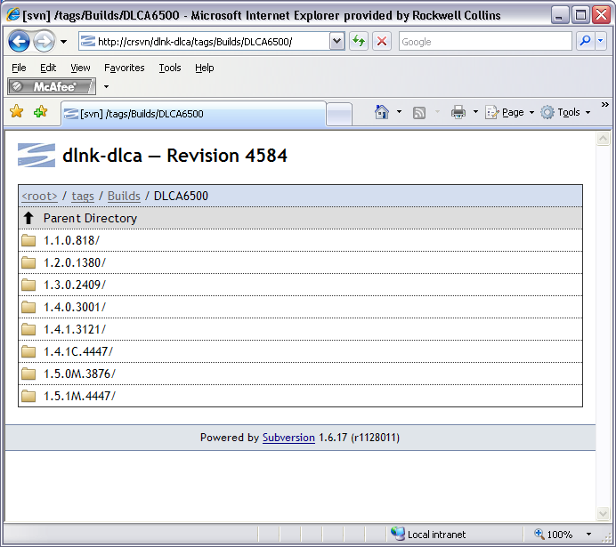

Go into the Repo-Browser in SVN and do the ‘Copy To’ function to copy a tag of <http://asvn/dlnk-dlca/trunk>, saving it in the tag directory with the naming convention of <version>.<major revision>.<minor revision><M (for M145) or C (for CSeries)>.<SVN version number + 1>, as shown below.

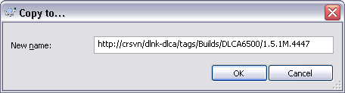

## Publishing the Build

1. Create a directory in \\ccanet\cs\dlnk\DLCA\ATN-FANS-A661GUI\Builds\DLCA6500\, with the naming convention:   
   EngBuild_<version>.<major revision>.<minor revision><M (for M145) or C (for CSeries)>.<SVN version number + 1>-<year>-<month>-<day>. Add subdirectories as shown below.  
   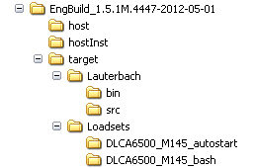
2. Copy the win32 executable, along with the matching DLCA6500_DMT.bdf and DLCA6500_DMT.tdf files to the \host sub directory.
3. Copy the VectorCAST instrumented build into the \hostInst sub directory.
4. Copy the results of the ‘sync’ operation into the \target\Lauterbach sub directory.
5. Copy the results of the 615A loadset creation to the \target\Loadsets sub directory.

## DLCA-6500 Build Announcements

For every build, the Build Manager will send out an e-mail to the Data Link distribution list (Collins CS [FMS-DataLinkProducts@rockwellcollins.com](mailto:FMS-DataLinkProducts@rockwellcollins.com)). The Build announcement contains:

**Subject:** DLCA-6500 Build X.X.X[M or C]

**E-Mail Body:**

**DLCA-6500 Build X.X.X[M or C]**

**SVN Tag**

http://asvn/dlnk-dlca/tags/Builds/DLCA6500/1.X.X.[M or C].XXXX  
    
**Release Builds**

**Host:**

\\ccanet\cs\dlnk\DLCA\ATN-FANS-A661GUI\Builds\DLCA6500\EngBuild_1.X.X[M or C].XXXX-YYYY-DD-MM \host

**Target:**

\\ccanet\cs\dlnk\DLCA\ATN-FANS-A661GUI\Builds\DLCA6500\EngBuild_1.X.X[M or C].XXXX-YYYY-DD-MM \DLCA6500_bash

\\ccanet\cs\dlnk\DLCA\ATN-FANS-A661GUI\Builds\DLCA6500\EngBuild_1.X.X[M or C].XXXX-YYYY-DD-MM\DLCA6500_autostart

**Memory Footprint**

|  |  |
| --- | --- |
| **Memory Type** | **Size (MB)** |
| ROM | X.X |
| RAM | X.X |

**Part Number List**

|  |  |
| --- | --- |
| **CPCI** | **CPN** |
| DLCA-6500 Application | 096-2550-XXX |
| Screen Field XML Configuration | 096-2548-XXX |
| I/O Configuration File | 096-2549-XXX |
| ATN Data XML File | 945-4469-XXX |
| HMI XML Configuration File | 096-5699-XXX |

**Data Link Tools**

|  |  |  |
| --- | --- | --- |
| **Data Link Tools** | **Version** | **CPN** |
| Air/Ground Protocol Stack | 1.0 | 096-4352-XXX |
| DLCA Data Generator | 3.4 | 096-5819-XXX |
| ATC Ground Station | 1.0 | 096-4322-XXX |
| DLCA Trace Tool | 1.0 | 811-1152-XXX |
| Chime Tester | X.X | XXX-XXXX-XXX |
| DM Tester | X.X | XXX-XXXX-XXX |

**Implemented Change Requests in this Build**

|  |  |
| --- | --- |
| **CR** | **Description** |
| FUSN00000001 | Use “Headline” in CR (In Overview Tab) |
| FUSN00000002 | … |

**Notes**

Specify information pertaining to the Build that is not covered above. This may include program specific information, Host/Target simulation information, and Special instructions regarding tools.

#### Creating the Build Branch from the trunk

Branch folder for trunk of DLCA-6500 project can be created in one of the following two ways:

##### Using script to create the branch folder (for Build Master Use)

1. Run the file **MakeBranch.bat** located at <http://asvn/dlnk-dlca/trunk/MakeBranch.bat>.
2. It will prompt for a build ID. Enter the build ID for which this branch is going to be created, and then it will create a branch of [http://asvn/dlnk-dlca/trunk/](http://asvn/dlnk-dlca/trunk/Code) in the http://asvn/dlnk-dlca/branches directory.

##### Manual method to create the branch folder

1. Right click on the trunk copy of DLCA-6500 and Navigate to **TortoiseSVN** option and select **Branch/tag** option present under submenu of **TortoiseSVN** option as shown in the below figure.

For example: Here we have http://asvn/dlnk-dlca/trunk checked out at C:\DLCA-6500

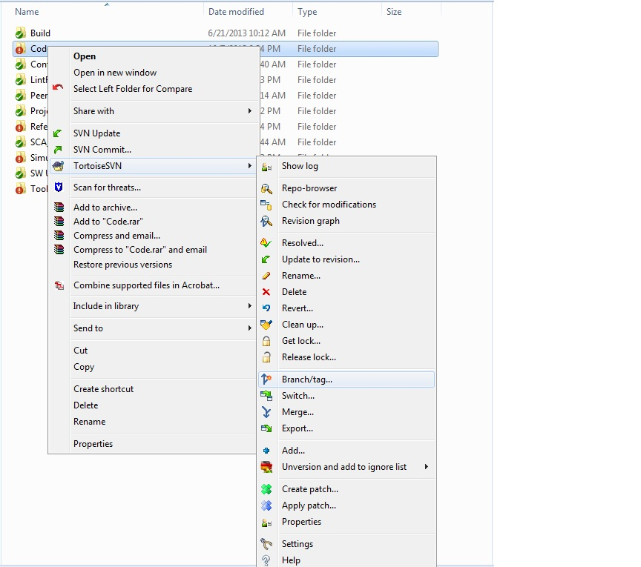

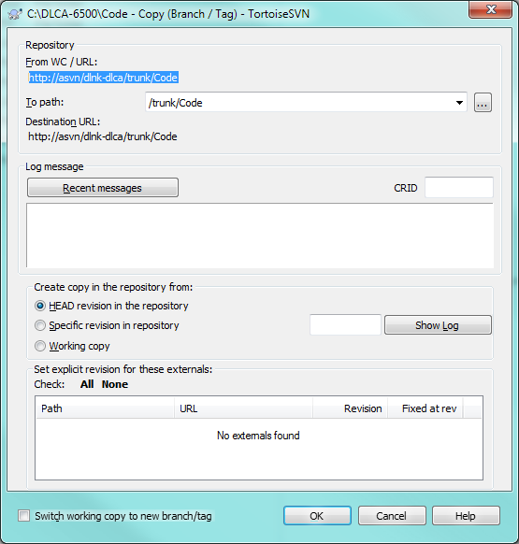

1. Click on browse button to select the branches path from the **Branch/Tag** prompt

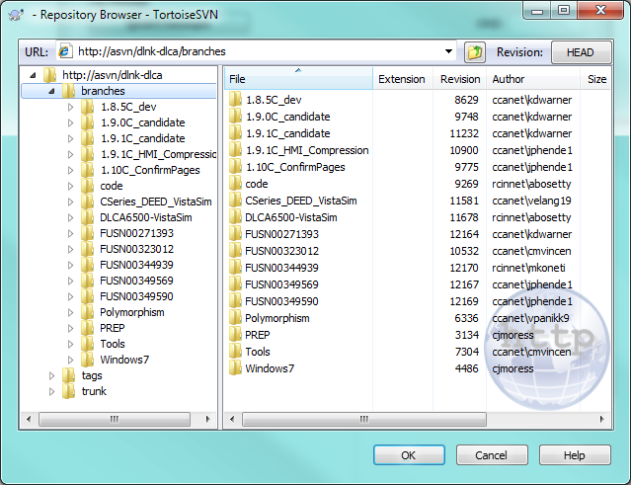

1. Select branches and click on **OK** button as shown in above figure. After selecting branches path **To path** filed gets updated to **“/branches”** as shown in below figure
2. Also make sure that **HEAD revision in the repository** option has been selected which is present under “**Create copy in the repository from:”.** This option should be selected to make sure that while creating branch code folder should be on latest revision.

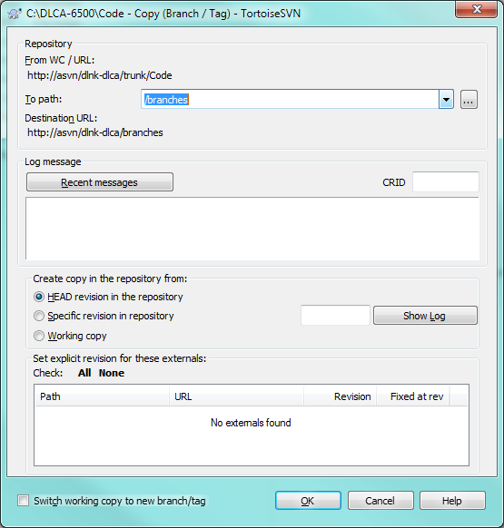

1. Append the build ID to the branches as shown in the below figure (use build ID such as 1.12C, not CR#) to create the branch copy at http://asvn/dlnk-dlca/branches/<buildID> In the log messages section, provide the build ID and a comment as shown in the below figure. Click OK.

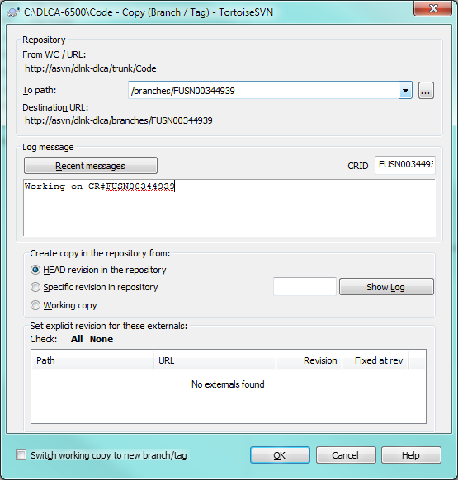

1. To make sure that the folder created after following above steps, go to Repo- browser option present in TortoiseSVN select branches option present in left side of the window as shown in below figure. All the files and folders present under the branches will be shown once it has been selected. Make sure that folder created using above steps shows up under branches.

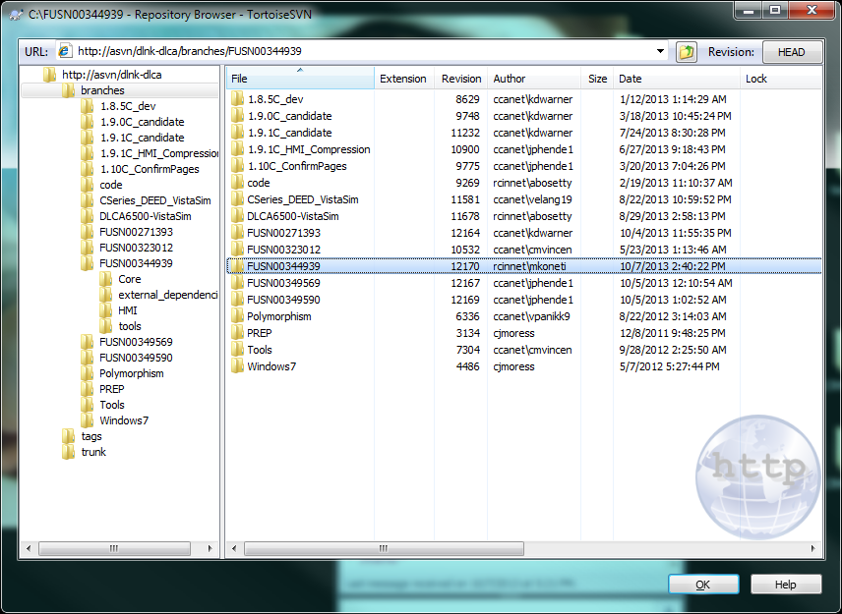

1. Now checkout the SVN in local C drive for newly created branch.

For ex:

Suppose we have http://asvn/dlnk-dlca/trunk/ at C:\DLCA-6500 the newly created branch checkout should be done at C:\DLCA-6500\1.12C

Note:

* To check out the branch go to C:\DLCA-6500 right click and select Repo browser from TortoiseSVN option
* Selecting the folder created using above steps 1.12C in this case) and performs a checkout. It checkouts the newly created folder at C:\DLCA-6500\<BuildID>. (C:\DLCA-6500\1.12C in this case).

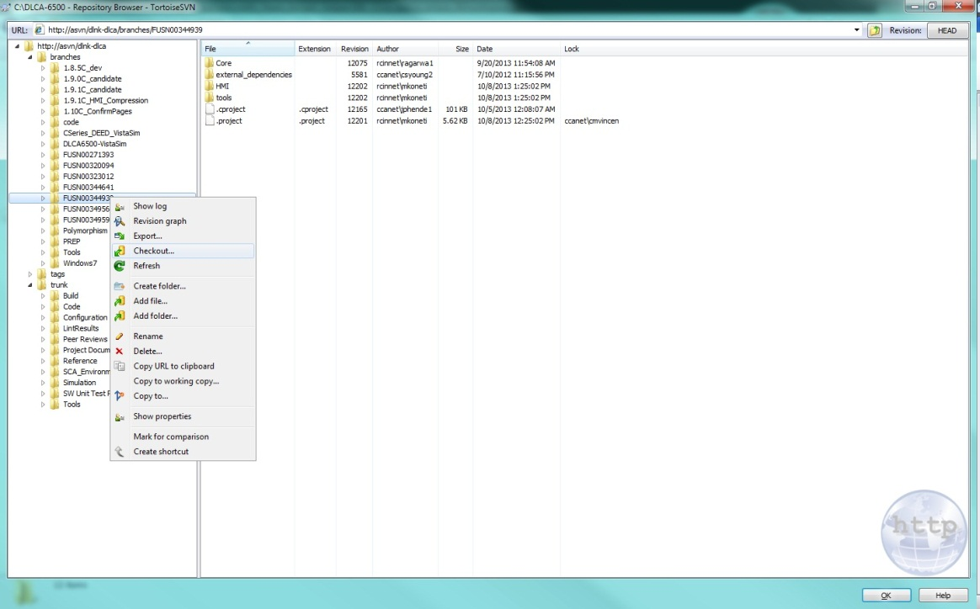

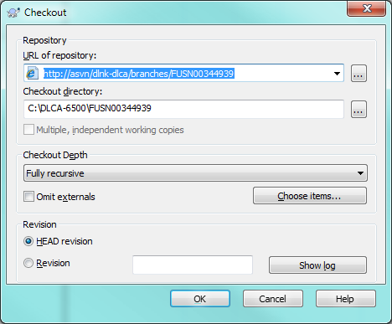

1. Work on the branch folder to fix all the issues present under CR (here CR is FUSN00344939). Commit these files (from the same path) before keeping in Peer Review.

#### Reintegrating branch to trunk

1. Right click on Trunk folder and select ‘Merge’ option. Select the ‘Reintegrate a branch’ option and select ‘Next’

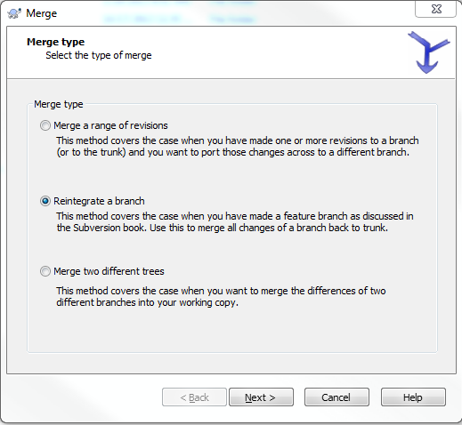

1. Now browse to the branch which needs to be reintegrated to trunk and click ‘Next’

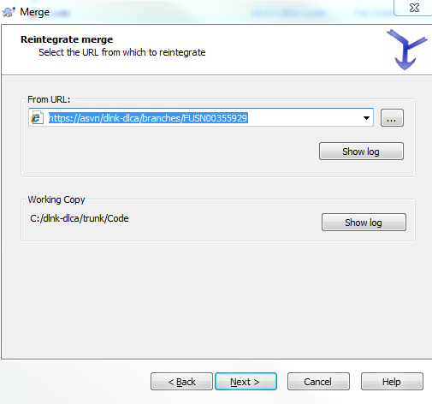

1. Before merging, select **‘Test Merge’** option to check for any conflict(s). In case of conflict(s), make sure to resolve the conflict(s) first and then proceed with the merge.

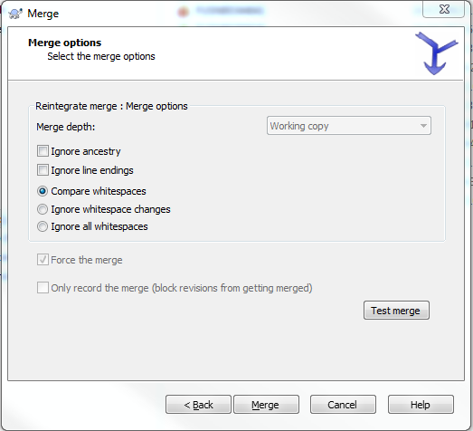

1. On selecting Merge, the branch changes will be incorporated to trunk but that will be on local system only. SVN does not perform a commit at this stage.
2. Perform a functional testing after the merge to ensure that the functionality is not affected.
3. Commit the merged changes to SVN.

#### Guidelines for Build Prep

1. It’s the developer’s responsibility to ensure that the artifact is correct before committing change(s).
2. All issues/conflicts associated with artifacts should be resolved before initiating PREP and before PREP closure.
3. Always perform a ‘Test Merge’ (SVN option) before actual merge to identify any conflicts.

Before re-integrating branch to trunk, always ensure that merge-up has been done and files updated under the current CR are the only changes between the two paths.

1. When merging the revision from SVN trunk to branch, ensure that paths are correct.
2. When same files are updated in trunk and branch then do a manual compare on the updates, avoid using SVN merge, use tools like Beyond Compare etc. to confirm the changes are acceptable.
3. Once again, run all your tests to ensure that issues have been fixed and no issues are left-out.
4. After re-integrating branch, always ensure the following in the PREP ‘Artifacts’ tab:

* the artifacts paths are updated to point to trunk
* Artifacts resulting version is from the trunk. This will allow us to meet our certification criteria.

1. For the main reviewer finding, always make sure that the ‘work version’ is from branches (i.e. before changing artifacts path) and the ‘resulting version’ is from the trunk (after changing artifacts path in PREP). Verifier should verify the changes from the code base and not through PREP. PREP tool cannot support proper comparison for this scenario.
2. When a new file is to be added, always add to the trunk first and then merge-up to branch to ensure there is no name duplication, tree conflicts and PREP issues occurring later on.
3. Once the PREP for a particular branch is closed, no more updates should be done on that branch.
4. When using development trunks for different program, it should be kept in mind that original code base (trunk) should not be updated for each CR implementation.
5. For the main reviewer finding, it’s advisable to reintegrate the branch under single SVN commit.

# EXCEL

## Open spreadsheets in separate windows.

1. Start --> Run --> type in "regedit" (without the quotes) --> Enter

2. Follow the path: HKEY_CLASSES_ROOT / Excel.Sheet.8 / shell / Open / command

a. In the right-hand pane right click on "Default" and choose modify

At the end of the path name in the Edit String box, remove /dde and replace with "%1" (include the quotes)

b. right-click on "command" and rename by adding something to the end (I put "old")

In the left-hand pane under "command" you will find the folder "ddeexec", right-click on this and rename (I put "old")

Now all spreadsheets ending in .xls will open in their own window.

Repeat these same steps for Excel.Sheet.12 to make this same change to files ending in .xlsx

If you also need to open .csv files in separate windows, make these same changes to Excel.CSV.

Close the Registry window and start opening your Spreadsheets in separate windows. No need to reboot.

# LynxOS Tools: Managing Scarce Licenses on Windows

Over the last year, the number of users of these tools has roughly doubled. Consequently, there is extreme contention for the 25 licenses at Rockwell Collins.

Please be mindful of the behavior of the LynuxWorks session manager, which claims a license and does not release that license until the session manager is exited.

The following ePedia articles document the behavior of the session manager, as well as some tactics for coping with the limited licenses:

<http://etipedia/wiki/LynxOS-178_FLEXlm_Licensing>

<http://etipedia/wiki/LynxOS-178_Installation#2.2.2>

<http://etipedia/wiki/Support_ticket_opened_with_LynuxWorks_for_session_manager_issues>

You can also use the Enterprise Tools Usage application at <http://etu> to inspect current usage and to discover licenses that have been held for extended periods of time.

The Dashboard pane displays the current status of the various LynuxWorks licenses. For example, at the time this message was sent (on a weekend), 12 of the 25 licenses

for the Windows hosted tools have been claimed, some for over 36 hours.

If you have further questions, post them on the LynxOS-178 forum:

<http://etiforum.rockwellcollins.com/forum/viewforum.php?f=91>

# Software Design Document

## High Level SDD – Microsoft Word

### [http://asvn/dlnk-dlca/trunk/Project Documents/High Level SDD/945-7650-xxx SDD.docx](http://asvn/dlnk-dlca/trunk/Project%20Documents/High%20Level%20SDD/945-7650-xxx%20SDD.docx)

### Diagrams

When adding diagrams to the Word High Level SDD we need to maintain a copy of the diagram that can be edited if future changes are needed. The easiest way to do this is to go to *Insert -> Object -> New Object -> Create New -> Microsoft Visio Object*. This object can then be edited in-place in Word by double clicking on it, or in Visio by right clicking on it and selecting *Visio Object -> Open*.

If Enterprise Architect diagrams are needed, they should be stored in [http://asvn/dlnk-dlca/trunk/Project Documents/High Level SDD/diagrams](http://asvn/dlnk-dlca/trunk/Project%20Documents/High%20Level%20SDD/diagrams), (unless they are part of a DAR). These diagrams can then be placed in to the Word document by going to *Diagrams -> Copy Image* in Enterprise Architect, and the pasting into Word.

## SDD Traceability

### Adding function definitions to SDD Doors proxy

A python script “**code_proxy_update.py**” is developed to parse through all the header files and create member function objects in Doors proxy for each header file

**Pre-requisites:**

* Make sure Lock is available for the required sections
* Doors format should be as follows

Ex:

ATN

file.h

description

Above illustration assumes three object are at different levels one below the other. Any other model the script needs to be modified.

* Python x.x should be installed.
  + Where x.x is version.
* Pythonwin x.x should be installed.
  + Where x.x is version.

**Script Location:** http://asvn/dlnk-dlca/trunk/Tools/DOORS/Python/Code proxy update

**Steps to be followed**

* Copy “code_proxy_update.py” and “pyDoors.py” to c:\\Pythonxx Folder.
* Open the script “code_proxy_update.py”
* Update variable **path** to point to your code location

***Note:*** *Read below instructions carefully while updating the variable path*

*# ---------------------------------------------------------------------------------------------*

*# Source Code root path*

*# Input should be based on Doors structure*

*# If you have files with same name in multiple folders then*

*# Input one folder at a time*

*# ------------ OR ---------------------------------*

*# If you have unique files then input root path*

*# and comment out the below line in Update_Doors_Proxy()*

*# script = script + ' if ((parent o)."Object Heading" "" == "' + header[item][0] + '")\n'*

*# ---------------------------------------------------------------------------------------------*

* Update variable **specific_header_file** to specific header file name

***Note:*** *Read below instructions carefully while updating the variable path*

***Note:*** *It is recommended to use this option because leaving it ‘None’ will update entire SDD which may impact other sections under review.*

*# ---------------------------------------------------------------------------------------------*

*# In case user wants to run for a specific header file then update the variable*

*#* ***s*pecific_header_file** *with the header file name.*

*# ------------ OR ---------------------------------*

*# Leave it as* ***None*** *to run for entire code folder*

*# ---------------------------------------------------------------------------------------------*

* Update variable **dlcaSDD** to point to your code proxy (should be same for everyone)
* Make sure you have write access to C: drive.

***Note:*** *If not modify all debug log paths in the script to known location with write access*

* Should have python x.x installed. (Used python 2.7 when this script was developed but any version should be good)
* Run the code_proxy_update.py
* Any dxl errors may cause because the description is not one level below the file name object. Just press “OK” to continue execution.

**Recommended usage**

* This script can be executed for a specific header file OR all header files in the specified path. It is always advised that execute for specific header file only because executing for entire folder might impact other sections under review.
  1. *Note:* 
     1. *In case if user modified multiple files and want to run the script, create a separate folder with the files modified and execute the script (leave the* **specific_header_file** *as “None”).*
     2. *Execution for a specific header file will be controlled by a variable in the script which need to be updated whenever user wants to execute the script for a specific header file.*
* However the python script will pop-up a warning to make sure that the user wants to run for complete code.

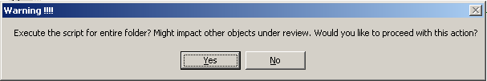

* 1. Yes – Continue the execution
  2. No – Halt the script

### Linking Requirements

#### Things to be aware/taken care during links creation

1. Every requirement must have a link to code proxy.
2. Header file objects may or may not have links
   1. Cases where the requirement talks about hardcoded values/Macro functions/functionality implemented within the header file.
3. Following types of functions/methods will not have any links to SRS
   * Destructors
   * Operator/type overloading functions
   * Copy constructors
   * Set/Get functions.
   * All files contained in the projects \SupportLib will not be linked
4. Following types of functions/methods may or may not have any links
   * All Public/Private/Protected methods mentioned except the types listed in above item.
   * Inline functions
   * Constructors (In case if the constructor is initializing variables to any specific values mentioned in the requirements)
5. Few scenarios should be considered/taken care while creating links

**Scenario 1 :**

**Code was implemented 1 functions for each of the below requirement**

OID 1: The DM function **shall** format and add the request packet to queue.

OID 2: The DM **shall** format the request packet per below format

OID 3: The DM **shall** add the request packet to queue when it is available.

**\\Code**

**void Format_request_packet()**

**{**

**.....**

**}**

**void Add_to_queue()**

**{**

**.....**

**}**

**void Format_and_add_queue()**

**{**

**Format_request_packet()**

**Add_to_queue()**

**}**

**Run() \\root or main function to the SW**

**{**

**.....**

**Format_and_add_queue()**

**....**

**}**

In this scenario the **linking** should be as follows

OID1 - > Format_and_add_queue() // should not link to other functions

OID2 - > Format_request_packet() // should not link to other functions

OID3 - > Add_to_queue() // should not link to other functions

**Scenario 2 :**

**Code was implemented 2 functions for below requirements**

OID 1: The DM function **shall** format and add the request packet to queue.

OID 2: The DM **shall** format the request packet per below format

OID 3: The DM **shall** add the request packet to queue when it is available.

**\\Code**

**void Format_request_packet()**

**{**

**.....**

**}**

**void Add_to_queue()**

**{**

**.....**

**}**

**Run() \\root or main function to the SW**

**{**

**.....**

**Format_request_packet()**

**Add_to_queue()**

**....**

**}**

In this scenario the linking might be tricky.

- If RUN is like a main entry point of the entire code then the **linking** should be as follows

OID1 - > Format_request_packet() and Add_to_queue()

OID2 - > Format_request_packet() // should not link to other functions

OID3 - > Add_to_queue() // should not link to other functions

**Reason for not linking requirement to "RUN" is because this function is like a "MAIN"**

**in C language. We cannot have bunch of requirements linked to "MAIN".**

- If RUN is like entry point for the **CLASS** then the linking should be per **Scenario 1. This is**

**because of inheritance**



#### Creating Links

Links can be created in two ways:

1. Manually link the SDD function name objects to Requirements

**(OR)**

1. Since the Doors access will be slow for offshore teams, List the SRS OIDs under "_Link_CSS" and "_Link_FANS" attributes in the below format and follow the below steps:

1234

2345

3456

***Note:*** *Fill in the OID and newline, no extra spaces. Last OID should end with a newline.*

**Step 1 :**   
Open SDD and SRS   
 **Step 2:**   
1) Make sure the list is correct (no commas, just enter key after every number/OID)   
2) Take Exclusive edit access   
 **Step 3:**   
Goto Link->Advanced->"Link by attribute"   
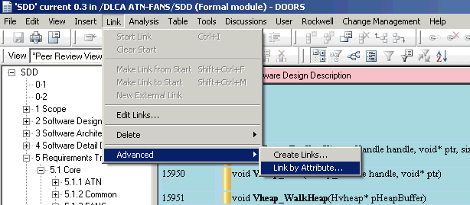  
 **Step 4:**   
   


**Step 5:**   
Click browse for Target module and select source as SRS-FANS/SRS-ATN/SRS-HMI modules as shown below   
  
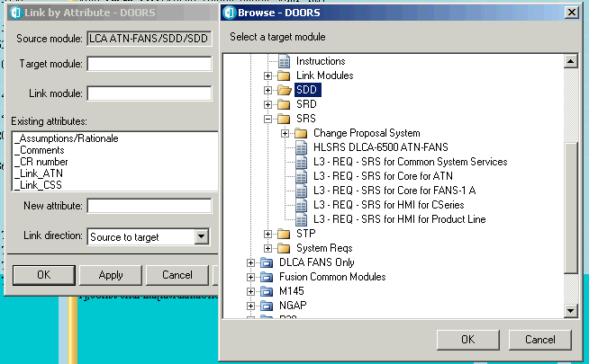  
 **Step 6:**   
Click browse for Link module and select "Design Links" as shown below   


**Step 7:**   
Select the attribute based on SRS you want to link   


**Step 8:**   
Click Apply.   
 **Step 9:**   
1) Links will be created   
2) Make sure the Links created are correct and then click Save.   
 **Step 10:**   
Release the lock on Doors Proxy.   
  
Run these steps for each and every SRS attribute by selecting appropriate modules in the above steps .   
 *Note : You can run Steps 1 to 8 and make sure you understood them. Step 9 is to save the module, so be careful if you are doing a trail because it is not possible to revert back the changes in Doors.*

# WINDOWS 7 UPGRADE TIPS

1. While installing “LynxOS-178 v2.2.2” the software center will recommend to use the path as “C:\rw_apps” for windows7, But we need to install it in “C:\ro_apps” since all the make files are pointing to this location.
2. For VISTA SIM issue

Follow the below steps to fix that issue

* 1. Delete all folders inside C:\vista\users
  2. Delete all folders inside C:\rw_apps\Verification\vista_sim\Vista_tools\CONFIGURATION\vista\users (Path may be different in your PC)\
  3. Create a new folder called "Temp" in C: drive (ex: C:\Temp)

# Source code Peer Review and SLOC information

A python script “**Review_status.py**” is developed to parse through all the Source code trunk, PREP database and create a spreadsheet **“Review_Status.xls”** with the below information

* SVN file name
* Last modified author
* SLOC count
* Last commit version
* Oldest previous PREP reversion
* Latest final PREP reversion
* Comments indicating if the file needs full review

**Pre-requisites:**

* Make sure PREP Project queries has the below query

*PREP_CS_DataLink FANS.ATN DLCA-6500_review_status*

If this query does not exist then create a query with following options

**Query name**: DLCA-6500_review_status

**Display settings**: Artifacts.Path, Artifacts.VersionFrom, Artifacts.VersionTo,

Artifacts.VersionFinal, PeerReviews.ID, PeerReviews.Status.

**Filters**: Artifacts.Path like <http://asvn/dlnk-dlca/trunk/Code> **AND**

NOT (PeerReviews.Status IN(‘Cancelled’))

* Python x.x to be installed

*Note: Python 2.7 can be found in the below location*

[*http://asvn/dlnk-dlca/trunk/Tools/Python*](http://asvn/dlnk-dlca/trunk/Tools/Python)

* Pythonwin x.x to be installed

*Note: Pythonwin 2.7 can be found in the below location*

[*http://asvn/dlnk-dlca/trunk/Tools/Python*](http://asvn/dlnk-dlca/trunk/Tools/Python)

* Follow the below steps to install python xls package

*Note: Python xls utilities package can be found in the below location*

[*http://asvn/dlnk-dlca/trunk/Tools/Python*](http://asvn/dlnk-dlca/trunk/Tools/Python)

* + Open command prompt
  + Go to ..\trunk\Tools\Python\xlutils-1.5.2\xlutils-1.5.2 in your local PC
  + Run the command “setup.py install” as shown below
* Follow the below steps to install python xlwt package

*Note: Python xlwt utilities package can be found in the below location*

[*http://asvn/dlnk-dlca/trunk/Tools/Python*](http://asvn/dlnk-dlca/trunk/Tools/Python)

* + Open command prompt
  + Go to ..\trunk\Tools\Python\ xlwt-0.7.4
  + Run the command “setup.py install” as shown below

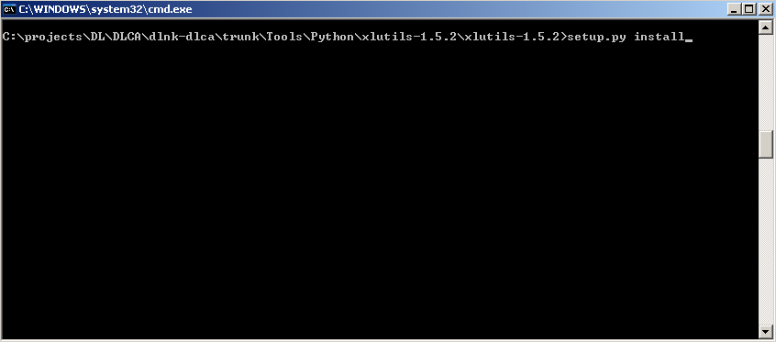

**Executing the script:**

Double click the python script “Review_status.py” from the path “\trunk\Tools\PREPTools\Python” in your local SVN checkout and the script will update the spreadsheet “Review_Status.xls” with the latest file status.

# Footprint Analysis

The following section describes the steps required to generate the footprint analysis for DLCA-6500, these steps are used to complete Section 3.1.3 Data Charaacterization and Measurement Analysis for DLCA-6500 in the Footprint Analysis. The analysis consist of obtaining memory and processor performance while running at maximum load. The maximum load is based on requirements where upper limits have been specified for message handling (uplink and downlink). In the case where specific limits are not specified an analysis was done to determine the proper limits to use, all limits are documented in the steps below. For the software analysis a special build was used by updating some of the baseline code with code that would provide an environment in which the DLCA-6500 would operate in a maximum loaded condition.

1. Memory Allocated is found in the file "http://asvn/dlnk-dlca/trunk/Build/CSeries/etc/DLCA_autostart.vct"

<VM#>

...

LogicalName=DLCA,

...

SysRamMemLim= 14680064; // 14.00 MB

PersStorOnLocalLim=1024;

</VM#>

1. Obtain the footprint code: http://asvn/dlnk-dlca/trunk/Code/tools/dlca_6500/makefiles/Footprint/src
2. Run the following batch file to copy the Footprint modified code into the appropriate directories for the target build. http://asvn/dlnk-dlca/trunk/Code/tools/dlca_6500/makefiles/Footprint/src/PlaceFootprintSources.bat.
3. Build the target build, using Eclipse, with the Footprint code.
4. Load the target build onto the hardware in the lab and run the application.
5. The results of the run will be written out to a Log file. Capture the information from the log file into the Footprint document.
6. Persistent storage is obtained from the number of ground ATN Network Service Access Point. The upper limit of Persistent Storage is 1200 bytes.
7. The amount of RAM used based on the scenario configured in the Footprint code is listed at the bottom of the Log file, “LynxOS sysram memory usage:”.
8. The stack usage based on the scenario configured in the Footprint code is listed at the bottom of the Log file, “LynxOS thread stack usage:”
9. Calculate the size of ROM( from DLCA Footprint based on the memory analysis: http://asvn/csdlnkver-dlca/RFS_091_6412_100/RFS_InspectionAnalysis\TP_COMM_MEMORY_001.doc Section 1.4) The size of ROM being used is determined by adding together the size of the files dlca.exe, DLCA_iocfg.xml and DLCA_screenfield.xml which are located in /fmc_sys_eng/Apps/DLCA/

EDS_M204:

* Copy the code from the below SVN path to dev repo path,

https://asvn/dlnk-dlca/trunk_PL5/Tools/Footprint Analysis/Code

* Create the new dlca.stripped file using the new code.
* Create footprint build for M204 program using the new stripped file.
* Load this into the EDS Dual TAM station and perform the test,

a) Logon to FANS

b) Setup the DM tool to provide Position data

c) Establish 4 ADS periodic contracts

d) Select START on the FOOTPRINT page (do not leave the page)

e) On another display, view messages in the message log (respond if you want to)

f) Continuously uplink the attached FANS uplink messages **(46 downlinks and 63 uplinks sent)**

g) ATC DL is **Disabled**and **Enabled**when message log page is full.

**Single cycle worst case value :19ms  
 6 consecutive cycle worst case value : 36ms**

* Copy the 6 consecutive cycle worst case value into the “New_calculation_method_M204_Chu” tab of footprint_calculation.xlsx

# Dr. Memory

Dr. Memory is a memory monitoring tool capable of identifying memory-related programming errors such as accesses of uninitialized memory, accesses to unaddressable memory (including outside of allocated heap units and heap underflow and overflow), accesses to freed memory, double frees, memory leaks, and (on Windows) access to un-reserved thread local storage slots.

Follow the below steps to execute this tool

* Just run with <http://asvn/dlnk-dlca/branches/1.12.0_dev/Simulation/DLCA6500-VistaSim/CSeries_HostMem.bat>
* Output of error will go to results.txt file in C:\rw_apps\dlnk-dlca\branches\1.12.0_dev\Simulation\DLCA6500-VistaSim\Apps\DLCA\Cseries.dlca.0-1\drmemory\logs\DrMemory-dlca.exe once you exit Vista
* More info at <http://www.drmemory.org/>

# Training & Tips

* 1. Improvements in our SW unit test
     + If your SW Unit Test are large and will not fit into the CT please add it to http://asvn/dlnk-dlca/trunk/SW Unit Test Procedure directory and add the reference into the CT under "Verification Description".
     + The above applies to all code bug and development CT
     + Please commit the UNIT TEST FILE in word which will contain both test case and the snap shot log of actual results
     + Also include any OID’s you are testing. For bug fix having multiple issues, try to mention the OID’s that you have tested under each issue separately.
     + Example: <http://asvn/dlnk-dlca/trunk/Reference/Training/example_FUSN00274441_FANSATN0001260_Unit_Test_Confirm_Req.pdf>
     + The idea behind documentation is :
       - Help the reviewers of the code in understanding if the updates are working per the requirements.
       - Help the Detection and Injection issues on 6500.
       - Help SS in the RIG testing.
     + Steps to follow:
       - Step 1 Run all unit test on target.
       - Step 2 Document what you tested
     + Expected format is :
       - * TEST CASE
         * ====================
         * OBJECTIVE:
         * INPUT/PRIOR CONDITIONS:
         * PROCEDURE:
         * EXPECTED RESULTS:
  2. PREP Tip: In PREP use the ClearQuest explorer to find all your files for a CR and drag them into the review no need to use the SVN explorer.

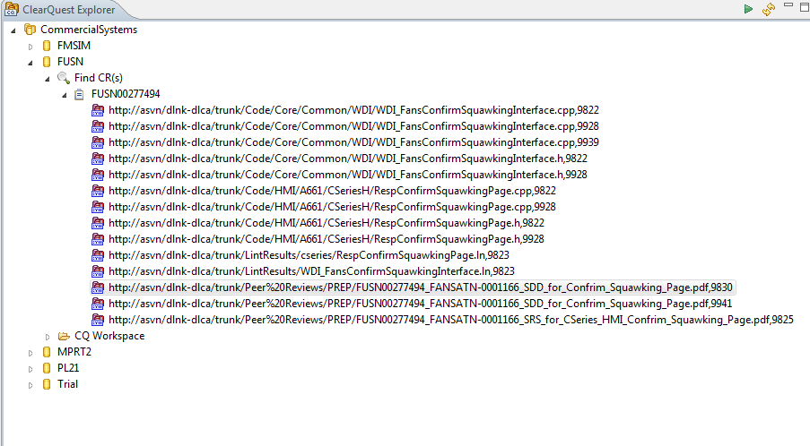

* 1. Test Station Utilization: IDC wants to use the Cedar Rapids Target Test stations more often. So that we do **not** step on each other’s time please reserve your time using TeamSpace calendar,
     + <http://teamspace/cs/fms/datalink/dlca6500/Lists/Calendar/calendar.aspx>

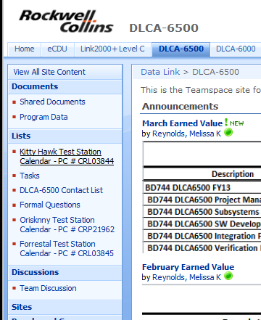

# Miscellaneous

In order to obtain after hour lab access, you will need to call the security office: **295-2222 or 1-800-314-0435** and provide your name and what labs you need access to. The labs being used for DLCA-6500 are: Building 131, Lab 1 and Building 131, Lab 2.

# Nameplates

The requirement for nameplates and other field loadable documentation is located in ePedia at:

<http://epedia/wiki/Field_Loadable_Software_Top_Level_Drawing_and_Identification_Requirements>

* C295 is Proline EDS and should follow the EDS template (Figure 3).

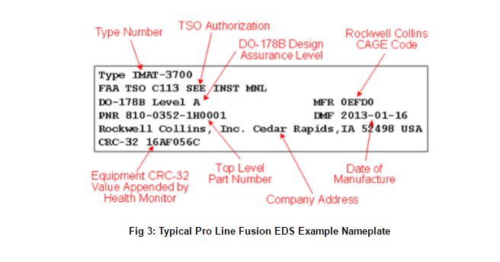

* MRJ, EEJ and KC-390 are Proline Fusion and should follow the Fusion template (Figure 4).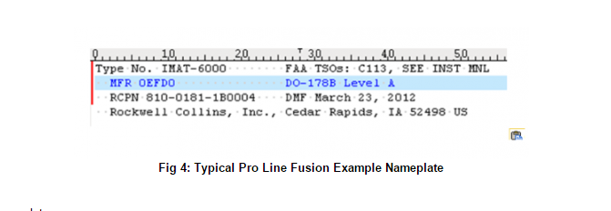

**Note: For the developmental (non-Certified) and as such should reference the E-Mod rather than the DO-178B/TSO information (refer to Figure 5).**

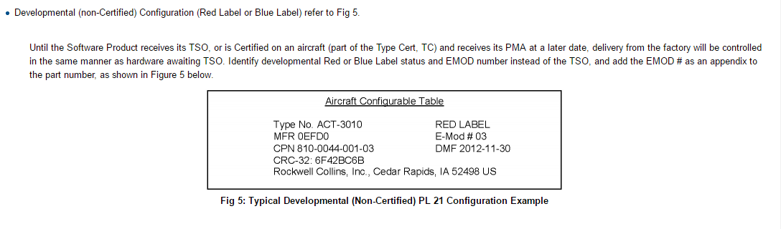

**DLCA6500 directory structure for nameplates:**

**<Part Number>**

**- <E Mod Number>**

**- nameplate.txt**

**- <E Mod Number>**

**- nameplate.txt**

**- <E Mod Number>**

**- nameplate.txt**

**svn path**: [https://asvn/dlnk-dlca/trunk_PL2/Project Documents/EMods/Nameplates/](https://asvn/dlnk-dlca/trunk_PL2/Project%20Documents/EMods/Nameplates/)

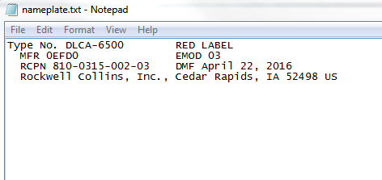

Sample **nameplate.txt** file for MRJ:

# Seamless transfer check between ATN <-> FANS

For seamless transfer between ATN->FANS and vice versa, ensure the below points are met:

* Get the ATC tool (096-4322-XXXX) from SCL and choose the file ‘AtnMibiface.cfg’
* At System Rig, perform the following:

1. Make sure the ‘ADM’ value from ‘AtnMibiface.cfg’ file is matching with the ‘ADM’ value mentioned in Page 4 of IDENT BLK PGM display page.
2. Make sure the ‘ARS’ value from ‘AtnMibiface.cfg’ file is matching with the ‘ARS’ value mentioned in Page 5 of IDENT BLK PGM display page.

**To Navigate Page4 and page5 of IDENT BLK PGM display page, follow the below steps:**

**Step 1:**

From the DL Application Menu (The RIU/CMU-40XX Core Software owns the APPLICATION MENU page), press the TECHNICAL button.

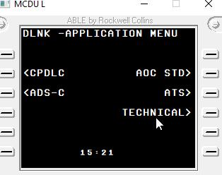

**Step 2:** From Technical Menu, Press the PASSWORD button

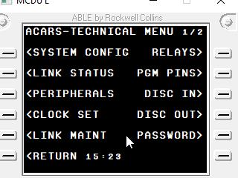

**Step 3:**

In Password page, enter the current time as password in XXXX format (below figure shows 15: 23- Enter 1523 as password)

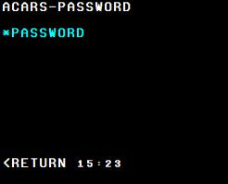

**Step 4:**

Once the password is entered, Select the APM menu option from Protected Menu page.

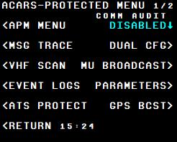

**Step 5:**

From APM menu page, Select IDENT BLK PGM option.

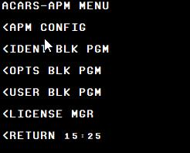

**Step 6:**

Select the page up/down buttons to navigate to IDENT BLK PGM pages 1 to 5. IDENT BLK PGM page 1 to 5 looks like the below images.

IDENT BLK PGM Page 1:



IDENT BLK PGM Page 2:



IDENT BLK PGM Page 3:



IDENT BLK PGM Page 4:



IDENT BLK PGM Page 5:



**Note:**

1. For more details on ARS and ADM fields, refer’ EUR Doc 028 EUR NSAP Address Registry vXX_X.pdf’
2. Refer DOORS module – ‘LLSRS for Tech App’ section Display Pages section from /DLNKX1/RIU-40XX CMU-4000/LL SW Reqs/Core for APPLICATION MENU display pages information.
3. ‘X’ highlighted in yellow color refers to choose latest version of the tool(s)/file(s).

Also, ensure that all the fileds (AFI, IDI, VER, RDF, LOC, SYS) of ‘AtnMibiface.cfg’ are matching with ACARS IDENT BLK PGM pages. If the values are not matching, write the values in ACARS IDENT BLK PGM pages to match with AtnMibiface.cfg.

Note: AFI, IDI, VER, RDF, LOC, SYS are commented out in AtnMibiface.cfg but still these values should match with ACARS IDENT BLK PGM page values.

